Data response

Factors affecting demand for breakfast cereals

Over recent years, many factors have affected the UK market for breakfast cereals. The single most important is probably health - or the perception of health. Between 2007 and 2013, the market grew £240 million by value - with almost all the gains going to existing and new brands perceived to be healthy. In 2007, Kellogg's Special K's focus on dieters made it seem healthy. In 2013, Weetabix, oat-based products and mueslis such as Alpen had the winning formula.

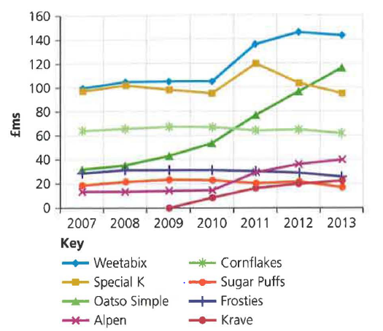
A second influence was the decision by the last government, in 2008, to prevent cereal producers from advertising children's brands in children's TV slots. This had little immediate effect on sales, but slowly it seems to have hurt brands such as Sugar Puffs and Frosties. (NB 'healthy' Alpen has more calories per 100 grams than Frosties, but marketing is about perceptions, not realities.) Despite the general strengths of 'healthy' cereals, Kellogg's has achieved success with Krave – a chocolate-based, indulgent cereal supposedly aimed at young men.

Figure 5.4 Annual UK breakfast cereal sales (source: The Grocer magazine)

One other factor has been hugely important to this market - the continuing move away from sit-down breakfasts towards breakfast’s on-the-go. In some ways, the producers can capture this change through cereal bars, but once out of the house, school children in particular may end up buying crisps and an energy drink rather than cereal. In 2013, the market for breakfast cereal grew 2.7 per cent by value, but fell 2.8 per cent by volume.

The final issue has been the recession. This has hit manufacturers in two ways: first, it has forced them to fight harder with promotional pricing, thereby lowering profit margins. In 2012, half of all breakfast cereal was bought on special offer. Second, and at least as important, there has been a switch to supermarket own-label cereals. In 2007, 18.9 per cent of sales were supermarket brands. By 2013, this figure had risen to 21.5 per cent.

Table 5.3 shows the actual UK sales figures recorded each year by The Grocer magazine. Weetabix is number 1 and Quaker's Oatso Simple has overtaken Special K to become number 2.
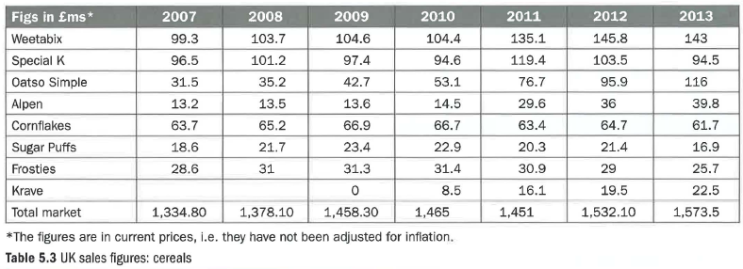

Questions (30 marks; 35 minutes)

1 Following a decline in its sales in 2009 and 2010, Special K had a great year in 2011. Explain two factors that may have caused this. (4)

2 Assess two factors that may have affected the demand for Alpen between 2007 and 2013. (8)

3
a) Calculate the market share for Frosties (to two decimal points) in 2007 and again for 2013. (2)
b) Explain why this information might be important to Kellogg's, owners of the Frosties brand. (4)

4 From the information provided and your wider knowledge, evaluate two factors that might affect the total market size for cereals over the coming 12 months. (12)

