Q1.The graph below shows the area of forest lost in Madagascar from 2009 to 2012.
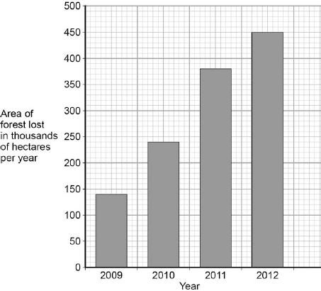
(a) The area of forest lost each year in Madagascar increased between 2009 and 2012.
Determine the total area of forest lost from the start of 2009 to the end of 2012.
.............................................................................................................................
.............................................................................................................................
Total area of forest lost = ...................... thousand hectares
(1)

(b) What are the possible reasons for the change in the area of forest lost per year between 2009 and 2012?

Tick two boxes.
The local people stop growing rice
Fewer new houses are needed for the population
The local people decided to farm cattle
More trees have been planted
A company starts growing plants for biofuels

(2)

(c) More forest was lost in 2012 than in 2009.
Use words from the box to complete the sentences.

 | carbon dioxide | excretion | nitrogen
 | oxygen | photosynthesis | respiration

The increase in the area of forest lost has caused an increase in the gas
...........................................
The increase of this gas has been caused because less of the gas is being
absorbed by plants for the process of ........................................... .
(2)

(d) Deforestation can have negative effects on our ecosystems.
What are the negative effects of deforestation?

Tick two boxes.
Animals and birds migrate because there is less food
More habitats are destroyed
There is less acid rain
There is more biodiversity
The global temperature decreases

(2)

(e) Scientists try to reduce the negative effects of human activity on our ecosystems.
One way is to protect rare habitats.
Give one other way of reducing the negative effects of human activity on our ecosystems.
.............................................................................................................................
.............................................................................................................................
(1)
(Total 8 marks)

Q2. The photograph shows an area where a tropical forest is being cleared.
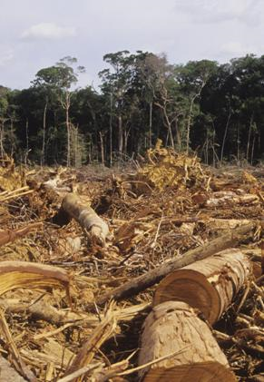

(a) Complete the sentences.
People could use timber from the forest for .................................................................... .
The cleared land can be used for ..................................................................................... .
Clearing forests increases the concentration of ............................................................... in the atmosphere.
This increase causes global .................................................................. .
(4)

(b) Clearing forests causes some species to become extinct.
(i) What is meant by extinct?
...........................................................................................................................
...........................................................................................................................
(1)

(ii) It is important to prevent species from becoming extinct.
Give one reason why.
...........................................................................................................................
...........................................................................................................................
(1)
(Total 6 marks)

Q3.Human activity affects ecosystems.
(a) Draw one line from each human activity to the effect on ecosystems.
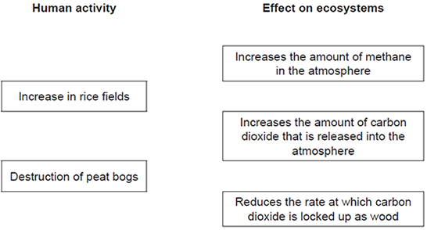
(2)

(b) (i) Deforestation also affects the atmosphere.
Give two reasons why deforestation takes place.
1 ................................................................................................................
...................................................................................................................
2 ................................................................................................................
...................................................................................................................
(2)

(ii) Changes in the gases in our atmosphere can cause global warming.
Give two possible effects of a rise in the Earth’s temperature.
1 ................................................................................................................
...................................................................................................................
2 ................................................................................................................
...................................................................................................................
(2)
(Total 6 marks)

Q4. Improving the quality of life for everyone without damaging the planet for the future is known as sustainable development.
One problem is the rapid growth in the Earth’s population of humans during the last 500 years. This is shown by the graph.
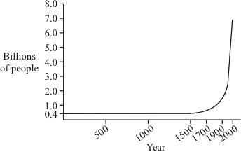

(a) When the Earth’s population was much smaller, the effects of human activities on forests were usually small and local.
In the past 500 years there has been large-scale deforestation in some areas. Give two reasons for this.
1 ..................................................................................................................................
2 ..................................................................................................................................
(2)

(b) Look at the bar chart. It shows the average amount of energy used by each person in one year in the USA, Japan and Bangladesh.
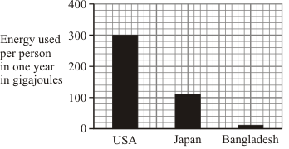

(i) Suggest one reason why so much more energy is used per person in the USA than in Bangladesh.
...........................................................................................................................
...........................................................................................................................
(1)

(ii) Using a lot of resources for energy harms the Earth.
Explain why.
...........................................................................................................................
...........................................................................................................................
...........................................................................................................................
(2)

(c) As we are using more resources, waste management is becoming more important. In the UK much of the solid waste is still being dumped in landfill sites. In 1996, the UK government introduced a landfill tax because landfill sites were being used up. However, the year after the landfill tax was introduced it was estimated that 18 million tonnes of landfill waste was not reported. The government was trying to encourage other forms of waste management, such as:
• reduce waste
• reuse waste
• recycle waste

(i) Explain the main problem caused by the landfill tax.
...........................................................................................................................
...........................................................................................................................
...........................................................................................................................
(2)

(ii) Describe one example of how each of the different forms of waste management can be put into practice.
Reduce waste ....................................................................................................
...........................................................................................................................
Reuse waste ......................................................................................................
...........................................................................................................................
Recycle waste ...................................................................................................
...........................................................................................................................
(3)
(Total 10 marks)

Q5.Human activities have many effects on our ecosystem.
The graph shows the volume of peat compost and peat-free compost used in gardening from 1999 to 2009.
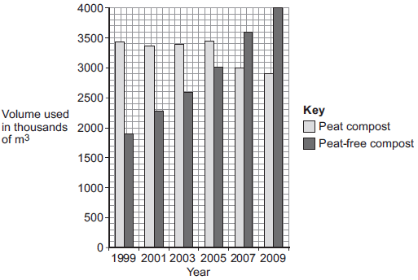
(a) Describe the trends shown in the graph.
........................................................................................................................
........................................................................................................................
........................................................................................................................
........................................................................................................................
........................................................................................................................
(2)

(b) What effect does the destruction of peat bogs have on the gases in the atmosphere?
........................................................................................................................
........................................................................................................................
(1)

(c) Deforestation is also damaging ecosystems.
Describe one effect of deforestation on ecosystems.
(1)
(Total 4 marks)

Q6.In many areas of the world the mass of household waste produced each year is increasing.
(a) Give two reasons why the mass of household waste is increasing each year.
1......................................................................................................................
........................................................................................................................
2......................................................................................................................
........................................................................................................................
(2)

(b) The table below shows how the mass of household waste in the UK has changed from 2004 to 2012.

 | Year | Total mass of  household waste in  thousands of tonnes  (including total  household recycling) | Total mass of  household recycling  in thousands of  tonnes | Percentage of  household waste  recycled
 | 2004 | 25 658 | 5785 | 22.5
 | 2006 | 25 775 | 7976 | 30.9
 | 2008 | 24 334 | 9398 | 38.6
 | 2010 | 23 454 | 9733
 | 2012 | 22 643 | 9782 | 43.2

(i) Calculate the percentage of household waste recycled in 2010.
...............................................................................................................
...............................................................................................................
...............................................................................................................
...............................................................................................................
......................... %
(2)

(ii) The UK government has been encouraging a ‘zero waste economy’.
In a ‘zero waste economy’, we reduce, reuse and recycle as much waste as possible.
A newspaper concluded that: ‘The government’s ‘zero waste economy’ has been successful.’
Use information from the table to describe the reasons for and against the newspaper’s conclusion.
...............................................................................................................
...............................................................................................................
...............................................................................................................
...............................................................................................................
...............................................................................................................
...............................................................................................................
...............................................................................................................
...............................................................................................................
(4)

(c) (i) Some waste releases carbon dioxide and methane into the atmosphere.
An increase in carbon dioxide and methane contributes to global warming.
Global warming can cause sea levels to rise.
Describe two other possible effects of global warming on our environment.
1.............................................................................................................
...............................................................................................................
2.............................................................................................................
...............................................................................................................
(2)

(ii) Storing the carbon dioxide helps to prevent more global warming.
Carbon dioxide can be stored (sequestered) in trees when they photosynthesise.
Give one different way in which carbon dioxide is sequestered in our environment.
...............................................................................................................
...............................................................................................................
(1)
(Total 11 marks)

Q7. In South Asia, forests are being cleared to grow palm oil trees. The palm oil is mainly used to produce fuel for motor vehicles.
The graph shows the production of palm oil in one South Asian country.
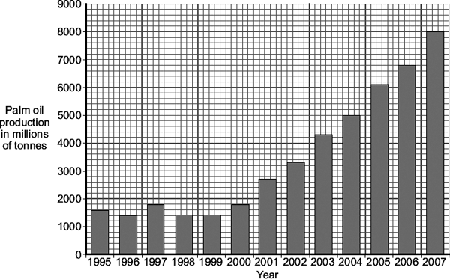
(a) Calculate the mean increase in palm oil production per year for the five year period 2000 to 2005.
Show clearly how you work out your answer.
........................................................................................................................
........................................................................................................................
Mean increase = .............................. millions of tonnes per year
(2)

(b) Clearing forests and replacing the forests with palm oil trees to produce fuel for motor vehicles will affect the composition of the atmosphere.
Explain how.
........................................................................................................................
........................................................................................................................
........................................................................................................................
........................................................................................................................
........................................................................................................................
........................................................................................................................
........................................................................................................................
........................................................................................................................
........................................................................................................................
........................................................................................................................
........................................................................................................................
........................................................................................................................
........................................................................................................................
........................................................................................................................
(5)
(Total 7 marks)

Q8. Scientists have discovered that curry spices affect sheep and cattle. Curry spices can reduce the amount of methane that grazing animals give off.
‘Bad’ bacteria in the animal’s stomach produce methane. About 12% of the animal’s food is changed into methane.
The curry spice coriander works like an antibiotic. Adding coriander to animal food reduces methane production by about 40%.
(a) (i) Why does adding coriander to an animal’s food reduce methane production?
...............................................................................................................
...............................................................................................................
(1)

(ii) Explain one advantage to a farmer of adding coriander to the animal’s food.
...............................................................................................................
...............................................................................................................
...............................................................................................................
...............................................................................................................
(2)

(b) Farm animals give off large amounts of methane.
Explain the effects of adding large amounts of methane to the atmosphere.
........................................................................................................................
........................................................................................................................
........................................................................................................................
........................................................................................................................
........................................................................................................................
........................................................................................................................
(3)
(Total 6 marks)

M1.(a) (140 + 240 + 380 + 450 = ) 1210
1

(b) the local people decided to farm cattle
1

a company starts growing plants for biofuels
1

(c) carbon dioxide
in this order only
1

photosynthesis
1

(d) animals and birds migrate because there is less food
1

more habitats are destroyed
1

(e) any one from:
• breeding programmes (for endangered species)
• regeneration (programmes)
• reintroduction of field margins / hedgerows
• awareness raising with politicians / public
• recycling
1
[8]

M2. (a) fuel / houses / paper
allow any object made from wood
1
farming / agriculture / replanting
allow roads / homes / factories
1
carbon dioxide / greenhouse gas / pollution or relative named pollutant
1
warming / temperature increase
1

(b) (i) none of species left / died out
1
(ii) may have products useful to humans / examples
allow preserve for future generations or ‘still there to look at’
allow affect food chains / cycles or extinction of other species
allow non human reasons eg loss of habitat
ignore environmental effects
1
[6]

M3.(a) 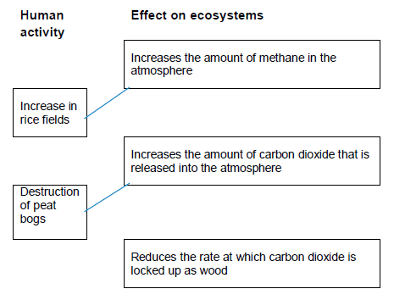
extra lines from left cancels mark
2

(b) (i) any two from:
• (to provide land) for farming / agriculture
• (to provide land) for quarrying
• (to provide land) for building
• to provide wood for building materials
• to provide fuel
• to provide paper
2

(ii) any two from:
• changes in earth’s climate, ie droughts, flooding, hurricanes
ignore temperature rise
allow ice caps melt
• rise in sea levels
• reduce biodiversity
• change in migration patterns
• may change distribution of species
ignore acid rain and the ozone layer and forest fires
2
[6]

M4. (a) any two from:
agriculture
accept land to grow crops or graze cattle
buildings
roads
any 2 different uses for wood for 1
mark each
accept wood for burning (energy)
accept timber for wood
2

(b) (i) (USA has) more wealth / technology /
devices / need for electricity
1
(ii) damage done
e.g. pollutant / mining / non-renewable / deforestation
1
linked effect
e.g. greenhouse effect / visual pollution / run out of resources / flooding
1

(c) (i) Problem – because some people did not want to pay the (landfill) tax
1
Waste dumped elsewhere
1
(ii) named example of
Reduce – such as less packaging / repairing
1
Reuse – such as glass bottles / shopping bags / ink jet cartridges
1
Recycle – such as metals, glass, paper
Mark as a whole
1
[10]

M5.(a) any two from:
• (volume of) peat compost has been steady and then declined or volume of peat compost has declined since 2005
allow 2007 instead of 2005
• (volume of) peat-free compost has increased (since 1999)
• (volume of) peat is higher than peat-free until 2005, then peat-free compost is higher (than peat)
allow 2007
• total volume of peat and peat-free compost has increased.
2

(b) increases carbon dioxide (in the atmosphere)
ignore methane
1
(c) any one from:
• reduces biodiversity
• destruction of habitats
• disruption of food chains.
1
[4]

M6.(a) (rapid) growth in population (size)
1
increase in the standard of living
accept description of increased standard of living, eg more packaging, more food thrown away or overbuying resources
1

(b) (i) 41.5
allow 1 mark for 9733 ÷ 23454
or
allow 1 mark for 0.415
or
allow 1 mark for 41.49 or 41 or 41.4
2

(ii) any four from
arguments for:
• there has been a reduction in total waste
• there has been an increase in (total mass of) recycling
• there has been an increase in the percentage of waste recycled
• it (may) not be possible to achieve zero waste.
arguments against:
• there is still a lot of waste (not recycled)
• there has only been a small reduction in total waste
• there was one year (2006) where total waste went up
• the rate of increase of percentage recycled is slowing down
• no information on materials reused
• no information on waste from factories / industry
max 3 marks for a one sided argument
allow as reason against if clear
allow still more than half or 56.8% of waste (not recycled).
4

(c) (i) any two from:
• reduce biodiversity or extinction
• change in migration patterns
• change in species distribution
• change in climate
ignore rise in sea levels
ignore temperature change
accept correct examples of climate change e.g. storms, flooding, drought
references to weather changing is insufficient
allow ice caps melting or habitat destruction.
2
(ii) any one from:
• absorbed by oceans / ponds / lakes
• peat bogs
allow used for skeletons / shells of sea creatures
allow in fossil fuels / limestone.
1
[11]

M7. (a) 860
correct answer gains 2 marks
if answer incorrect evidence of (6100 - 1800) ÷ 5
or 4300 ÷ 5
or (900 + 600 + 1000 + 700 + 1100) ÷ 5 gains 1 mark
allow ecf from 1 incorrect graph reading
2

(b) ignore references to oxygen / sulfur dioxide / nitrogen oxides / acid rain ignore global warming
Effects of deforestation
deforestation increases the amount of carbon dioxide in the atmosphere
award this point only if linked to deforestation
1

any two from:
• due to less photosynthesis or less carbon dioxide taken in
or carbon dioxide not locked up in (forest) trees
• due to burning of forest / from machinery
• due to activity of microorganisms / decay
2

Effects of growing palm for fuel
carbon dioxide released when palm oil used as fuel
1

(eventually) CO₂ intake and output might balance out or burning palm
oil carbon neutral
accept less carbon dioxide than from burning fossil fuels
1
[7]

M8. (a) (i) kills / gets rid of / reduces methane bacteria
allow kills / gets rid of / reduces bad bacteria
ignore acts like antibiotic
1

(ii) less food converted to methane
allow can keep more cattle without further environmental damage
ignore energy
1

more growth / meat / muscle / milk produced / more profit / fatter animals
ignore references to bacteria and disease
1

(b) absorbs energy / heat radiated by Earth
allow absorbs / traps energy / heat / from Earth
do not allow absorbs energy / heat from Sun
1

some energy / heat reradiated
ignore reflected
do not allow reradiates energy / heat from Sun
1

leading to global warming / enhanced greenhouse effect
accept effects of global warming eg melting ice caps
accept methane is a greenhouse gas
ignore references to ozone
1
[6]

