NHS 'misses A&E waiting time target'
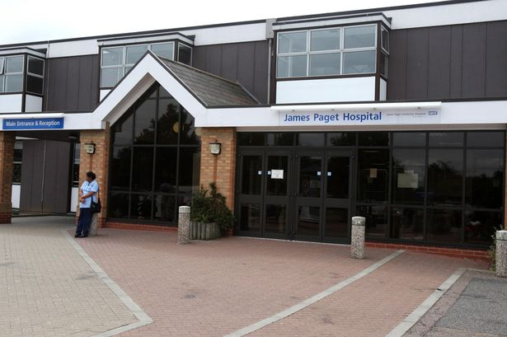
The NHS in England missed its A&E waiting time target in the first three months of the year, researchers say.
A total of 313,000 patients waited more than four hours, up 39% on the similar period in 2012, the King's Fund said after analysing official statistics.
That represented 5.9% of patients when the NHS is only allowed a leeway of 5% - the worst performance for nine years.
There is also evidence performance in areas such as infection control and cancer care could be deteriorating.
The government has made extra money available for the worst-hit areas, but the news points to what many experts have been warning about.
Last month both doctors and managers claimed the system was heading for a crisis as hospitals were struggling to cope with rising demand amid pressures on funding and staffing levels.
Budget squeeze
There have been reports of temporary waiting areas being set up in car parks and store rooms to help some units manage demand.
Patients should be seen, diagnosed and treated within four hours, but the analysis showed 5.9% had waited longer than that, although the figures for recent weeks do show an improvement, the think tank said.
This is the first time the target has been missed since the leeway allowed - so that doctors can prioritise the sickest patients - was relaxed from 2% to 5% in 2010. Before then the target tended to be missed each winter.
'Heaving'
Meanwhile, a separate analysis by Monitor, found evidence that performance in areas such as cancer care, non-emergency operations and infection control could be deteriorating because of the growing pressures.
Sir Richard Thompson, president of the Royal College of Physicians, said: "This is no surprise - patients are presenting at emergency departments in increasing numbers because there is nowhere else they can go.
"Patients arriving at the 'front door' of the hospital have an impact on acute services throughout the hospital, and we need to redesign emergency care systems around the patient, while making sure that clinicians' workloads and working practices are safe and sustainable."
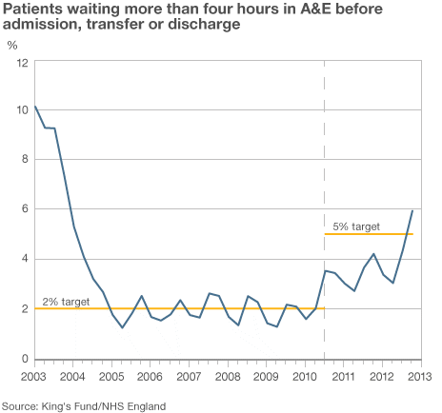
Clare Gerada, chairwoman of the Royal College of GPs, agreed.
She said GP surgeries and hospitals were "heaving under the workload" and the whole NHS was at risk of "grinding to a halt".
And shadow health secretary Andy Burnham said the situation would get worse unless urgent action was taken.
"I would use around half of the (£2bn) underspend in the NHS to provide emergency support to shore up councils' social care services," he said. "We need more home-based care to keep older people supported at home and out of hospitals."
But the government has in part blamed a "disastrous" legacy from Labour, including the renegotiation of GPs' contracts which allowed them to opt out of providing out-of-hours care.

QUESTION:
What examples of government failure are illustrated in this article?

