The business cycle

The business cycle is the pattern of boom then slowdown that has been a feature of the UK economy for more than 150 years. When the economy is growing rapidly (around 3 per cent a year), consumers and companies have the confidence to spend and invest. This extra boost to output risks creating an unsustainable boom, which may lead to a bust, such as the one in 2009.

Figure 45.1 shows the tricky period for the UK economy between the start of recession in 2008 and the second quarter of2014, when the economy finally returned to its pre-recession peak. The straight black line shows the GDP trend excluding the recession and the unprecedentedly slow recovery. The graph also shows the normal progress of the UK economy. For more than 200 years, it has grown at an average of just under 2.5 per cent per annum – that is, growth is normal. Therefore, the general expectation is that the underlying market conditions will be positive, with the size of markets expanding on a regular basis.
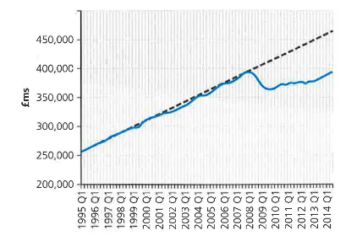

Figure 45.1 UK gross domestic product, 1995-2014; chained volume measures, quarterly figures, seasonally adjusted (source: ONS)

When market conditions are as tough, as in 200812009, there are likely to be failures as businesses run out of cash (Woolworths, La Senza and many others went under). There may also be huge pressures placed on company workforces, as people are forced to choose between redundancy and real wage cuts. In the recessions of 1980 and 1990, job losses pushed unemployment up above three million. The recent recession saw instead a huge squeeze on people's real incomes, meaning that the pain was shared more fairly across the population. Government statistics show that between July 2008 and March 2014 earnings rose 8.6 per cent while prices rose 16.9 per cent. This made people 7.1 per cent worse off (even worse if the tax to be paid on the extra earnings is included). In addition to this squeeze on incomes, Figure 45.2 shows why consumer confidence was hard hit in 2009, with people worried whether they would be next for a redundancy notice. No wonder that, at times, even products like chocolate and chewing gum saw falls in sales volume as market conditions tightened.

