Investigating Muscle Fatigue
Information
- Muscles work anaerobically when worked hard.
- Fatigue is caused by a build up of lactic acid in the muscle.
- Arm exercises are an easy way to investigate muscle fatigue.

Hypothesis
As the mass of the weights increases, muscles will fatigue quicker.

Equipment
A set of 8 identical textbooks
A stopwatch
A lab partner

Variables
Independent variable – number of textbooks
Dependent variable – time taken for muscles to fatigue/ seconds
Control variables – type of textbook, height books are lifted to, rest time between lifting.

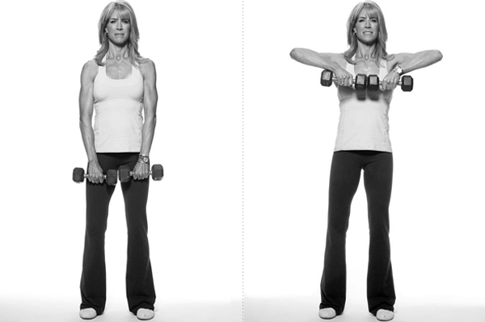
Method
READ THROUGH THE METHOD FULLY BEFORE BEGINNING YOUR EXERCISE.
1. Stand up, in a clear space, with no objects around you.
2. Hold one textbook flat, at waist height, with the front cover facing the floor.
3. When you are ready to begin, tell your partner, who should start the stopwatch.
3. Lift the textbook to be in line with your chin, keeping the front cover facing the floor (as in the diagram shown)
4. Lower the textbook back to the starting position.
5. Repeat the exercise, at a comfortable rate, until your muscles become too sore to continue.
6. Stop the stopwatch once the exercise is complete and record your result.
7. Sit down and rest for 3 minutes before repeating the exercise using 2 books.
8. Continue to repeat the exercise, using an additional book each time.

Safety
1. Ensure that the floor is clear of all objects before starting the exercise to avoid any trip hazards.
2. If you feel you are going to drop the books, stand clear to prevent books falling onto your feet.
3. Stop the exercise as soon as it becomes too painful to continue. Do not over exert and injure muscles.

