Q&A
The Ansoff Growth matrix is another marketing planning tool that helps a business determine its product and market growth strategy. Ansoff’s product/market growth matrix suggests that a business’ attempts to grow depend on whether it markets new or existing products in new or existing markets.
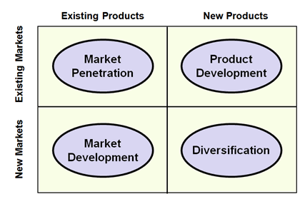
The output from the Ansoff product/market matrix is a series of suggested growth strategies which set the direction for the business strategy. These are described below:
Market penetration
Market penetration is the name given to a growth strategy where the business focuses on selling existing products into existing markets.
Market penetration seeks to achieve four main objectives:
• Maintain or increase the market share of current products – this can be achieved by a combination of competitive pricing strategies, advertising, sales promotion and perhaps more resources dedicated to personal selling
• Secure dominance of growth markets
• Restructure a mature market by driving out competitors; this would require a much more aggressive promotional campaign, supported by a pricing strategy designed to make the market unattractive for competitors
• Increase usage by existing customers – for example by introducing loyalty schemes
A market penetration marketing strategy is very much about “business as usual”. The business is focusing on markets and products it knows well. It is likely to have good information on competitors and on customer needs. It is unlikely, therefore, that this strategy will require much investment in new market research.
Market development
Market development is the name given to a growth strategy where the business seeks to sell its existing products into new markets.
There are many possible ways of approaching this strategy, including:
• New geographical markets; for example exporting the product to a new country
• New product dimensions or packaging: for example
• New distribution channels (e.g. moving from selling via retail to selling using e-commerce and mail order)
• Different pricing policies to attract different customers or create new market segments
Market development is a more risky strategy than market penetration because of the targeting of new markets.
Product development
Product development is the name given to a growth strategy where a business aims to introduce new products into existing markets. This strategy may require the development of new competencies and requires the business to develop modified products which can appeal to existing markets.
A strategy of product development is particularly suitable for a business where the product needs to be differentiated in order to remain competitive. A successful product development strategy places the marketing emphasis on:
• Research & development and innovation
• Detailed insights into customer needs (and how they change)
• Being first to market
Diversification
Diversification is the name given to the growth strategy where a business markets new products in new markets.
This is an inherently more risk strategy because the business is moving into markets in which it has little or no experience.
For a business to adopt a diversification strategy, therefore, it must have a clear idea about what it expects to gain from the strategy and an honest assessment of the risks. However, for the right balance between risk and reward, a marketing strategy of diversification can be highly rewarding.

