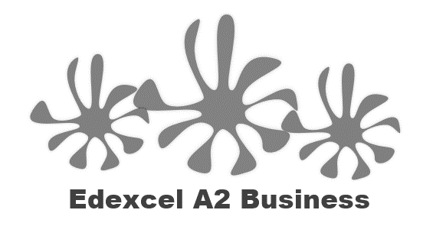
1.3.1 Product / Service Design

Starter
- When choosing a new pair of jeans, would you buy them based on:
- Design or style
- How hardwearing they are
- How cheaply they can be made, so how much they cost you?
- Choose one

Definition of product and service design:
____________________________________________________________________________________________________________________________________________________________________
1
2
3
Design Mix
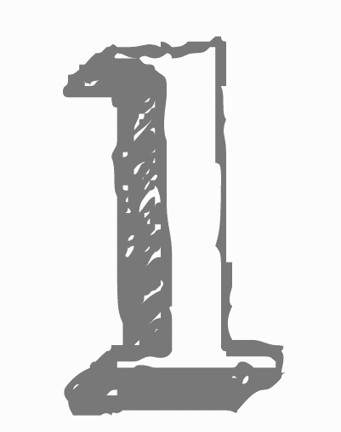
Aesthetics

- Consumers are asked through marketing ______________ about their feelings towards products: how the product looks, tastes, ________________
- Aesthetics can mean how the ____________________ respond to the product e.g. the smell of a scented candle
- More stylish and beautiful products tend to ________________ better and can charge a ______________________ price
- Aesthetics can even be the _______________________ attachment that the customer has with the ______________________

Function, purpose…
- Will the product or service be fit for ______________________?
- What does the _________________________ do? In a Dyson vacuum cleaner, it is designed to clean without needing a bag inside which lost suction when it got full
- How well does it __________________________? In a car this may be its mpg (miles per gallon, the higher the number the less petrol it will need) or its top ______________________________

- Questions the design team might ask the _______________________ department…
  - What is the minimum ____________ that we can make this product for whilst retaining ___________________?
  - Can it be made __________________?
  - Can it be produced for a lower cost than the ___________________________?
- Lower cost of production will mean competitive advantage for the business – they can pass on lower prices to customers, making the product more _________________

Changes in the elements of the design mix to reflect social trends
______________________________________________________________________________________________________________________________________________________________________________________________________________________________________________________
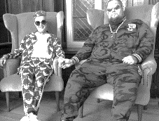
Bespoke design
______________________________________________________________________________________________________________________________________________________________________________________________________________________________________________________

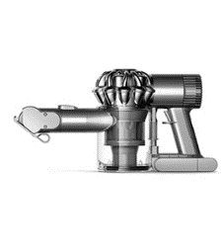
Standard design
______________________________________________________________________________________________________________________________________________________________________________________________________________________________________________________
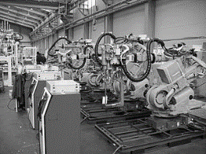
Efficiencies

______________________________________________________________________________________________________________________________________________________________________________________________________________________________________________________

Design for waste minimisation

____________________________________________________________________________________________________________________________________________________________________
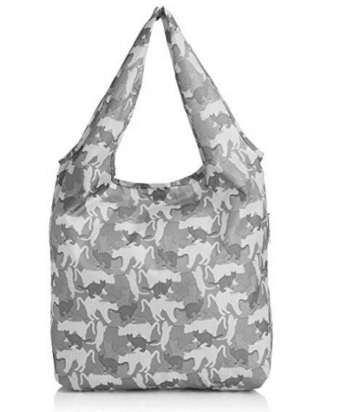Reuse
__________________________________________________________________________________________________________________________________________________________________________________________________________________________________________________________________________________________________________________________________________________________________________________________________________________________

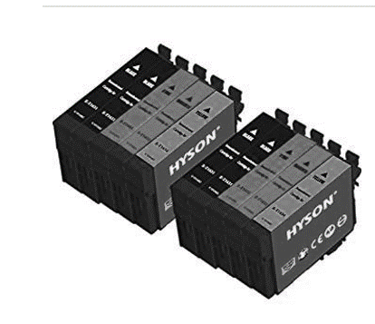Recycle
__________________________________________________________________________________________________________________________________________________________________________________________________________________________________________________________________________________________________________________________________________________________________________________________________________________________

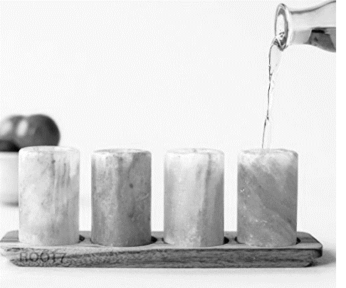Ethical sourcing
__________________________________________________________________________________________________________________________________________________________________________________________________________________________________________________________________________________________________________________________________________________________________________________________________________________________



