1.5.1 Role of an Entrepreneur

Starter
- If you were going to start a business – what would be your product or service?

Write a definition of entrepreneur here:
____________________________________________________________________________________________________________________________________________________________________
Creating and setting up a business
Setting up a business
________________________________________________________________________________________________________________________________________________________________________________________________________________________________________________________________________________________________________________________________________
Setting up an online only business
________________________________________________________________________________________________________________________________________________________________________________________________________________________________________________________________________________________________________________________________________
Setting up a business with
________________________________________________________________________________________________________________________________________________________________________________________________________________________________________________________________________________________________________________________________________

Setting up a business with
________________________________________________________________________________________________________________________________________________________________________________________________________________________________________________________________________________________________________________________________________
Setting up a business with
________________________________________________________________________________________________________________________________________________________________________________________________________________________________________________________________________________________________________________________________________

Starting a business as a sole trader
________________________________________________________________________________________________________________________________________________________________________________________________________________________________________________________________________________________________________________________________________
Running and expanding/developing a business
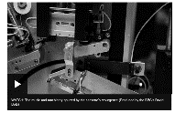
Running a business: day-to-day
________________________________________________________________________________________________________________________________________________________________________________________________________________________________________________________________________________________________________________________________________
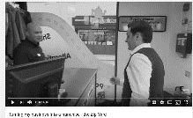
Expanding a business
________________________________________________________________________________________________________________________________________________________________________________________________________________________________________________________________________________________________________________________________________

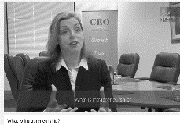
Intrapreneurship
________________________________________________________________________________________________________________________________________________________________________________________________________________________________________________________________________________________________________________________________________
Barriers to entrepreneurship

#1 Entrepreneurial capacity

________________________________________________________________________________________________________________________________________________________________________________________________________________________________________________________________________________________________________________________________________

#2 Access to finance
_______________________________________________________________________________________________________________________________________________________________________________________________________________________________________________________________________________________________________________________________________
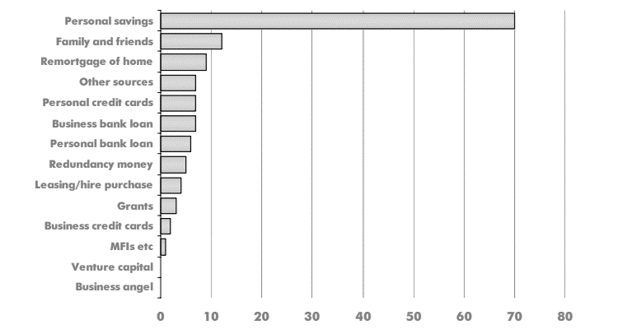

#3 Lack of training
________________________________________________________________________________________________________________________________________________________________________________________________________________________________________________________________________________________________________________________________________
#4 Fear of failure
________________________________________________________________________________________________________________________________________________________________________________________________________________________________________________________________________________________________________________________________________
#5 Lack of confidence

________________________________________________________________________________________________________________________________________________________________________________________________________________________________________________________________________________________________________________________________________

Anticipating risk and uncertainty in the business environment
Write a definition of risk here:
________________________________________________________________________________________________________________________________________________________________________________________________________________________________________________________________________________________________________________________________________

Financial risks
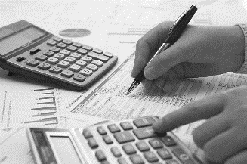
Lack of security

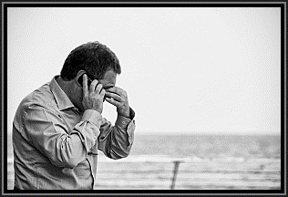

Write a definition of uncertainty here:
________________________________________________________________________________________________________________________________________________________________________________________________________________________________________________________________________________________________________________________________________
Uncertainty and Tsunami
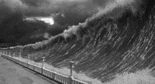
Uncertainty and health scares
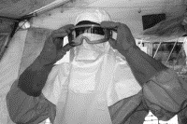
Uncertainty and commodity price shocks
Uncertainty and changes in
exchange rates
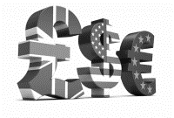
Uncertainty and changes in interest rates
Uncertainty and the horse meat scandal

