Data response

Income elasticity

Figure 9.3 shows the difference between the rise in wages and the rise in prices between 2001 and 2014 – and therefore shows the trends in real wages. In the period from January 2010 to July 2014, Aldi's share of the UK grocery market rose from 2.8 per cent to 4.8 per cent, while Tesco's share fell from 30.3 per cent to 28.9 per cent. Look at Figure 9.3 and answer the questions below.

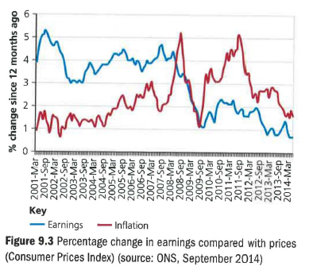
Questions

(25 marks; 30 minutes)

1 Explain what the graph is showing about real wages in the UK between 2001 and 2014. (5)

2 Assess what the text and diagram imply about the income elasticity of:
a) Tesco
b) Aldi (no need for calculations). (8)

3 In mid-2013, UK households were suffering a 2 per cent fall in real incomes. In that period, sales at Aldi rose by 18 per cent.
a) Calculate the implied income elasticity figure for Aldi. (4)

b) Assess two possible factors that may be distorting the apparent correlation between Aldi's sales and consumers' real incomes. (8)

