4.3.2 Niche markets

Starter – tick which definition is correct

- A niche is a shallow recess, especially one in a wall to display a statue or other ornament

- A niche is a comfortable or suitable position in life or employment

- A niche is the subset of the market on which a specific product is focused

Define a niche market here:
________________________________________________________________________________________________________________________________________________________________________________________________________________________________________________________________________________________________________________________________________
Cultural diversity

International business communication

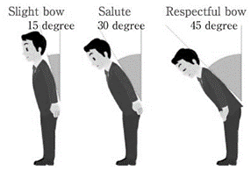

Cultural differences

Cultural diversity

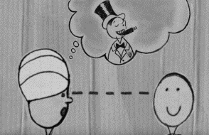

Your discussion thoughts can go here…

Features of global marketing
Define a global niche market here:
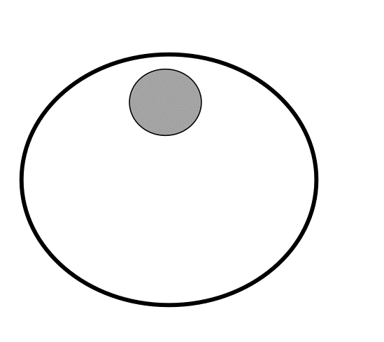
________________________________________________________________________________________________________________________________________________________________________________________________________________________________________________________________________________________________________________________________________

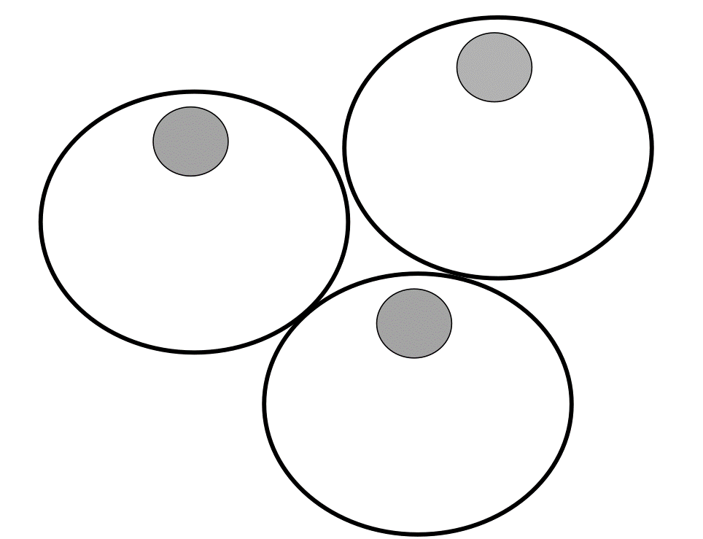

Complete the diagram

Global niche markets

________________________________________________________________________________________________________________________________________________________________________________________________________________________________________________________________________________________________________________________________________
Global niche example Harley Davidson

________________________________________________________________________________________________________________________________________________________________________________________________________________________________________________________________________________________________________________________________________

Selling in a global market niche
Advantages | Disadvantages

Product
Price
Place
Promotion

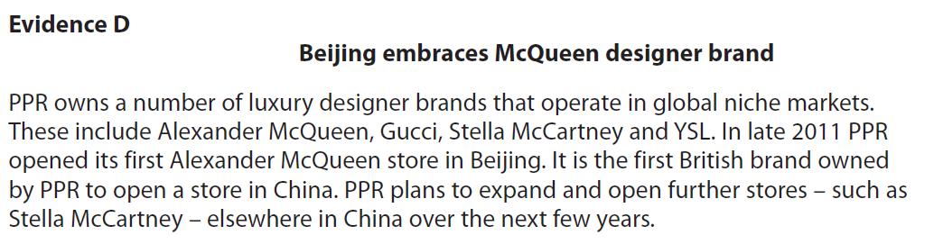

[6]

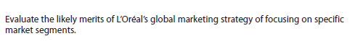

[10]

