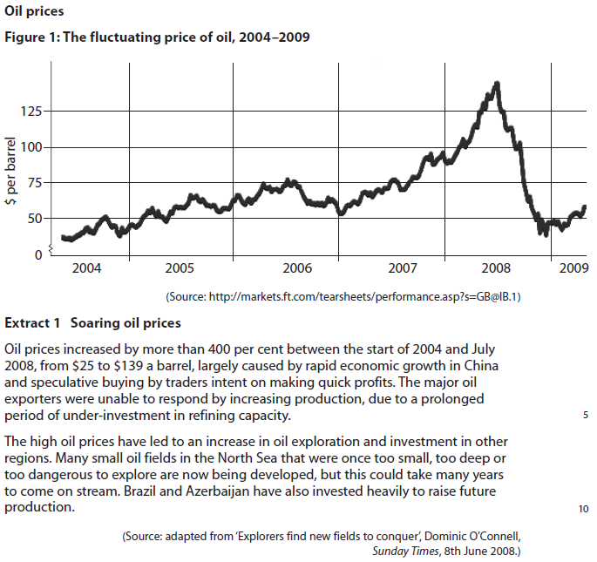
9) a) ii. January 2010
QUESTION: With reference to the figure and extract above, discuss whether the price elasticity of supply of oil is likely to be inelastic or elastic.

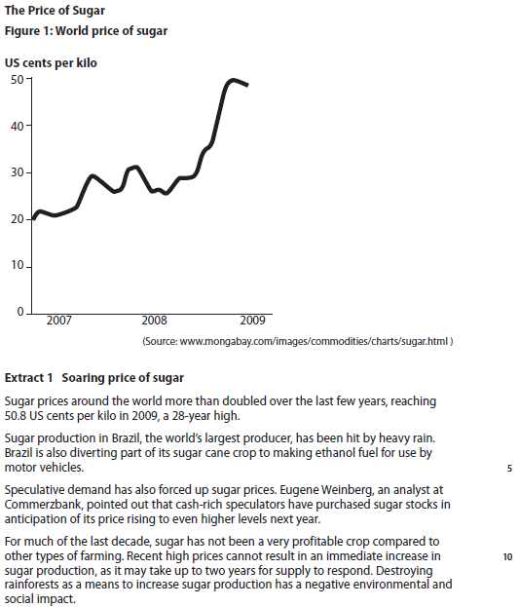
9a January 2011
QUESTION: With reference to the figure and extract above, discuss whether the price elasticity of supply of sugar is likely to be inelastic or elastic.

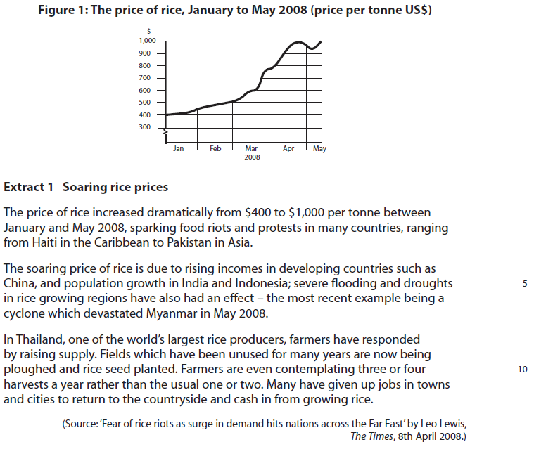
10c June 2009
QUESTION: With reference to the extract above, discuss whether the price elasticity of the supply of rice in Thailand is likely to change over time.

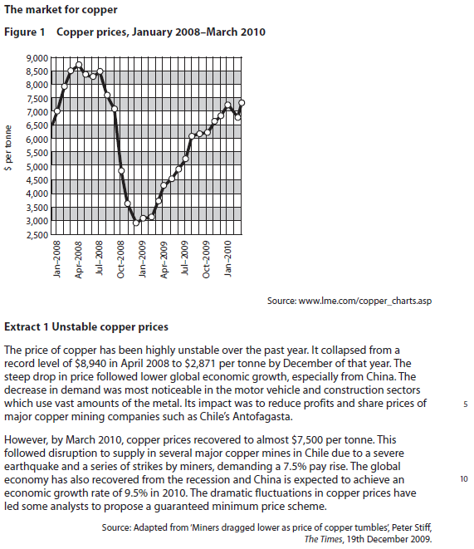
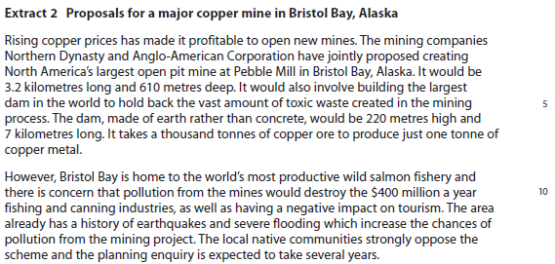
10c June 2011
QUESTION: With reference to the information provided and your own knowledge, assess whether
the supply of copper is likely to be price elastic or price inelastic.
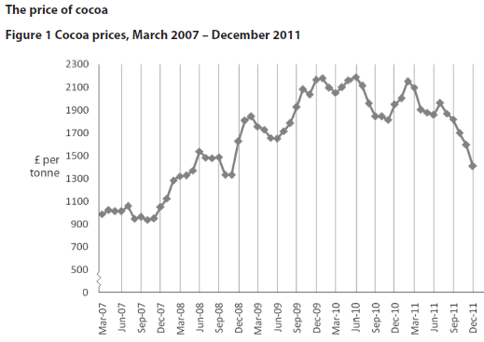
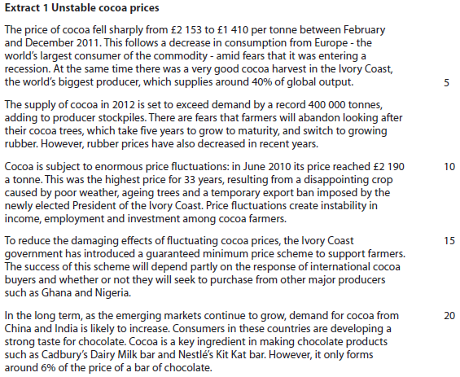
9b June 2013
QUESTION: With reference to the information provided and your own knowledge, assess whether the supply of cocoa is likely to be price elastic or price inelastic.

Oil
https://qualifications.pearson.com/content/dam/pdf/A%20Level/Economics/2013/Exam%20materials/6EC01_01_msc_20100212.pdf
Originally: With reference to the figure and extract above, discuss how the price elasticity of supply of oil may differ in the short run and long run.

Sugar

https://qualifications.pearson.com/content/dam/pdf/A%20Level/Economics/2013/Exam%20materials/6EC01_01_rms_20110309.pdf
Originally: With reference to the figure and extract above, explain why price elasticity of supply of sugar is likely to change over time.

Rice
http://qualifications.pearson.com/content/dam/pdf/A%20Level/Economics/2013/Exam%20materials/8EC01_GCE_Economics_msc_20090717_US021258.pdf
mark scheme p10
Originally: With reference to the extract above, discuss whether the price elasticity of the supply of rice in Thailand is likely to change over time.

Copper

https://qualifications.pearson.com/content/dam/pdf/A%20Level/Economics/2013/Exam%20materials/6EC01_01_rms_20110817.pdf
mark scheme p18

Cocoa

https://qualifications.pearson.com/content/dam/pdf/A%20Level/Economics/2013/Exam%20materials/6EC01_01_msc_20130815.pdf

Commodity | KAA Point  (Including quote(s) from the data) | Evaluation Point
Oil
Sugar
Rice
Copper
Cocoa
Theme 1 - Price Elasticity of Supply

