Information Sheet

Elephants
Staying cool is very important when you live in a hot place. You can take your coat off, but this is not an option for animals! Though elephants are mammals, they do not have fur. To lose heat to the air, warm blood flows through arteries and veins in their large thin ears.
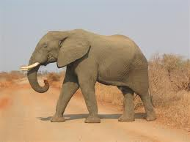

Arctic fox
Keeping warm when you live in a cold place is also important. Arctic foxes have thick fur and small ears. Their bodies are compact so they have a small surface area compared to their volume. All this helps to insulate them and helps them to survive. They are hunters and their white fur camouflages them.
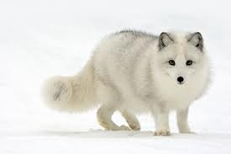

Cacti
Where it’s hot in arid deserts, what little rain does fall drains away quickly. Plants need water for lots of reasons such as for photosynthesis to make their food; to transport various substances; and for support. Most of the water that plants absorb from the soil, evaporates to the air. Cacti are adapted to conserve and store water. They have a swollen stem to store water; a thick waxy cuticle (cover) to reduce water evaporation; spines instead of flat leaves to reduce water loss; and shallow roots to absorb lots of water when it rains.
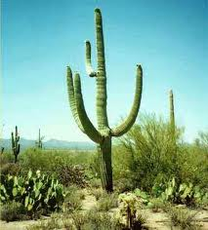

Arctic willow
Compared with the tropics, not many plants live in very cold places. The arctic willow avoids the freezing winds by growing low over the ground – its trunk and branches are never more than a few centimetres off the ground. The dark arctic soil is warmed by the sun. So the willow can absorb warmth from the ground.
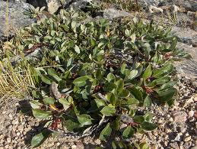
Caribou
In a caribou’s habitat, winter temperatures can drop below -50 ̊C. Even summer temperatures often hover around 0 ̊C. Caribou spend time standing in deep snow, yet their legs do not freeze. This is because they have a “heat exchange system” in their legs. The arteries and veins in their legs are close together. Warm blood flowing from their heart heats up the cold blood returning from their legs. This is a very good adaptation to life in such a cold place.
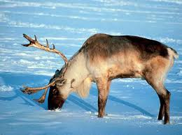

Camel
- A camel has humps where it stores fat, which can be converted to “metabolic water”.
- It can drink 20 litres of water in just a few minutes and has a stomach which can hold over 20 litres of water.
- It produces very little urine.
- It has no insulating fat under the skin, so body heat is lost easily.
- It has long legs which keeps it above the hot ground.

