Exchange rates

The exchange rate measures the quantity of foreign currency that can be bought with one unit of domestic currency. Movements in the exchange rate can dramatically affect profitability because the exchange rate affects prices of imported and exported goods. In exams, the value of the pound (£) is usually considered only in relation to the US dollar ($) or the euro (€).
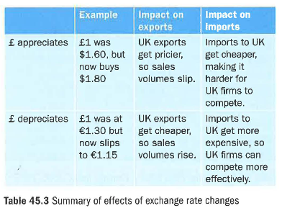
Appreciation of the pound occurs when the value of the pound rises. This means each pound can buy more dollars or euros. Depreciation means a fall in the value of the pound. It can buy fewer dollars or euros. Table 45.3 gives a numerical example of appreciation and depreciation.

The impact of a high exchange rate
On firms with large export markets

UK firms that sell a high proportion of their output overseas will prefer a low exchange rate (that is, a weak pound). Why is this so? The best way of explaining is via a numerical example.

America is an important export market for Morgan Cars. Morgan charges its UK customers £25,000 for a basic two-seater Roadster.

To achieve the same profit margin in America, Morgan has to charge a price in US dollars that will convert into £25,000. If the exchange rate against the US dollar is £1 = $1 .60, Morgan has to charge its American customers:
£25,000 x $1.60 = $40,000

If the pound appreciates to be worth $2, to generate the same £25,000 of export revenue per car, Morgan must charge its American customers:

£25,000 x $2 = $50,000

In other words, Morgan would have to increase the US price of its cars by $10,000 to maintain the current profit made on each car sold. The price increase would be off-putting to car buyers, so sales would fall.

On firms that import most of their raw materials or stock

Retailers such as Sports Direct, which import much of their stock, like a strong pound. A high exchange rate reduces the cost of buying goods from abroad. For example, Nike trainers are imported from the American producer. If the US price of a pair of trainers is $40, the price paid by Sports Direct is as follows.

If the exchange rate is £1 = $1.60, the trainers will cost Sports Direct: $40/$1.60 = £25

However, if the exchange rate goes up to £1 = $2, the same trainers cost £20 ($40/$2 = £20). A high exchange rate benefits Sports Direct because it buys imports more cheaply, allowing it to make more profit per pair of imported trainers sold to UK customers.

The impacts of a low exchange rate The impacts of a weak exchange rate are the reverse of the impacts of a strong exchange rate. A strong pound can damage exporters, especially manufacturers.

Exporters love to see the pound depreciate in value. On the other hand, companies such as Sports Direct are damaged by a low exchange rate because their imported stock costs them more. If Sports Direct reacts to the falling exchange rate by raising its prices, the company could lose customers. If the company does nothing, it will make less profit on each sale of an imported item.

