1.5.6 Moving from entrepreneur to leader

Starter
- Imagine you started a market stall selling photos that you have had made into greetings cards.
- The business has been so successful you need to take on extra staff. What are your first 3 decisions?

1)

2)

3)

Enterpreneur_______________________________________________________________________________________________________________________________________________________________________________________________________________________________________
Leader______________________________________________________________________________________________________________________________________________________________________________________________________________________________________________
Learning to delegate
________________________________________________________________________________________________________________________________________________________________________________________________________________________________________________________________________________________________________________________________________

Trusting others

________________________________________________________________________________________________________________________________________________________________________________________________________________________________________________________________________________________________________________________________________

Listen to others

________________________________________________________________________________________________________________________________________________________________________________________________________________________________________________________________________________________________________________________________________

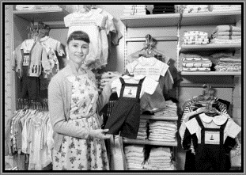
Be less reactive

________________________________________________________________________________________________________________________________________________________________________________________________________________________________________________________________________________________________________________________________________
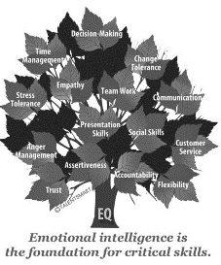
Develop emotional intelligence

________________________________________________________________________________________________________________________________________________________________________________________________________________________________________________________________________________________________________________________________________

Discussion
