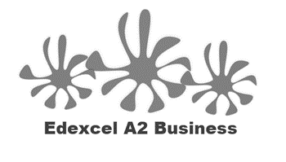
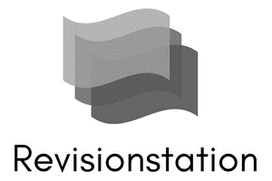
1.3.3 Pricing Strategies

Starter – how much would you charge for these products?

 |  |  | Your price
A | 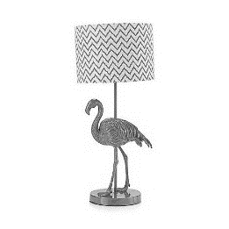 | Butterfly Home by Matthew Williamson Pink flamingo table lamp | £
B |  | Sennheiser Black 'Urbanite XL' over ear wireless bluetooth headphones | £
C | 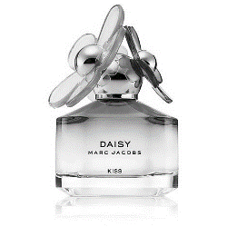 | Marc Jacobs 'Daisy Kiss' eau de toilette 50ml | £
D | 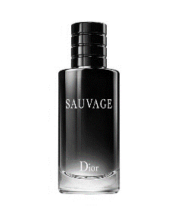 | DIOR 'Sauvage' eau de toilette | £

Write your definition of pricing here:
________________________________________________________________________________________________________________________________________________________________________________________________________________________________________________________________________________________________________________________________________

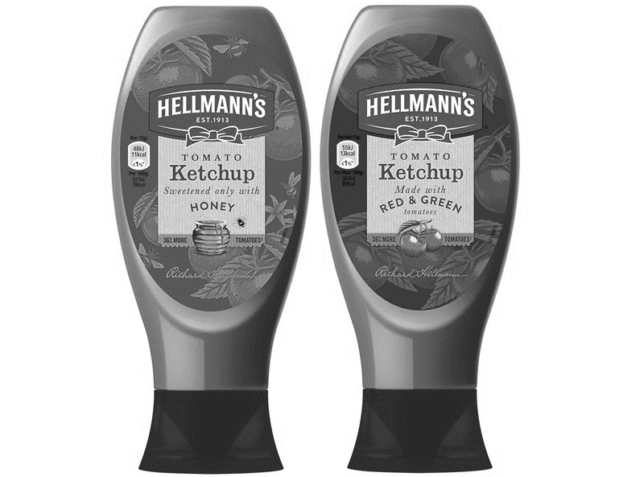
Pricing strategy introduction

________________________________________________________________________________________________________________________________________________________________________________________________________________________________________________________________________________________________________________________________________
Types of pricing strategy

Cost plus pricing

- A cost-plus pricing strategy seeks to set a price for a product or service which covers the ________________ AND provides a good _______________ margin for the business
- Cost-plus is the most ___________________ approach to pricing because it achieves the business objective of ____________________ profits
- Many Young Enterprise _______________ work out their projected profits by using cost-plus ____________

#1 Cost-plus benefits and drawbacks
Benefits | Drawbacks

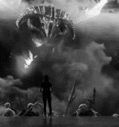
#2 Skimming pricing
- A skimming price strategy is used when ________________________ a new product
- The price is set high to start, this will create high ________________ and may be used to pay back high Research and Development _______________ costs
- Usually used in ______________________ or very innovative products which have few _________________________
- As competitors eventually ___________________ the market the price is then ______________________

#2 Skimming benefits and drawbacks
Benefits | Drawbacks

#3 Competitive pricing

- Some products or __________________________ are priced in line with competitors
- This means that customers will have to __________________ a product or service on “non-price” methods such as; ____________________ of service or speed
- Strategy usually used where products in a _______________________ are all very similar
#3 Competitive benefits and drawbacks
Benefits | Drawbacks

#4 Penetration pricing

- This means setting prices really _________ on a new product to encourage sales and to persuade customers to ____________ the product. Then when they like the product and have to keep _______________ it the business _________________ the price
- Low prices should gain the business more _______________ ______________ (market penetration)
- Mass market – repeat _____________ e.g. tea bags, biscuits which are called Fast Moving ___________________ Goods (FMCG).

#4 Penetration benefits and drawbacks
Benefits | Drawbacks

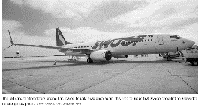
#5 Predatory Pricing

- In ____________________ (markets with just a few large businesses e.g. budget airlines) existing businesses may hold off the __________________ of a new entrant to the market by ________________ their prices so that any competitor cannot make a ____________________.
- This is when _______________________ price cutting is used to deter competitors or __________________ them out of the market
- Depends on the ______________________ of the brand, will consumers switch or stay ________________________?
- Depends on the financial ____________________ of the firm can they afford to cut _______________________?
#5 Predatory pricing benefits and drawbacks
Benefits | Drawbacks
#6 Psychological pricing

- This means pricing a product at £1.99 rather than £2.00 to appear ___________________________
- Some businesses consider pricing carefully as it is often an _________________ of ___________________
- High value or ____________________ items like luxury cars avoid pricing just below but instead may price higher to _______________________ their customers’ expectations
#6 Psychological benefits and drawbacks
Benefits | Drawbacks

Factors that determine a pricing strategy

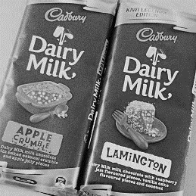
#1Number of USPs/amount of differentiation

__________________________________________________________________________________________________________________________________________________________________________________________________________________________________________________________________________________________________________________________________________________________________________________________________________________________

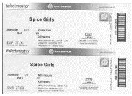
#2Price elasticity of demand

__________________________________________________________________________________________________________________________________________________________________________________________________________________________________________________________________________________________________________________________________________________________________________________________________________________________
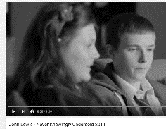
#3 Level of competition in the business environment

__________________________________________________________________________________________________________________________________________________________________________________________________________________________________________________________________________________________________________________________________________________________________________________________________________________________
#4 Strength of brand

______________________________________________________________________________________________________________________________________________________________________________________________________________________________________________________

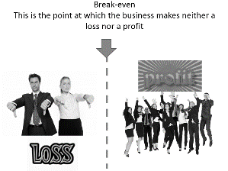
#6 Costs and the need to make a profit

__________________________________________________________________________________________________________________________________________________________________________________________________________________________________________________________________________________________________________________________________________________________________________________________________________________________
Changes in pricing to reflect social trends

Online sales
________________________________________________________________________________________________________________________________________________________________________________________________________________________________________________________________________________________________________________________________________

Changes in prices to reflect social trends
________________________________________________________________________________________________________________________________________________________________________________________________________________________________________________________________________________________________________________________________________
Discussion – write the results of your discussion below:

