4.2.3. Assessment of a country as a production location

Starter – discussion of the photo

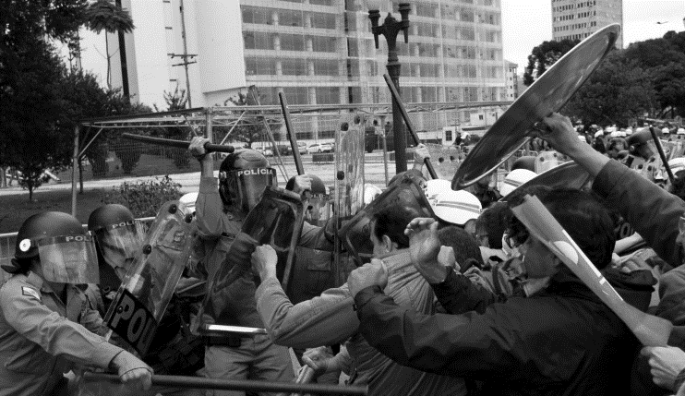

________________________________________________________________________________________________________________________________________________________________________________________________________________________________________________________________________________________________________________________________________
____________________________________________________________________________________________________________________________________________________________________

Factor | UK | South Korea | Singapore
Costs of production
Skills and availability of labour force
Infrastructure
Location in trade bloc
Government incentives
Ease of doing business
Political stability
Natural resources
Likely return on investment

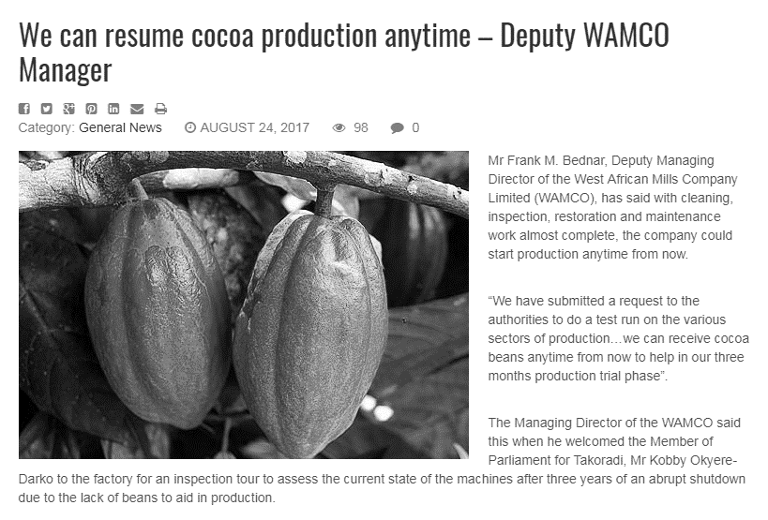
Costs of production
UK is expensive

Wages around the world

Skills and availability of labour force
Unemployment rates mean available labour

_______________________________________________________________________________________________________________________________________________________________________________________________________________________________________________________________________________________________________________________________________
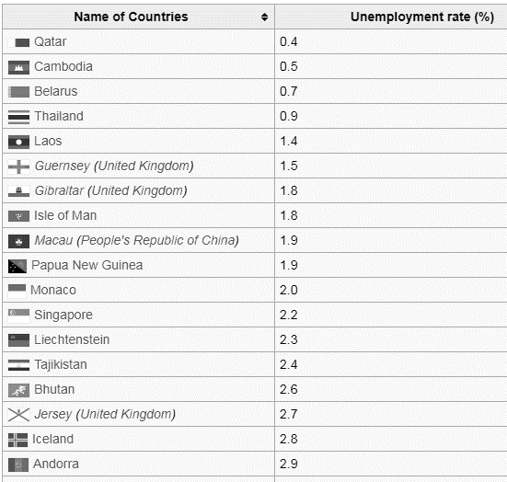

___________________________________________________________________________________________________________________________________________________________________

Global school rankings
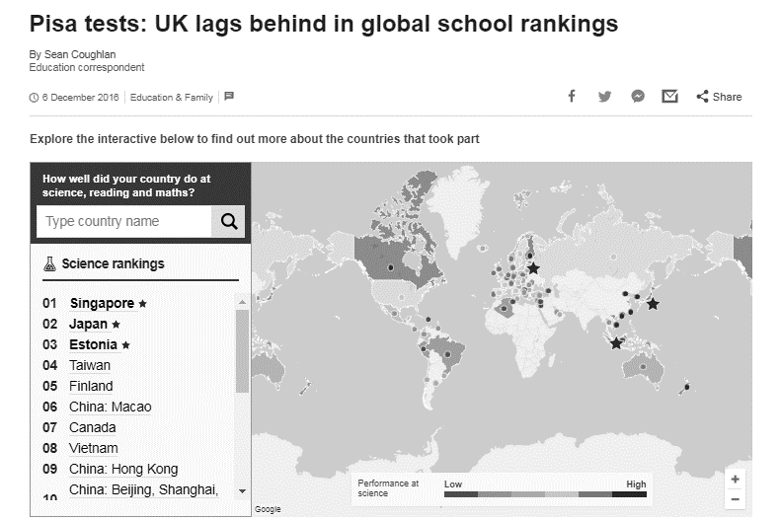
___________________________________________________________________________________________________________________________________________________________________
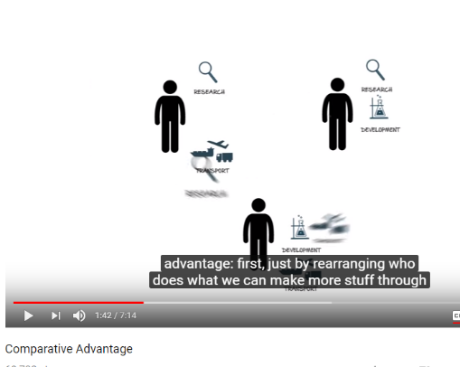
Skills of workforce

_______________________________________________________________________________________________________________________________________________________________________________________________________________________________________________________________________________________________________________________________________

Infrastructure
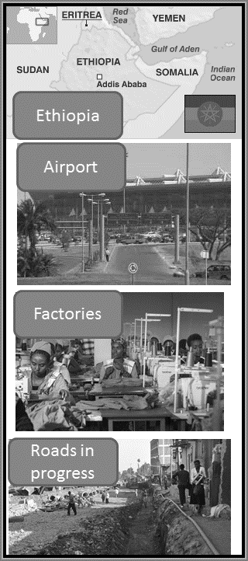

Location in trade bloc
Trading blocs

_______________________________________________________________________________________________________________________________________________________________________________________________________________________________________________________________________________________________________________________________________
Government incentives
_______________________________________________________________________________________________________________________________________________________________________________________________________________________________________________________________________________________________________________________________________

Ease of doing business
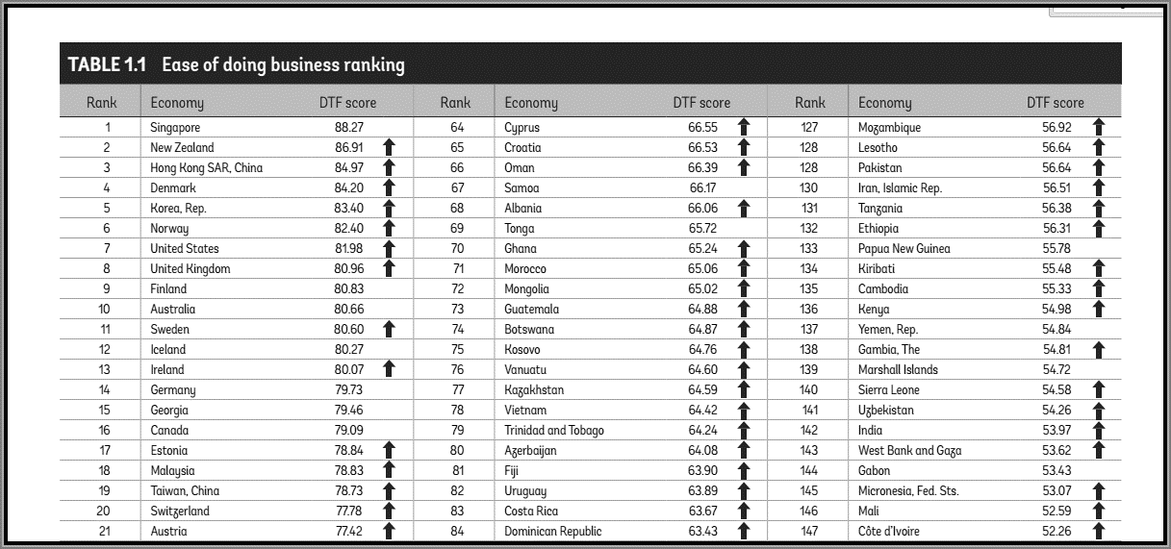

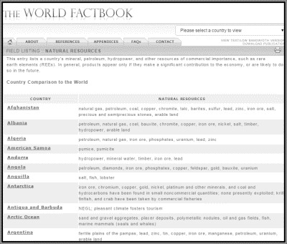
Natural resources
Natural Resources – list of countries

_______________________________________________________________________________________________________________________________________________________________________________________________________________________________________________________________________________________________________________________________________
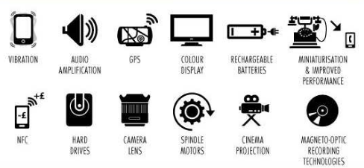
Natural resources – China rare earth metals
_______________________________________________________________________________________________________________________________________________________________________________________________________________________________________________________________________________________________________________________________________

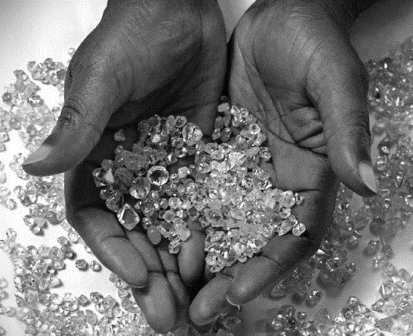
Natural resources – African diamonds

_______________________________________________________________________________________________________________________________________________________________________________________________________________________________________________________________________________________________________________________________________

Likely return on investment

________________________________________________________________________________________________________________________________________________________________________________________________________________________________________________________________________________________________________________________________________

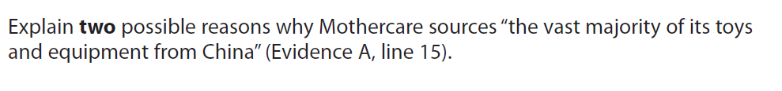
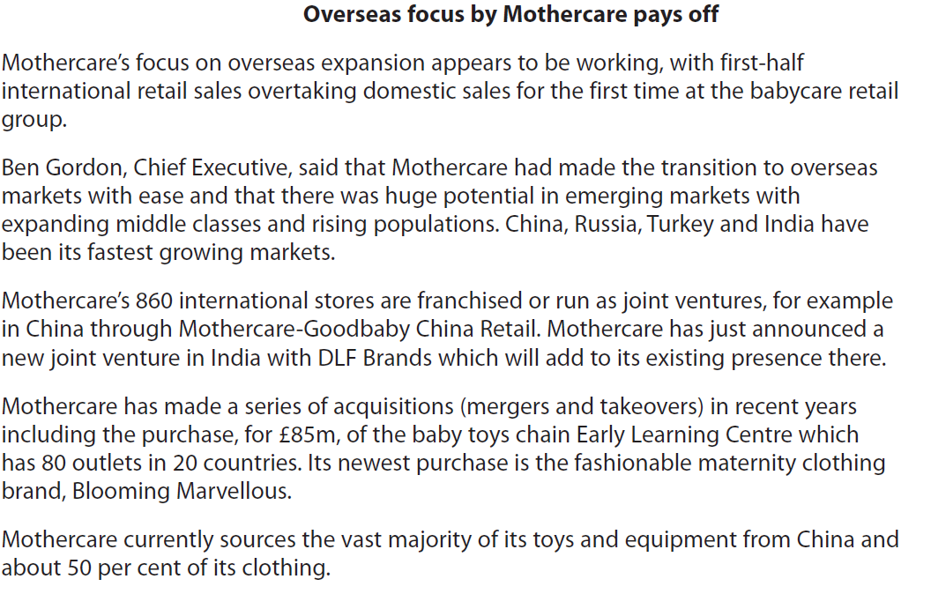

[6]

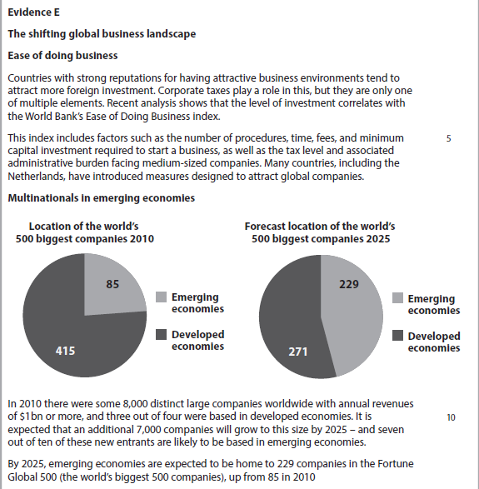

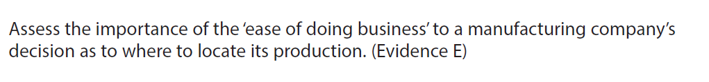

[10]

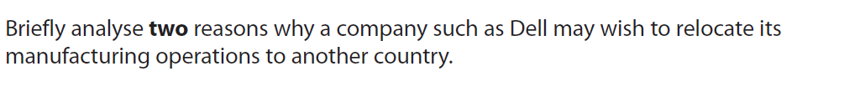

[6]

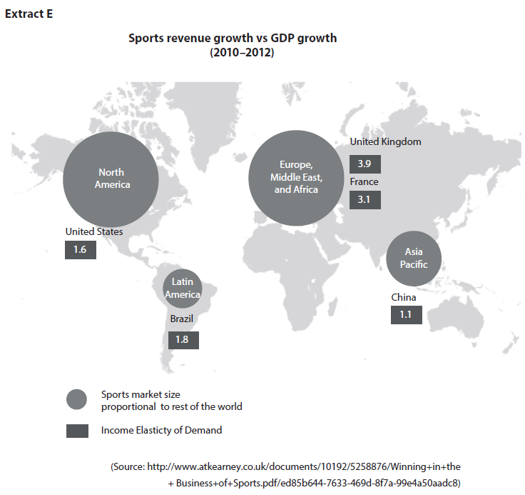
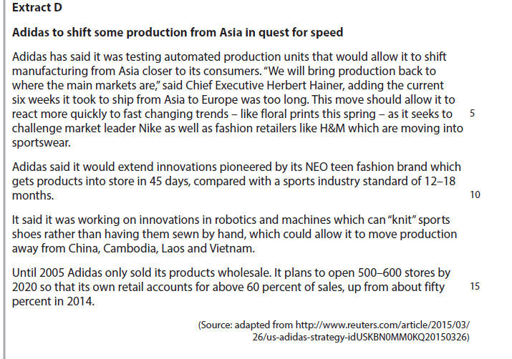

Continued case study from previous page:
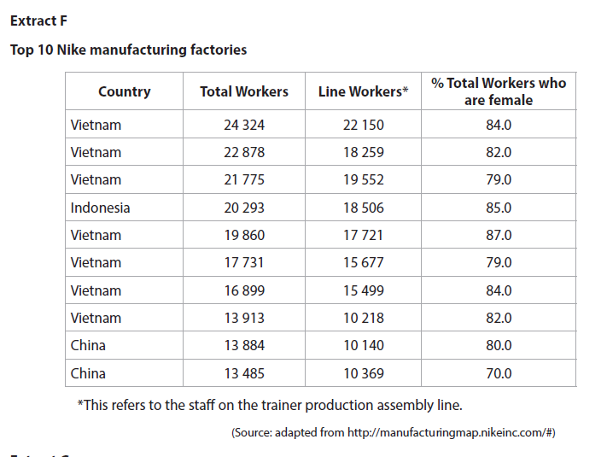
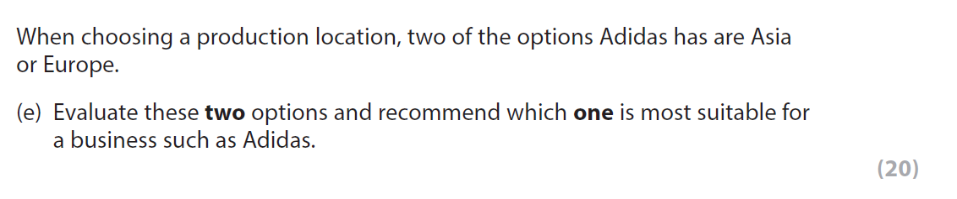

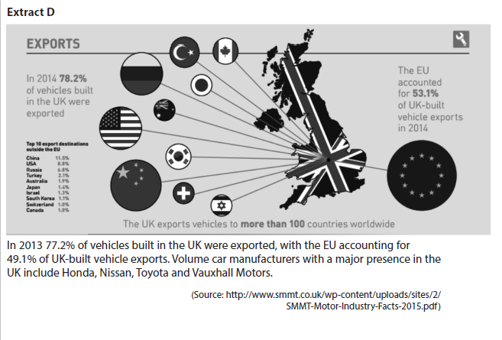
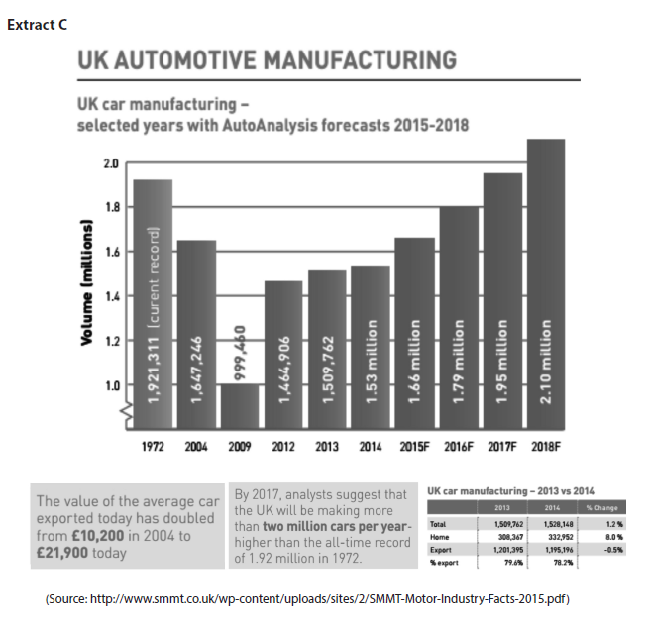

Continued from case study on previous page…
