1.1.3 Market positioning
a) Market mapping
b) Competitive advantage of a product or service
c) The purpose of product differentiation
d) Adding value to products/services
The role of market positioning in marketing strategy
Businesses use marketing to create value for customers by making two key decisions:

Decision 1: Choose which customers to serve
This involves:
- Market segmentation (analysing the different parts of a market)
- Targeting (deciding with market segments to enter)

Decision 2: Choose how to serve those customers
This also involves two important parts of marketing strategy:
- Product differentiation (what makes it difference from the competition)
- Market positioning (how customers perceive the product)

Having chosen which segments to target – a business needs to decide how to compete in those segments. Marketing people call this choice the value proposition. What position will be taken?

It is important to remember that the market position (or value proposition) is defined by customers – the place a product occupies in customer minds relative to competing products.

A useful framework for analysing market positioning is a “positioning map”. A market (or positioning) map illustrates the range of “positions” that a product can take in a market based on two dimensions that are important to customers.

a) Market mapping: When launching a new product or service, companies need to decide exactly where they want to position the brand in relation to customer perceptions and the positioning of competitors. This is largely achieved by market mapping.

Definition: Market Mapping - Market mapping is the process of finding the variables which differentiate brands in a market and then plotting them on a map – to identify a gap in the market

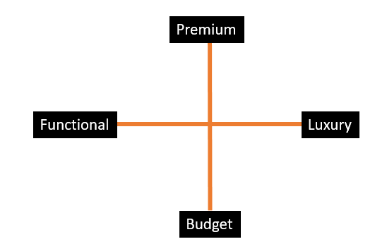
Examples of variables:
- Modern ------- traditional
- Mass ----------- niche
- Functional -----luxury
- High Quality ---low quality
- Luxury ---------- economy
- Premium --------budget

Uses of market mapping
- Market mapping could be used to identify a gap in the market
- It could also be used by a start-up to identify which products to produce or which services to provide – so they are market orientated (not product orientated)
- It could also be used by a traditional brand to reposition itself in the market

Advantages of positioning maps
- Help spot gaps in the market
- Useful for analysing competitors
- Encourages use of market research

Disadvantages of positioning maps
- Just because there is a “gap” doesn’t mean there is demand
- Not a guarantee of success
- How reliable is the market research?

b) Competitive advantage of a product or service

Definition of competitive advantage:
- An advantage a business has over its competitors, allowing it to generate larger than average turnover for the industry, either in low cost leadership or on price leadership
- The concept of competitive advantage was first thought of by Michael Porter in his book called “Competitive Advantage” which was published in the 1980’s
- The main idea is that a business can win by being cheaper or by being different

Market Positioning and Competitive Advantage

Remember that customers choose products based on their perception of a product’s value proposition – how they perceive the merits of the product relative to the alternatives (competing products).

Therefore, providing a superior value proposition than the competition is a likely source of competitive advantage – but only if it can be sustained.

There are various possible value differences that have the potential to deliver competitive advantage:

Offer more for less: E.g. Aldi: good quality at low prices
Offer more for more: E.g. high-priced luxury products with prestige value
Offer more for the same: E.g. introduce new features & better performance for the same price
Offer less for much less: E.g. no-frills low cost flying and hotels; good quality, back to basics & low price

Ways that a business can achieve competitive advantage:
Price
- Some businesses choose to use a very low-cost model and compete on price
- This can be found in many industries including retail and the holiday market
Added Value
- Added value can be achieved through a process
- Birds Eye takes Cod and Pollock and adds value to the fish and produces a range of fish products
Innovation
- Innovation is about putting a new idea or approach into action.
- Innovation is commonly described as 'the commercially successful exploitation of ideas'.
Reliability - The quality of being trustworthy or of performing consistently well.
- Reliability helps you keep your customers
- Reliability and trust go hand in hand
- Reliability keeps bad reviews at bay
Quality - "Quality is about meeting the needs and expectations of customers"
Customers want quality that is appropriate to the price that they are prepared to pay and the level of competition in the market.

c) The purpose of product differentiation
The ways in which a company gains competitive advantage e.g. strong product branding, price, marketing and customer service
Consumers must be able to perceive that your brand is different from its competitors and may be willing to pay a higher price
- Where a product is different from the competition in some way
- Consumers must be able to perceive this difference and may be willing to pay a premium price for the product

Methods of differentiation
- Through reputation (hair salon, restaurant)
- Through customer service or after sales service (Marks and Spencer)
- Through value for money (ASDA, Lidl, Aldi, Primark)
- Through product features (Cars, mobile phones)

An important part of the marketing of the product is through product differentiation. This means making the product different from its competitors.
A Unique Selling Point (sometimes called a Unique Sales Proposition) is a feature or benefit that separates a product from its competitors. The concept of a USP is one of the basics of effective marketing and business that has stood the test of time.
This could be a lower price, a smaller version of the product, offering extra functions, or even simply producing a standard product in a range of colours or designs.
A business needs to look at its unique selling points compared to competitors. If it doesn't have any, the business will probably struggle to make the product seem attractive to customers (the remaining option is usually to compete solely on price).
If a business finds that its customers are switching to competitors or buying purely on price, it should be asked whether the business has identified the USPs for its products and services. If it has, then the question is whether it is communicating USPs clearly to customers?
d) Adding value to products/services

Added value is equivalent to the increase in value that a business creates by undertaking the production process. It is quite easy to think of some examples of how a production process can add value.

Adding value = the difference between the price of the finished product/service and the cost of the inputs involved in making it

- Design – develop new technology/design features to make their product unique (differentiation advantage)
- Production – achieving quality and efficiency adds value.
  - Quality will ensure a higher price can be charged (differentiation advantage)
  - Efficiency helps cut costs of the input (cost advantage)
- Marketing – creating an image that makes the product more desirable, a brand differentiation advantage
- Offering convenience – customers will often pay a little more for a product that they can have straightaway, or which saves them time.

The key benefits to a business of adding value include:
- Charging a higher price
- Creating a point of difference from the competition
- Protecting from competitors trying to steal customers by charging lower prices
- Focusing a business more closely on its target market segment

