Q1. Hormones control the menstrual cycle.
(a) Name two of the hormones involved in the menstrual cycle.
1 .....................................................................................................................
2 .....................................................................................................................
(2)

(b) Hormones are used in some types of contraception.
Complete the sentence.
When used as contraceptives, hormones stop ...................... becoming mature.
(1)

(c) There are several ways of using hormones as contraceptives.
These include:
• taking a contraceptive pill each day for 21 days of the menstrual cycle
• using a contraceptive implant.
The contraceptive implant is put under the skin of a woman’s arm.
The implant releases contraceptive hormones for three years before the implant needs to be replaced.
(i) Suggest one advantage of using this implant rather than taking contraceptive pills.
...............................................................................................................
...............................................................................................................
(1)

(ii) Suggest one disadvantage of using this implant rather than taking contraceptive pills.
...............................................................................................................
...............................................................................................................
(1)
(Total 5 marks)

Q2.The human body produces many hormones.
(a) (i) What is a hormone?
........................................................................................................................
........................................................................................................................
(1)

(ii) Name an organ that produces a hormone.
........................................................................................................................
(1)

(iii) How are hormones transported to their target organs?
........................................................................................................................
(1)

(b) Describe how the hormones FSH, oestrogen and LH are involved in the control of the menstrual cycle.
.................................................................................................................................
.................................................................................................................................
.................................................................................................................................
.................................................................................................................................
.................................................................................................................................
.................................................................................................................................
.................................................................................................................................
.................................................................................................................................
(3)
(Total 6 marks)

Q3. The graph shows changes in the levels of three hormones in a menstrual cycle.
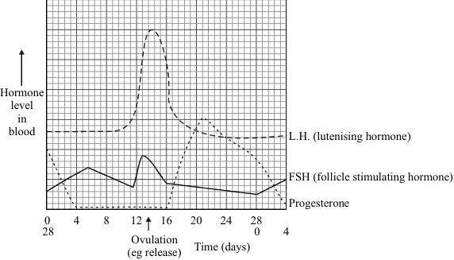

(a) What does the graph suggest the stimuli might be which cause the egg to be released?
.....................................................................................................................................
.....................................................................................................................................
.....................................................................................................................................
.....................................................................................................................................
(3)

(b) One type of contraceptive pill keeps the level of progesterone high for most of the cycle.
Suggest how this might work.
.....................................................................................................................................
.....................................................................................................................................
.....................................................................................................................................
(2)

(c) Outline two arguments for and two against using hormones as contraceptives.
For: 1 ..............................................................................................................
..............................................................................................................
2 ..............................................................................................................
..............................................................................................................

Against: 1. .............................................................................................................
..............................................................................................................
2 ..............................................................................................................
..............................................................................................................
(4)
(Total 9 marks)

Q4. A woman wants to have a baby. She has been told that her body is not making and releasing eggs. However she has thousands of cells which could develop into them. A possible treatment is to give her a hormone called FSH. This hormone will start the development of these cells.
Once the eggs have developed, explain what causes their release.
...............................................................................................................................................
...............................................................................................................................................
...............................................................................................................................................
...............................................................................................................................................
...............................................................................................................................................
...............................................................................................................................................
(Total 4 marks)

M1. (a) any two from:
• FSH
do not accept FHS
• LH
do not accept LSH
• oestrogen
allow progesterone as alternative to any hormone
2

(b) egg(s) / egg cell(s) / ova
do not accept ovaries
do not accept fertilised eggs
1

(c) (i) any one from:
ignore faster
• don’t have to take (pill) every day
ignore side effects
• can’t forget to take
ignore cost
• more reliable
• lasts 3 years / lasts longer
• hormone level in blood more constant
1

(ii) any one from:
ignore cost
• eg painful (to insert) / uncomfortable / causes rash
ignore side effects unqualified
• woman can’t take it out
• more difficult to stop treatment
• needs to be removed if woman decides to become pregnant
allow have to wait three years to become pregnant
1
[5]

M2. (a) (i) any one from:
• chemical messenger / message
allow substance / material which is a messenger
• chemical / substance produced by a gland
allow material produced by a gland
• chemical / substance transported to / acting on a target organ
• chemical / substance that controls body functions
1

(ii) gland / named endocrine gland
brain alone is insufficient
allow phonetic spelling
1

(iii) in blood / plasma or circulatory system or bloodstream
accept blood vessels / named
do not accept blood cells / named
1

(b) each hormone must be linked to correct actionapply list principleignore the gland producing hormone
FSH stimulates oestrogen (production) / egg maturation / egg ripening
ignore production / development of egg
1

oestrogen inhibits FSH
allow oestrogen stimulates LH / build up of uterine lining
1

LH stimulates egg / ovum release / ovulation
accept LH inhibits oestrogen
accept LH controls / stimulates
growth of corpus luteum
ignore production of egg
1
[6]

##
(a) LH or FSH (only one mentioned)
gains 1 mark
but
LH and/or FSH (both mentioned)
gains 2 marks
rises (sharply)
for 1 further mark
3

(b) FSH or LH level kept low
no ovulation/egg not released
for 1 mark each
2

(c) for:
very effective/prescribed/
personal preference/convenient/
promote family values
any two for 1mark each
against:
upset internal environment
named side effects (allow two)
religious belief
no protection against VD/AIDS
long-term effects
moral belief
any two for 1 mark each
4
[9]

M4. oestrogen produced
gains 1 mark
but N.B. sequence important here
oestrogen produced by ovary
gains 2 marks
LH produced
gains 1 mark
but
LH produced by pituitary
gains 2 marks
LH causes egg release
for1 mark
[4]

