Emergency Quotations Sheet
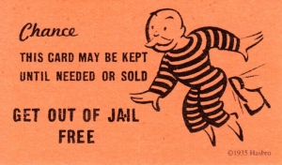
Use these quotes in exams when you are stuck for something to write. Make sure you relate them to the question.
Buddhism
‘My religion is kindness.’ Dalai Lama
‘Do not harm a sentient being.’ Buddha
‘To understand all is to forgive all.’ Buddha (?)
‘Do not take what is not offered.’ Five Precepts of Buddha
‘Better than a thousand hollow words is one word that brings peace.’ Buddha
Christianity
‘In the beginning God created the heavens and the earth.’ (Genesis 1:1)
‘You shall not kill.’ God (Ten Commandments)
‘Blessed are the peacemakers.’ Jesus (Matthew 5)
‘Love your neighbour as yourself.’ God. (Leviticus 19:18)
‘God is love.’ Apostle John (1 John 4:16)

Emergency Quotations Sheet
Use these quotes in exams when you are stuck for something to write. Make sure you relate them to the question.
Buddhism
‘My religion is kindness.’ Dalai Lama
‘Do not harm a sentient being.’ Buddha
‘To understand all is to forgive all.’ Buddha (?)
‘Do not take what is not offered.’ Five Precepts of Buddha
‘Better than a thousand hollow words is one word that brings peace.’ Buddha
Christianity
‘In the beginning God created the heavens and the earth.’ (Genesis 1:1)
‘You shall not kill.’ God (Ten Commandments)
‘Blessed are the peacemakers.’ Jesus (Matthew 5)
‘Love your neighbour as yourself.’ God. (Leviticus 19:18)
‘God is love.’ Apostle John (1 John 4:16)

