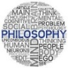
Philosophy – Making Connections.

Person/example | Description | Type | Results

