3.2.2 Mergers and takeovers

Starter – what links Jimmy Choo with Michael Kors

________________________________________________________________________________________________________________________________________________________________________________________________________________________________________________________________________________________________________________________________________
Write a definition of a merger here:
______________________________________________________________________________________________________________________________________________________________________________________________________________________________________________________
Write a definition of a take-over here:
______________________________________________________________________________________________________________________________________________________________________________________________________________________________________________________

Reasons for mergers and takeovers
Tactical | Strategic
1 | 1
2 | 2
 | 3
Add in examples from the next few slides

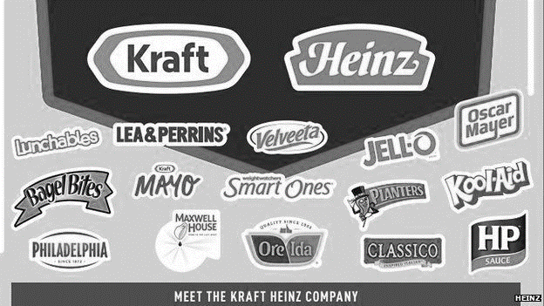
Distinction between mergers and takeovers
Merger defined

________________________________________________________________________________________________________________________________________________________________________________________________________________________________________________________________________________________________________________________________________
Dixons
________________________________________________________________________________________________________________________________________________________________________________________________________________________________________________________________________________________________________________________________________
Why?
________________________________________________________________________________________________________________________________________________________________________________________________________________________________________________________________________________________________________________________________________
Orange
________________________________________________________________________________________________________________________________________________________________________________________________________________________________________________________________________________________________________________________________________
Why?
________________________________________________________________________________________________________________________________________________________________________________________________________________________________________________________________________________________________________________________________________
Takeover – friendly
Friendly; A business may be _____________________________________ with cash flow problems and invite a takeover from a stronger business – known as a “___________________________ _________________________” as they come in to ________________________________ the struggling business

Write about the Morrisons takeover of safeways here:

Takeover - hostile
________________________________________________________________________________________________________________________________________________________________________________________________________________________________________________________________________________________________________________________________________
Write about the glass manufacturer here:

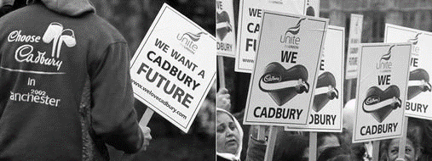
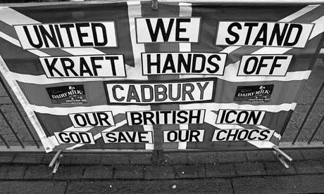
Write about the Kraft / Cadbury takeover here:

________________________________________________________________________________________________________________________________________________________________________________________________________________________________________________________________________________________________________________________________________
________________________________________________________________________________________________________________________________________________________________________________________________________________________________________________________________________________________________________________________________________
________________________________________________________________________________________________________________________________________________________________________________________________________________________________________________________________________________________________________________________________________

Horizontal and vertical integration
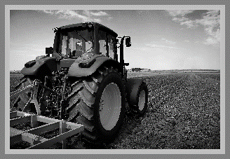

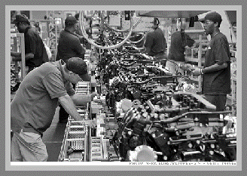

Horizontal integration

________________________________________________________________________________________________________________________________________________________________________________________________________________________________________________________________________________________________________________________________________

Horizontal integration example:
________________________________________________________________________________________________________________________________________________________________________________________________________________________________________________________________________________________________________________________________________

Vertical integration
________________________________________________________________________________________________________________________________________________________________________________________________________________________________________________________________________________________________________________________________________
Vertical integration example:
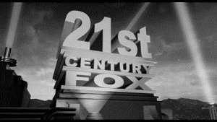

________________________________________________________________________________________________________________________________________________________________________________________________________________________________________________________________________________________________________________________________________
______________________________________________________________________________________________________________________________________________________________________________________________________________________________________________________

Financial risks
Financial rewards
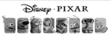
Problems of rapid growth
Short-term

Problems

Management pressure

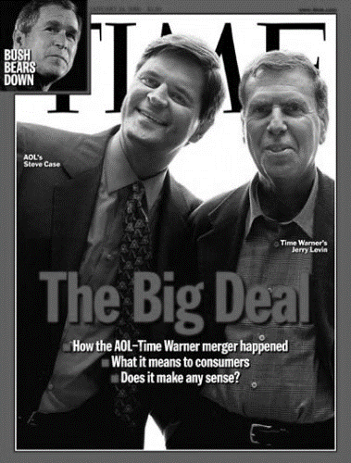

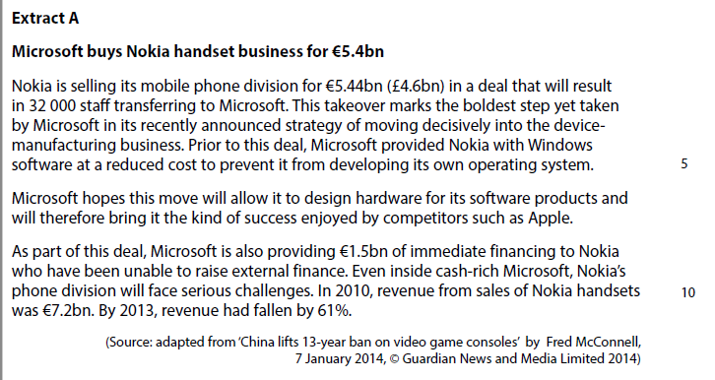
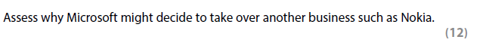

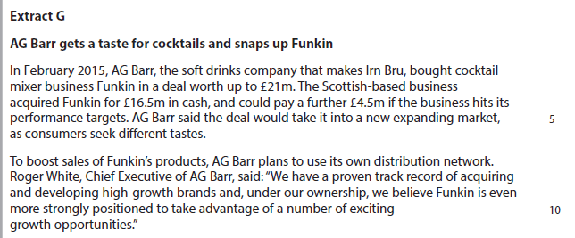
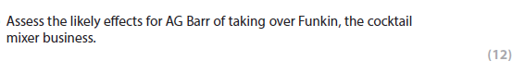

[8]

