Subsidies
How could you use subsidies to solve the following social problems? Refer to elasticity in your answers.
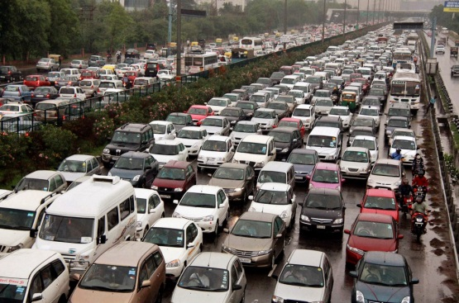
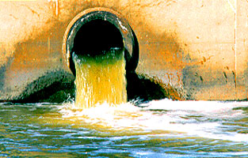
Define the term subsidy

Why does the government choose to subsidise certain goods?

Subsidy diagram – three stages
Draw the process of applying a subsidy in three stages, making sure each diagram is fully labelled and annotated with a short explanation what is occurring in each diagram.
1.
2.
3.

Details/Annotations:
Why does the supply curve shift to the right?

What does the vertical distance between S1-S2 illustrate?

Why isn’t the vertical distance between the supply curves the same as the decrease in the market price?

Subsidies and price elasticity of demand
Draw a subsidy for a good with an inelastic demand curve and an elastic demand curve. For each diagram, comment upon the changes in market price and the portion of subsidy which goes to the consumer and producer.
Inelastic demand:

Elastic demand:

