2.2.4 Budgets

Starter
- Have you ever been given £20 to go into town to spend?
__________________________________________________________________________________
- How much did you spend?
__________________________________________________________________________________
- Did you have to give back what was left over?
__________________________________________________________________________________

Write a definition of budgets here:

____________________________________________________________________________________________________________________________________________________________________
Budgets explained
________________________________________________________________________________________________________________________________________________________________________________________________________________________________________________________________________________________________________________________________________

Purpose of budgets

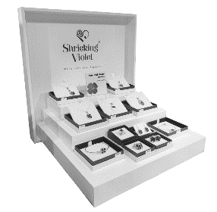
#1 Purpose: Planning

__________________________________________________________________________________________________________________________________________________________________________________________________________________________________________________________________________________________________________________________________________________________________________________________________________________________

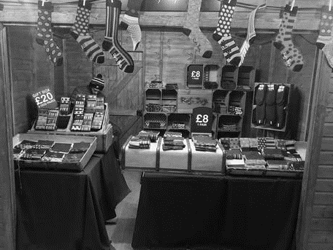
#2 Purpose: Forecasting

__________________________________________________________________________________________________________________________________________________________________________________________________________________________________________________________________________________________________________________________________________________________________________________________________________________________
#3 Purpose: Communication

__________________________________________________________________________________________________________________________________________________________________________________________________________________________________________________________________________________________________________________________________________________________________________________________________________________________

#4 Purpose: Motivation

__________________________________________________________________________________________________________________________________________________________________________________________________________________________________________________________________________________________________________________________________________________________________________________________________________________________

Types of budget
Historical Budget

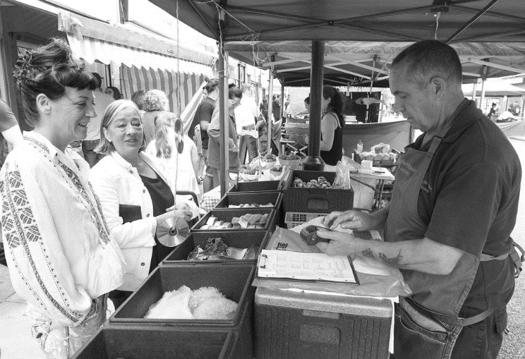
Zero – based Budget

Variance analysis

How can budgets improve the performance of a business?

Budgeted income example
 | Jan £ | Feb £ | Mar £
Budgeted income | 19,000 | 20,000 | 30,000
Actual income | 16,600 | 22,000 | 19,000
Variance
Favourable or adverse?

Budgeted expenditure example

 | Jan £ | Feb £ | Mar £
Budgeted expenditure | 11,000 | 11,000 | 11,000
Actual expenditure | 11,500 | 12,000 | 9,000
Variance
Favourable or adverse?

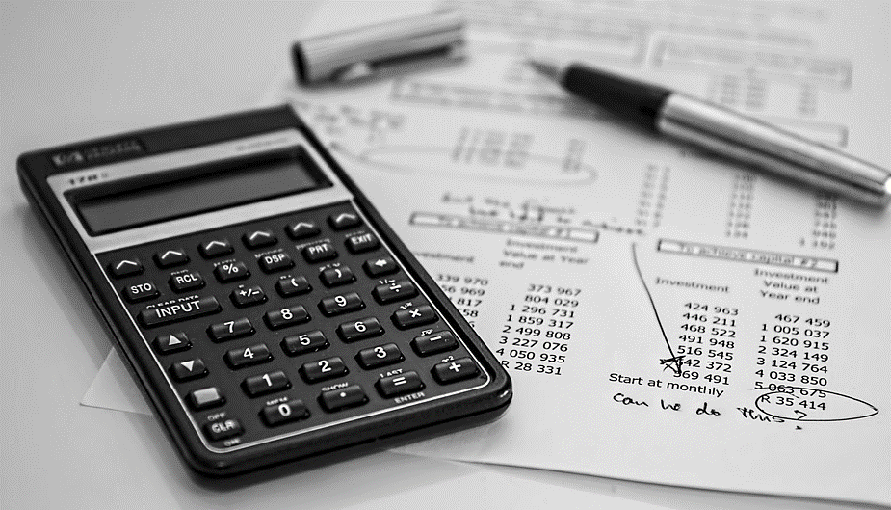

Difficulties of budgeting

Limitations of budgeting

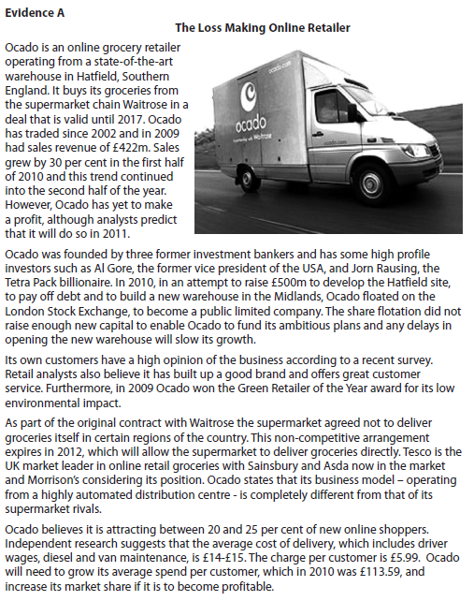

[8]

