Q1.Cells, tissues and organs are adapted to take in different substances and get rid of different substances.
The table shows the concentration of four ions outside cells and inside cells.

 | Ion | Concentration outside cells in mmol per dm³ | Concentration inside cells in mmol per dm³
 | Sodium | 140 | 9
 | Potassium | 7 | 138
 | Calcium | 2 | 27
 | Chloride | 118 | 3

(a) Use information from the table above to complete the following sentences.
Sodium ions will move into cells by the process
of .................................................................. .
Potassium ions will move into cells by the process
of .................................................................. .
(2)

(b) Some students investigated the effect of the different concentrations of sugar in four drinks, A, B, C and D, on the movement of water across a partially permeable membrane.
The students:
• made four bags from artificial partially permeable membrane
• put equal volumes of 5% sugar solution in each bag
• weighed each bag containing the sugar solution
• placed one bag in each of the drinks, A, B, C and D
• after 20 minutes removed the bags containing the sugar solution and weighed them again.

The diagram below shows how they set up the investigation.
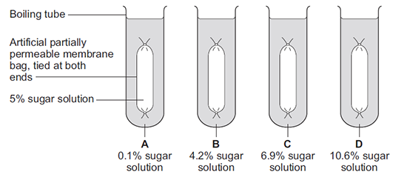
(b) (i) The bag in drink A got heavier after 20 minutes.
Explain why.
...................................................................................................................
...................................................................................................................
...................................................................................................................
...................................................................................................................
(3)

(ii) In which drink, A, B, C or D, would you expect the bag to show the smallest change in mass?

Tick (✔) one box.

 | A |  |  | B |  |  | C |  |  | D

(1)

(iii) Explain why you think the bag you chose in part (b)(ii) would show the smallest change.
...................................................................................................................
...................................................................................................................
...................................................................................................................
...................................................................................................................
(2)
(Total 8 marks)

Q2.The image below shows an epithelial cell from the lining of the small intestine.
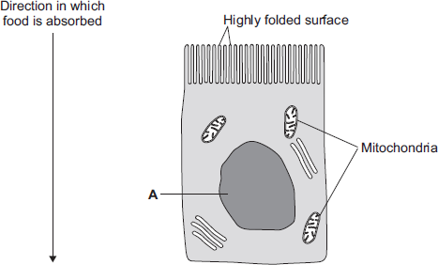
(a) (i) In the image above, the part of the cell labelled A contains chromosomes.
What is the name of part A?
...............................................................................................................
(1)

(ii) How are most soluble food molecules absorbed into the epithelial cells of the small intestine?
Draw a ring around the correct answer.

 | diffusion | osmosis | respiration

(1)

(b) Suggest how the highly folded cell surface helps the epithelial cell to absorb soluble food.
........................................................................................................................
........................................................................................................................
(1)

(c) Epithelial cells also carry out active transport.
(i) Name one food molecule absorbed into epithelial cells by active transport.
...............................................................................................................
(1)

(ii) Why is it necessary to absorb some food molecules by active transport?
...............................................................................................................
...............................................................................................................
(1)

(ii) Suggest why epithelial cells have many mitochondria.
...............................................................................................................
...............................................................................................................
...............................................................................................................
...............................................................................................................
(2)

(d) Some plants also carry out active transport.
Give one substance that plants absorb by active transport.
........................................................................................................................
(1)
(Total 8 marks)

Q3.Substances can move into cells and out of cells.
(a) Draw a ring around the correct answer to complete each sentence.

 | Water moves into cells and out of cells by | active transport.  osmosis.  reabsorption.

 |  | freely permeable
 | The water moves through a | non-permeable | membrane.
 |  | partially permeable

(2)

(b) Students put plant cells into two different strengths of sugar solutions, A and B.
The diagram below shows what the cells looked like after 1 hour.
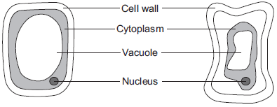
 | Cell in  sugar solution A  (after 1 hour) |  | Cell in  sugar solution B  (after 1 hour)

(i) Describe two ways in which the cell in sugar solution B is different from the cell in sugar solution A.
1 ............................................................................................................
...............................................................................................................
2 ............................................................................................................
...............................................................................................................
(2)

(ii) A student put red blood cells into water.
Suggest what would happen to the cells.
...............................................................................................................
...............................................................................................................
...............................................................................................................
(1)

(c) In the human body, glucose is absorbed into the blood from the small intestine.
The small intestine contains many villi.
Which two of the following help the absorption of glucose in the small intestine?

Tick () two boxes.
Villi have a cell wall.
Villi are covered in thick mucus.
Villi give the small intestine a large surface area.
Villi have many blood capillaries.

(2)
(Total 7 marks)

Q4.Plants need different substances to survive.
Figure 1 shows the roots of a plant.
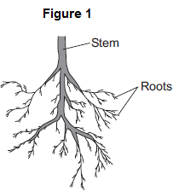
(a) (i) Mineral ions are absorbed through the roots.
Name one other substance absorbed through the roots.
...............................................................................................................
(1)

(ii) The plant in Figure 1 has a higher concentration of mineral ions in the cells of its roots than the concentration of mineral ions in the soil.
Which two statements correctly describe the absorption of mineral ions into the plant’s roots?
Tick () two boxes.

The mineral ions are absorbed by active transport.
The mineral ions are absorbed by diffusion.
The mineral ions are absorbed down the concentration gradient.
The absorption of mineral ions needs energy.

(2)

(iii) The plant in Figure 1 has roots adapted for absorption.
Figure 2 shows a magnified part of a root from Figure 1.
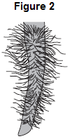
Describe how the root in Figure 2 is adapted for absorption.
...............................................................................................................
...............................................................................................................
...............................................................................................................
...............................................................................................................
(2)

(b) The leaves of plants have stomata.
What is the function of the stomata?
........................................................................................................................
........................................................................................................................
(1)

(c) Figure 3 shows the underside of two leaves, A and B, taken from a plant in a man’s house.
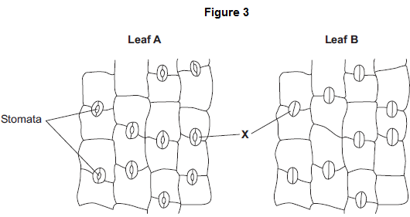
(i) In Figure 3, the cells labelled X control the size of the stomata.
What is the name of the cells labelled X?
Tick () one box.

Guard cells
Phloem cells
Xylem cells

(1)

(ii) Describe how the appearance of the stomata in leaf B is different from the appearance of the stomata in leaf A.
...............................................................................................................
...............................................................................................................
(1)

(iii) The man forgets to water the plant.
What might happen to the plant in the next few days if the stomata stay the same as shown in leaf A in Figure 3?
...............................................................................................................
...............................................................................................................
(1)
(Total 9 marks)

Q5. Some substances move through membranes.
A student set up an investigation.
The student:
• tied a thin membrane across the end of a funnel
• put concentrated sugar solution in the funnel
• put the funnel in a beaker of water
• measured the level of the solution in the funnel every 30 minutes.
The diagram shows the apparatus.
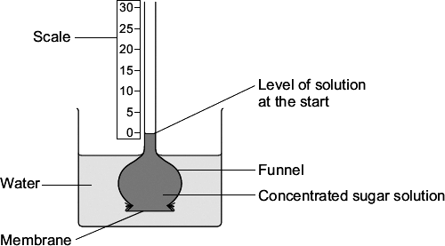
The graph shows the results.
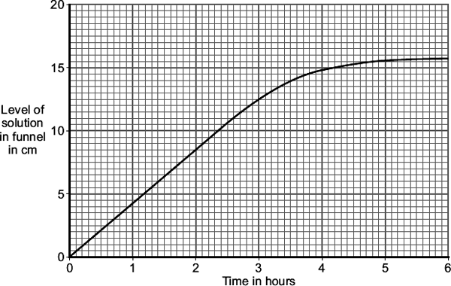
(a) After 3 hours, the level of the solution in the funnel is different from the level at the start.
Explain why, as fully as you can.
........................................................................................................................
........................................................................................................................
........................................................................................................................
........................................................................................................................
........................................................................................................................
........................................................................................................................
(3)

(b) The student repeated the investigation using dilute sugar solution instead of concentrated sugar solution.
In what way would you expect the results using dilute sugar solution to be different from the results using concentrated sugar solution?
Give the reason for your answer.
........................................................................................................................
........................................................................................................................
........................................................................................................................
........................................................................................................................
(2)
(Total 5 marks)

M1.(a) diffusion
1

active transport
1
this order only

(b) (i) concentration (of sugar) in the bag was higher (than in the drink)
allow concentration (of sugar) in the drink was lower (than in the bag)
or
higher concentration of water outside the bag or in the drink / boiling tube
allow higher water potential outside the bag or lower water potential inside the bag
1

(so) water moved in (to the tubing)
allow water moves down its concentration gradient
do not allow sugar moving
1

by osmosis
allow diffusion (of water)
do not allow sugar moving by osmosis or water moving by active transport
1

(ii) B
1

(iii) close(st) to the concentration in the bag or to 5%
allow small(est) diffusion gradient or close(st) to an equilibrium
1

(so rate of) diffusion / osmosis is slow
allow (so) less water moves in (to the bag)
ignore ref. to sugar
1
[8]

M2.(a) (i) nucleus
1
(ii) diffusion
1

(b) increases / larger surface area (for diffusion)
ignore large surface area to volume ratio
1

(c) (i) sugar / glucose
accept amino acids / other named monosaccharides
1
(ii) against a concentration gradient
or
from low to high concentration
1
(iii) (active transport requires) energy
1
(from) respiration
1

(d) minerals / ions
accept named ion ignore nutrients
do not accept water
1
[8]

M3.(a) osmosis
1
partially permeable
1

(b) (i) any two from:
allow correct answers in terms of A
• vacuole is small(er)
• cytoplasm has shrunk
allow cytoplasm is smaller
• gap between cytoplasm and cell wall
• cell wall curves inwards
allow cell B is flaccid or cell A is turgid
• the (cell) membrane has moved away from the wall
2

(ii) any one from:
• water will move / diffuse in
• (cells) will swell
• (cells) will burst
ignore turgid
1

(c) villi give the small intestines a large surface area
1
villi have many blood capillaries
1
[7]

M4.(a) (i) water / H₂O
accept oxygen
allow H₂O
do not allow H²O or H2O
1
(ii) the mineral ions are absorbed by active transport
1
the absorption of mineral ions needs energy
1
(iii) have (many root) hairs
1
(which) give a large surface area (for absorption)
1

(b) carbon dioxide in
or
oxygen out
or
control water loss
accept gas exchange
ignore gases in and out
ignore gain / lose water
1

(c) (i) guard cells
1
(ii) (stomata are) closed
allow there is no gap / space
1
(iii) plant will wilt / droop
ignore die
1
[9]

M5. (a) water enters (funnel / sugar solution) or water diffuses in (to the funnel)
do not accept if diffusion of sugar
1

membrane partially / selectively / semi permeable or by osmosis
allow description
1

because concentration (of sugar) greater
inside funnel than outside / water / in beaker
assume ‘concentration’ refers to sugar unless candidate indicates otherwise
the position of the solutions may be implied
1

(b) (level / it) rises more slowly or levels out earlier or does not rise as much
accept inference of less steep gradient (of graph)
allow less / slower osmosis / diffusion / less water passes through or less water enters funnel
allow water enters / passes through slower
1

less difference in concentration (between solution / funnel and water / beaker)
accept due to lower diffusion / concentration gradient / described
1
[5]

