Q1. Our bodies control the concentration of glucose in the blood.
Draw a ring around the correct answer to complete each sentence.
(a) The concentration of glucose in the blood is controlled by a

 | carbohydrase.
hormone called | insulin.
 | protease.

(1)

 |  | intestine.
(b) | This hormone is produced by the | stomach.
 |  | pancreas.

(1)

(c) If the body does not produce enough of this hormone,

 | diabetes.
the person develops | cystic fibrosis.
 | Huntington’s disease.

(1)
(Total 3 marks)

Q2.Some people with diabetes do not produce enough insulin to keep their blood glucose at the correct levels.
(a) (i) Which organ monitors blood glucose levels?

Tick (✔) one box.
liver
pancreas
skin

(1)

(ii) What effect does insulin have on glucose in the blood?

Tick (✔) one box.
Insulin causes glucose to move into the cells.
Insulin increases the amount of glucose in the blood.
Insulin converts glucose to starch.

(1)

(b) Some people with diabetes inject insulin several times a day.
There are different types of insulin.
The graph shows some information about three different types of insulin, A, B and C.
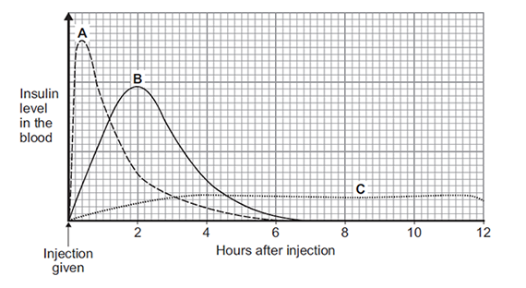
(i) Which type of insulin, A, B or C, should a person with diabetes inject just before eating a meal high in carbohydrates?
.......................................................
Give a reason for your answer.
...................................................................................................................
...................................................................................................................
(2)

(ii) A woman with diabetes has a blood glucose level of 12 mmol per dm³ of blood.
The woman’s normal blood glucose level is 6 mmol per dm³.
The woman will need to inject insulin to lower her blood glucose level.
For each unit of insulin injected the blood glucose level will fall by 3 mmol per dm³.
How many units of insulin does the woman need to inject to bring her blood glucose level down to the normal level?
...................................................................................................................
Number of units = .......................................
(1)

(c) Some people have pancreas transplants to treat diabetes.
Give one possible disadvantage of a pancreas transplant.

Tick (✔) one box.
The pancreas could be rejected.
The patient will need to inject insulin every day.
The patient’s blood glucose levels may rise and fall too much.

(1)
(Total 6 marks)

Q3. It is important that the concentration of glucose (sugar) in the blood is controlled.
(a) (i) Which hormone controls the concentration of glucose in the blood?
...............................................................................................................
(1)

(ii) Which organ produces this hormone?
...............................................................................................................
(1)

(b) The concentration of glucose in the blood of two people, A and B, was measured every half an hour.
One hour after the start, both people drank a solution containing 50 g of glucose.
The graph shows the result.
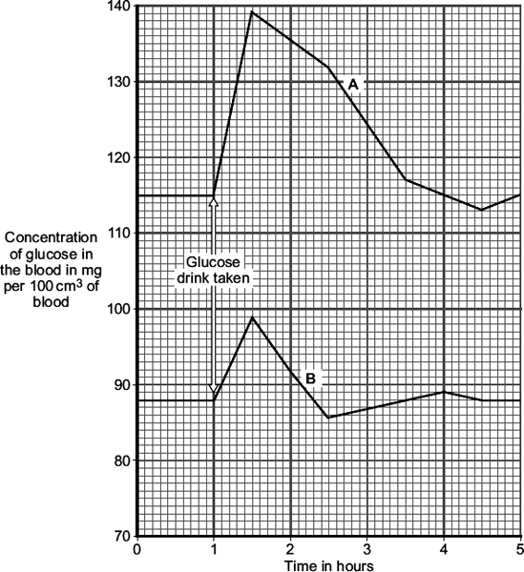

(i) By how much did the blood glucose concentration in person B rise after drinking the glucose drink?
.................................................. mg per 100 cm³ of blood
(1)

(ii) A doctor suggests that person A has diabetes.
Give two pieces of evidence from the graph to support this suggestion.
1 ............................................................................................................
...............................................................................................................
2 ............................................................................................................
...............................................................................................................
(2)

(iii) Give one reason for the fall in blood glucose concentration in person B, shown in the graph.
...............................................................................................................
(1)
(Total 6 marks)

Q4. Diabetes is a disease in which a person’s blood glucose concentration may rise.
Doctors give people drugs to treat diabetes.
The table shows some of the side effects on the body of four drugs, A, B, C and insulin, used to treat diabetes.

Drug | Side effects on the body
A | Weight loss  Liver, kidney and heart damage  Feeling of sickness
B | Weight gain  Damage to some cells in pancreas
C | More water is kept in the body  Weight gain  Increased chance of bone breakage in women
Insulin | A little more water is kept in the body  Weight gain  Increased risk of lung damage

(a) Which drug, A, B, C or insulin, is most likely to result in an increase in blood sugar concentration in some people?
Explain your answer.
Drug ..............................................................................................................
Explanation
........................................................................................................................
........................................................................................................................
(2)

(b) (i) Drugs A, B and C can be taken as tablets.
The chemicals in the tablets are absorbed into the blood from the digestive system.
Insulin is a protein.
Insulin cannot be taken as a tablet.
Why?
...............................................................................................................
(1)

(ii) Other than using drugs, give two methods of treating diabetes.
1 ............................................................................................................
2 ............................................................................................................
(2)
(Total 5 marks)

Q5.The number of cases of Type 2 diabetes in the UK is increasing rapidly.
(a) Describe how insulin and glucagon help control the blood sugar concentration in a healthy person.
........................................................................................................................
........................................................................................................................
........................................................................................................................
........................................................................................................................
........................................................................................................................
........................................................................................................................
........................................................................................................................
........................................................................................................................
........................................................................................................................
........................................................................................................................
........................................................................................................................
........................................................................................................................
........................................................................................................................
........................................................................................................................
(6)

(b) What is Type 2 diabetes?
........................................................................................................................
........................................................................................................................
(1)

(c) Body mass index (BMI) is a person’s body weight divided by the square of his or her height.
(i) Graph 1 shows the relationship between BMI and the percentage probability of developing Type 2 diabetes.
Graph 1
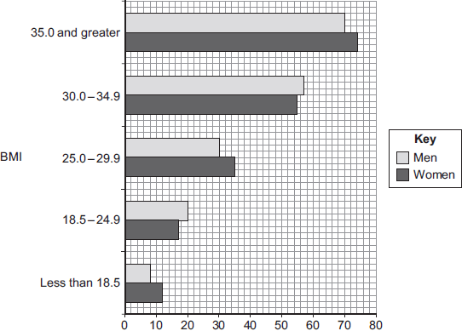
Percentage probability of developing Type 2 diabetes

Suggest an explanation for the relationship between BMI and the risk of developing Type 2 diabetes.
...............................................................................................................
...............................................................................................................
...............................................................................................................
...............................................................................................................
(2)

(ii) Graph 2 shows changes in the number of new cases of Type 2 diabetes in the UK.
Graph 2
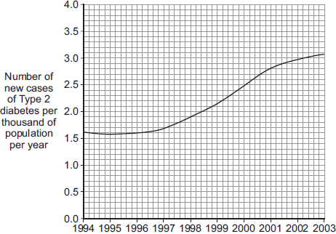
Year

Suggest explanations for the trend shown by the data in Graph 2.
...............................................................................................................
...............................................................................................................
...............................................................................................................
...............................................................................................................
...............................................................................................................
...............................................................................................................
(3)
(Total 12 marks)

M1. (a) insulin
extra ring drawn cancels the mark
1

(b) pancreas
extra ring drawn cancels the mark
1

(c) diabetes
extra ring drawn cancels the mark
1
[3]

M2.(a) (i) pancreas
1

(ii) Insulin causes glucose to move into cells.
1

(b) (i) A
1

rapid rise or fastest
1

(ii) 2
1

(c) The pancreas could be rejected.
1
[6]

M3. (a) (i) insulin
accept glucagon (correct spelling only)
1

(ii) pancreas
accept phonetic spelling
allow pancrease
1

(b) (i) 11(.0)
accept in range 10.5-11 (.0)
1

(ii) any two from:
ignore numbers unless comparative
• high(er) concentration (of blood glucose) (anywhere / any time)
accept 115 not 88
139 not 99
• large(r) increase (in concentration after the drink)
accept increase by 24 not 11 / their b(i)
• fast(er) / steep(er) rise
accept it takes 3 hours not 1 ¼ hours to get back to original level
accept it takes a long time to get back to normal
• slow(er) fall
2

(iii) any one from:
• insulin present / produced
accept glucagon not produced
• (used in) respiration
allow exercise
• taken into cells
allow converted to glycogen
allow taken into liver (cells) / muscle (cells)
allow produce / make energy
1
[6]

M4. (a) B
1

less / no insulin (produced) or insulin produced in pancreas
allow pancreas can’t monitor (blood) sugar (level)
ignore pancreas can’t control (blood) sugar (level)
allow increased glucagon production
allow A as liver stores less glucose / sugar for 2 marks only
1

(b) (i) (it / protein / insulin) digested / broken down
if ref to specific enzyme must be correct (protease / pepsin)
ignore denatured
do not accept digested in mouth / other incorrect organs
1

(ii) any two from:
ignore injections
• (attention to) diet
accept examples, eg eat less sugar(y food) or eat small regular meals
allow eat less carbohydrate / control diet
ignore cholesterol or balanced / healthy diet
• exercise
ignore keep fit / healthy
• (pancreas) transplant / stem cells / genetic engineering
2
[5]

M5.(a) any six from:
• hormone(s) / named produced by pancreas
• if blood glucose levels are too high, insulin is produced / released
• allowing glucose to move from the blood into the cells / named eg liver
• glucose is converted to glycogen
• if blood glucose levels fall, glucagon is produced / released
• glycogen is converted to glucose
• causing glucose to be released into the blood
6

(b) diabetes that occurs when the body (cells) do not respond / are less responsive to insulin
1

(c) (i) higher BMIs due to increase in mass / weight (relative to height) / obesity
1
obesity / being overweight / being fat is a (significant) risk factor for Type 2 diabetes
allow causes Type 2 diabetes
1

(ii) any three from:
• related to described change in diet eg fast foods
• and less exercise
• which increases the chance of obesity / increases BMI
• increased awareness has helped to slow the increase
3
[12]

