How to Get Anki Electronic Flashcards

We at the RE Department are aware that there is a lot of Pali and Sanskrit vocabulary tied up in the Buddhism study that you have had to do lately. For this reason, we have decided to have compassion (karuna) on you and make your life easier. Therefore, we have made available some electronic flashcards that you can download and use at your leisure (if you have such a thing) in order to make it much easier to learn all of the strange words that you’re confused by at the moment. I guarantee that if you use this properly it will make your exam easier and help you to remember the stuff. If you spend just 10 minutes per day on this it will have a real impact on your memory of the information. You can use it on your phone or other device as well as on a computer and it’s free.

The example on the left is the question. It is asking you what a Buddha rupa is. You then click ‘Show Answer’ at the bottom. After you have seen this card, a different card will appear with a different question and then another and so on. Sometimes it will repeat the same question if you found it difficult so that you can remember it better.

In the example below, the answer is shown in the right-hand screen capture. Then you choose whether you found that easy, okay or got it wrong. If you got it wrong, click ‘again’ and the card will come back in a few minutes with the same question. If you click ‘Easy’ it won’t come back for four days because it was easy. ‘Good’ is for in-between difficulty and the card will be shown again in about ten minutes. This means that it tests you on what you don’t know very well and you learn it faster. There are over 90 of these on Buddhist practices that I have made over the weekend. If I get a chance, I will make some for the other topics as well but I can’t promise.

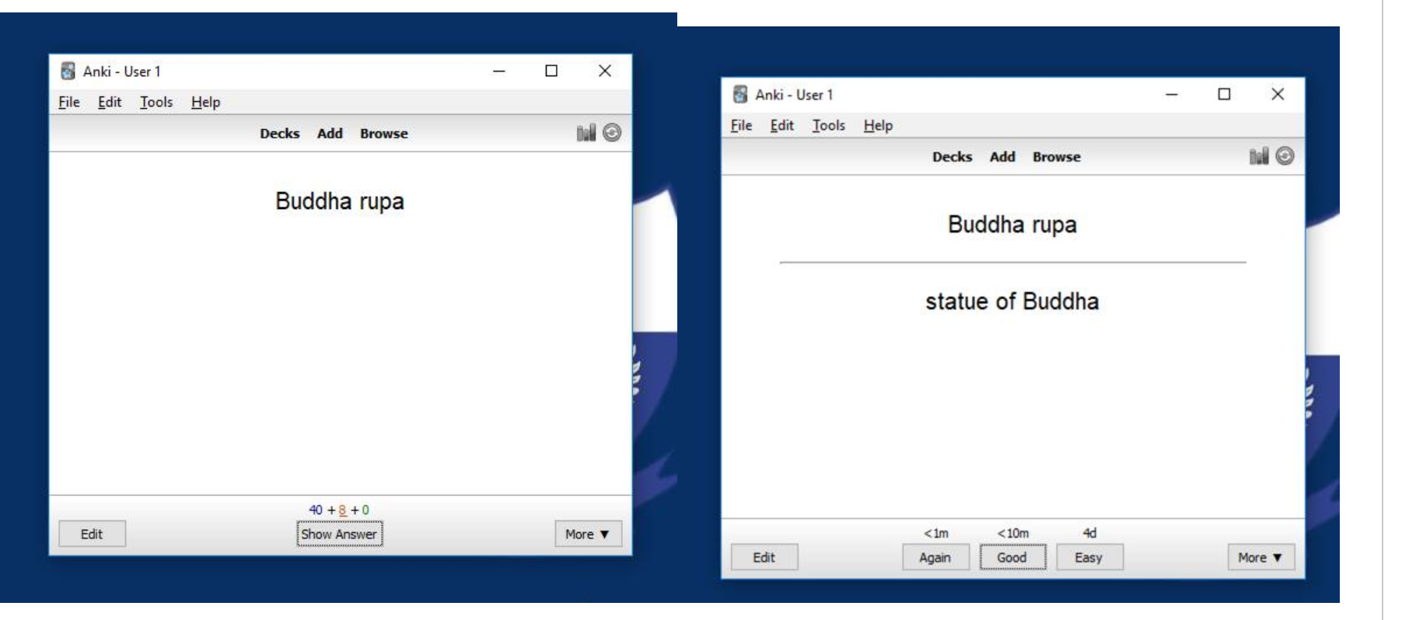

You can use this on pc or a device or a mobile phone. For most operating systems it’s totally free (and safe to download). There is one operating system that you have to pay for (I forget which). There are also tons of cards that people have uploaded that you can use for languages and other subjects so the same software can help you revise for your other exams.

In order to install Anki on your device go to: https://apps.ankiweb.net/

Click on the correct operating system for your device and follow the instructions. Check with your parents first, if appropriate.

Once you have installed it, open it and look at the buttons at the bottom. Click ‘Get shared’.

A web page opens and you type in the search box for ‘Buddhism’. In the results, click on ‘Buddhist Practices for AQA GCSE’. (The picture above already has this deck of cards downloaded but let’s imagine that it doesn’t.)

This takes you to a page where you scroll down and click ‘Download’.
When it’s done, click on the arrow next to the downloaded file at the bottom of the screen and pick ‘Show in folder’, as seen below.

Double click on the file. It will then appear in your list of decks permanently, as long as the file is not deleted.

Now you are ready to start revising.

MHa

