Porter's Model of Generic Strategies for Competitive Advantage

Porter suggested four "generic" business strategies that could be adopted in order to gain competitive advantage. The strategies relate to the extent to which the scope of a business' activities are narrow versus broad and the extent to which a business seeks to differentiate its products.
The short video below provides an overview of Porter's Generic Strategies and there are some additional study notes below the video.
The key strategic challenge for most businesses is to find a way of achieving a sustainable competitive advantage over the other competing products and firms in a market.
A competitive advantage is an advantage over competitors gained by offering consumers greater value, either by means of lower prices or by providing greater benefits and service that justifies higher prices.
The four strategies are summarised in the figure below:
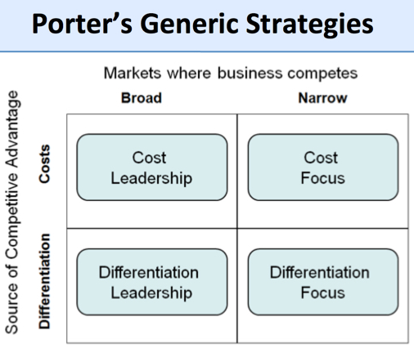
The differentiation and cost leadership strategies seek competitive advantage in a broad range of market or industry segments.
By contrast, the differentiation focus and cost focus strategies are adopted in a narrow market or industry.

Cost Leadership
With this strategy, the objective is to become the lowest-cost producer in the industry.
The traditional method to achieve this objective is to produce on a large scale which enables the business to exploit economies of scale.
Why is cost leadership potentially so important? Many (perhaps all) market segments in the industry are supplied with the emphasis placed on minimising costs. If the achieved selling price can at least equal (or near) the average for the market, then the lowest-cost producer will (in theory) enjoy the best profits.
This strategy is usually associated with large-scale businesses offering "standard" products with relatively little differentiation that are readily acceptable to the majority of customers. Occasionally, a low-cost leader will also discount its product to maximise sales, particularly if it has a significant cost advantage over the competition and, in doing so, it can further increase its market share.
A strategy of cost leadership requires close cooperation between all the functional areas of a business. To be the lowest-cost producer, a firm is likely to achieve or use several of the following:
- High levels of productivity
- High-capacity utilisation
- Use of bargaining power to negotiate the lowest prices for production inputs!
- Lean production methods (e.g., JIT)
- Effective use of technology in the production process
Access to the most effective distribution channels
Cost Focus
Here a business seeks a lower-cost advantage in just one or a small number of market segments.
The product will be basic - perhaps a similar product to the higher-priced and featured market leader, but acceptable to sufficient consumers. Such products are often called "me-too's".
Differentiation Focus
In the differentiation focus strategy, a business aims to differentiate within just one or a small number of target market segments.
The special customer needs of the segment mean that there are opportunities to provide products that are clearly different from competitors who may be targeting a broader group of customers.
The important issue for any business adopting this strategy is to ensure that customers really do have different needs and wants - in other words that there is a valid basis for differentiation - and that existing competitor products are not meeting those needs and wants.
Differentiation focus is the classic niche marketing strategy. Many small businesses are able to establish themselves in a niche market segment using this strategy, achieving higher prices than un-differentiated products through specialist expertise or other ways to add value for customers.
There are many successful examples of differentiation focus. A good one is Tyrrells Crisps which focused on the smaller hand-fried, premium segment of the crisps industry.
Differentiation Leadership
With differentiation leadership, the business targets much larger markets and aims to achieve competitive advantage through differentiation across the whole of an industry.
This strategy involves selecting one or more criteria used by buyers in a market - and then positioning the business uniquely to meet those criteria. This strategy is usually associated with charging a premium price for the product - often to reflect the higher production costs and extra value-added features provided for the consumer.
Differentiation is about charging a premium price that more than covers the additional production costs, and about giving customers clear reasons to prefer the product over other, less differentiated products.
There are several ways in which this can be achieved, though it is not easy and it requires substantial and sustained marketing investment. The methods include:
- Superior product quality (features, benefits, durability, reliability)
- Branding (strong customer recognition & desire; brand loyalty)
- Industry-wide distribution across all major channels (i.e. the product or brand is an essential item to be stocked by retailers)
- Consistent promotional support – often dominated by advertising, sponsorship etc

Great examples of a differentiation leadership include global brands like Nike and Mercedes. These brands achieve significant economies of scale, but they do not rely on a cost leadership strategy to compete. Their business and brands are built on persuading customers to become brand loyal and paying a premium for their products.

