28.6 Workbook
Revision questions
(30 marks; 30 minutes)
1 Using examples that are relevant to the UK, distinguish between imports and exports. (3)

2 Dyson vacuum cleaners used to manufacture its products from a factory located in Wiltshire in the UK. Today, the vacuum cleaners sold under the Dyson brand in Britain are all imported from a factory based in Malaysia. Assess the possible impacts of this decision on Dyson's various stakeholder groups. (10)

3 Use Figure 28.1 to estimate the value of UK imports in 2004 and 2013. Then calculate the percentage change. Show your workings. (4)
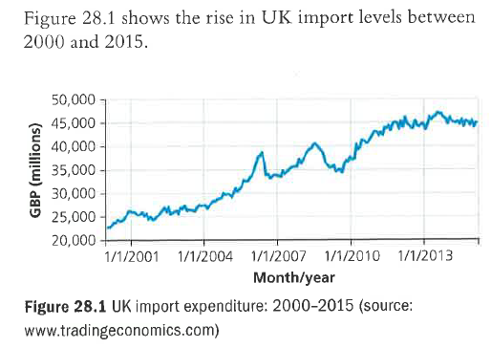

4 Assess two possible reasons why a small firm such as the Little Valley Brewery might choose to expand by exporting, rather than by foreign direct investment. (8)

5 Tesco tried to expand in America by setting up its own chain of Fresh & Easy grocery stores. Unfortunately for Tesco, its expansion into America failed because the new stores failed to attract sufficient numbers of customers to break even. Using the example of Tesco, assess the dangers of trying to grow via foreign direct investment. (10)

