Q1. (a) List A gives the names of three hormones.
List B gives information about the three hormones.
Draw a line from each substance in List A to the correct information in List B.
List A  Hormone |  | List B  Information
Used in some contraceptive pills
to stop eggs maturing
FSH
Used as a fertility drug to make
eggs mature
LH
Causes the lining of the womb
to break down
Oestrogen
Stimulates the release of eggs
in IVF

(3)

(b) The table gives information about three methods of giving hormones to stop a woman becoming pregnant.
 | The ‘pill’ | The ‘patch’ | The ‘implant’
How the  hormone  is given | Swallowed each  day for 21 days out  of every 28 days. | Stuck onto the skin.  Each patch lasts three  weeks.  There is a one week gap between each patch. | Needs an operation to  put it under the skin.  Lasts for up to 5 years.

Use the information in the table to answer these questions.
(i) Which of the three methods is likely to be the most reliable?
...............................................................................................................
(1)

(ii) Explain why you chose this method.
...............................................................................................................
...............................................................................................................
(1)

(iii) Give one disadvantage of the method you have chosen.
...............................................................................................................
(1)
(Total 6 marks)

Q2.(a) Which organ of the human body produces egg cells?
Draw a ring around the correct answer.
liver ovary testis
(1)

(b) An egg joins with a sperm and develops into an embryo.
How many chromosomes are there in each cell of a human embryo?
Draw a ring around the correct answer.
23 46 48
(1)

(c) Some women find it difficult to have a baby. A doctor may suggest that these women should use In Vitro Fertilisation (IVF) to help them have a baby.
Table 1 shows how successful IVF was for women of different ages at one clinic.
Table 1

 | Age of women in years | Percentage of women who had a baby
 | <35 | 35
 | 35–37 | 31
 | 38–39 | 25
 | 40–42 | 32
 | 43–44 | 7
 | >44 | 0

(i) A student thought that the result for women aged 40–42 was anomalous.
Suggest why the student thought this result was anomalous.
...................................................................................................................
...................................................................................................................
(1)

(ii) Describe the general trend in the results in Table 1.
You should ignore the anomalous result.
...................................................................................................................
...................................................................................................................
(1)

(d) Some babies are born with a faulty chromosome.
Scientists investigated whether the chance of having a baby with a faulty chromosome is also related to the age of the woman.
Table 2 shows the scientists’ results.

 | Table 2
 |  | Age of women in years | Number of women per 1000 who had a baby with a faulty chromosome
 |  | 25 | 2.0
 |  | 30 | 2.6
 |  | 35 | 6.1
 |  | 40 | 19.6
 |  | 45 | 66.0

(i) A 45-year-old woman is more likely than a 25-year-old woman to have a baby with a faulty chromosome.
How many times more likely?
...................................................................................................................
...................................................................................................................
Answer = ........................................... times
(2)

(ii) Suggest two reasons why many fertility clinics will not accept women over 40 years of age for IVF treatment.
Use information from Table 1 and Table 2 in your answer.
1 ................................................................................................................
...................................................................................................................
2 ................................................................................................................
...................................................................................................................
(2)
(Total 8 marks)

Q3. In-vitro fertilisation (IVF) is used to help some women get pregnant.
(a) Name the two hormones used in IVF treatment.
1 .....................................................................................................................
2 .....................................................................................................................
(2)

(b) The diagram shows the process of IVF.
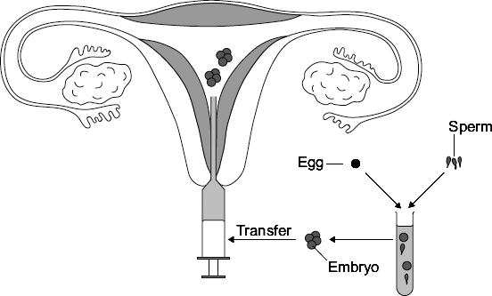
Describe the process of IVF. Use information from the diagram to help you.
........................................................................................................................
........................................................................................................................
........................................................................................................................
........................................................................................................................
........................................................................................................................
........................................................................................................................
........................................................................................................................
........................................................................................................................
........................................................................................................................
(4)
(Total 6 marks)

Q4. The graph shows how the likelihood of getting pregnant and the likelihood of infertility change with a woman’s age.
The data is for healthy women who have unprotected sexual intercourse during one year.
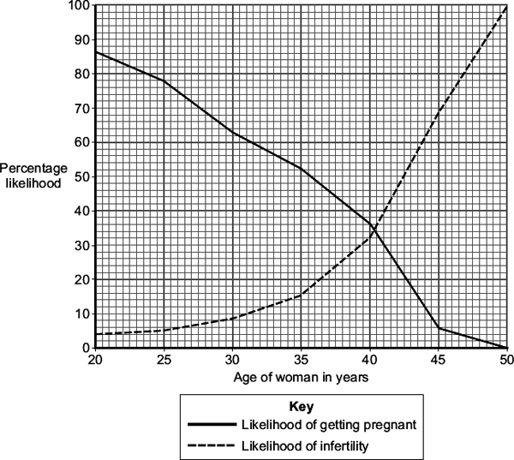
(a) Use information from the graph to answer this question.
A woman in her mid-twenties is thinking about waiting until her late-thirties before she has children.
A doctor advises the woman not to wait.
Explain why the doctor gives this advice.
........................................................................................................................
........................................................................................................................
........................................................................................................................
........................................................................................................................
........................................................................................................................
(2)

(b) The hormones FSH and LH are used in fertility treatment.
Give the function in fertility treatment of:
(i) FSH
...............................................................................................................
...............................................................................................................
(1)

(ii) LH.
...............................................................................................................
...............................................................................................................
(1)

(c) In the first stage of in-vitro fertilisation (IVF), eggs from the mother are fertilised with sperm from the father.
Describe the next stages of IVF.
........................................................................................................................
........................................................................................................................
........................................................................................................................
........................................................................................................................
(2)
(Total 6 marks)

Q5. Hormones can be used as contraceptives.
(a) Explain one way in which a hormone can prevent conception (pregnancy).
........................................................................................................................
........................................................................................................................
........................................................................................................................
........................................................................................................................
(2)

(b) Two methods of giving contraceptive hormones to a woman are the vaginal ring and the hormone implant.
Vaginal ring
The vaginal ring is a flexible ring 54 mm in diameter containing hormones.
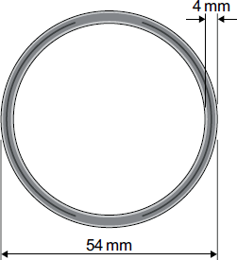
The woman puts in and takes out the vaginal ring herself; there is no ‘wrongߣ way to put the ring in.
Each ring is designed for one cycle of use, which is three weeks of continuous ring use, followed by one week without the ring.
About 0.3 % of women become pregnant in the first year of ring use.
4 % of women stop using the ring because of vaginal discomfort.
Hormone implant
A health professional puts the hormone implant under the skin of the woman’s arm.
The implant releases contraceptive hormones for three years before the implant needs to be replaced.
The hormone implant is 100 % effective.
About 2 % of women stop using the hormone implant, mainly because of irregular menstrual bleeding.
Evaluate the use of the vaginal ring compared with the hormone implant.
Remember to give a conclusion to your evaluation.
........................................................................................................................
........................................................................................................................
........................................................................................................................
........................................................................................................................
........................................................................................................................
........................................................................................................................
........................................................................................................................
........................................................................................................................
........................................................................................................................
........................................................................................................................
........................................................................................................................
(4)
(Total 6 marks)

Q6. The diagram shows an intra-uterine contraceptive device (IUCD).
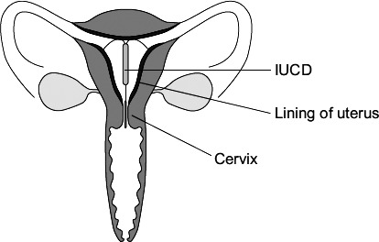
The IUCD is put inside the uterus (womb). The IUCD contains a hormone. The hormone diffuses directly into the uterus. The supply of hormone in the IUCD lasts for about five years.
The hormone works by:
• causing the cervix to produce a thick plug of mucus
• causing the lining of the uterus to become very thin.
For every 1000 women using the IUCD for one year about 2 women become pregnant. There are about 10 pregnancies for every 1000 women using the contraceptive pill for one year.
Evaluate the use of the IUCD compared with the contraceptive pill.
Use the information in this question and your own knowledge and understanding.
Remember to give a conclusion to your evaluation.
.................................................................................................................................
.................................................................................................................................
.................................................................................................................................
.................................................................................................................................
.................................................................................................................................
.................................................................................................................................
.................................................................................................................................
.................................................................................................................................
.................................................................................................................................
.................................................................................................................................
.................................................................................................................................
(4)
(Total 4 marks)

Q7.Endocrine glands produce hormones.
(a) Hyperthyroidism is caused by an overactive thyroid gland.
Suggest what would happen in the body of a person with hyperthyroidism.
........................................................................................................................
........................................................................................................................
........................................................................................................................
........................................................................................................................
........................................................................................................................
........................................................................................................................
(3)

(b) Describe the roles of FSH and LH in the menstrual cycle.
........................................................................................................................
........................................................................................................................
........................................................................................................................
........................................................................................................................
(2)

(c) The combined pill is a contraceptive that contains progesterone and oestrogen.
The ‘mini-pill’:
• is a contraceptive that only contains the progesterone hormone
• has to be taken at the same time each day to prevent pregnancy.
The success rate of the mini-pill in preventing pregnancy is lower than that of the combined pill.
Explain why missing a dose of the mini-pill would reduce the success rate of the mini-pill.
........................................................................................................................
........................................................................................................................
........................................................................................................................
........................................................................................................................
........................................................................................................................
........................................................................................................................
........................................................................................................................
........................................................................................................................
........................................................................................................................
........................................................................................................................
(4)
(Total 9 marks)

M1. (a) 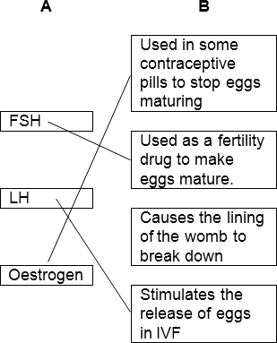
mark each line from left hand box
two lines from left hand box cancels mark for that box
3

(b) (i) implant
1

(ii) any one from:
allow explanation for their method in (b)(i)
• lasts for 5 years / long(est)
• cannot forget to take / replace it / lose it
• (hormone) there all the time
ignore expense
ignore STDs
ignore side effects
1

(iii) any one from:
accept correct disadvantage for wrong method in (b)(i)
• needs surgery / operation
allow it could go wrong
• painful
• infection
• have to wait five years for a child or more difficult to have a change of mind
ignore expense
ignore STDs
ignore side effects
1
[6]

M2.(a) ovary
1

(b) 46
1

(c) (i) does not fit the pattern
or
it is higher than the 3rd value / it should be lower than the 3rd value / it should be between the 3rd and 5th values
do not allow use of incorrect figures
1

(ii) As age increases % of women (having a baby) decreases
1

(d) (i) 33
allow 1 mark for
if no answer / wrong answer
2

(ii) low success rate
1
more likely to have a baby with health problems / abnormalities / a faulty chromosome
1
[8]

M3. (a) FSH / follicle stimulating hormone
allow FHS
either order
1

LH / luteinizing hormone
1

(b) any four from:
• egg(s) collected from ovary
• (eggs) mixed with sperm or fertilisation occurs
allow eggs and sperm put into tube
• fertilised egg divides
• embryo formed
• (embryos) inserted into womb / uterus
ignore references to vagina
• FSH matures egg and LH releases eggs
4
[6]

M4. (a) chance of getting pregnant decreases with age
ignore figures
1

chance of infertility increases with age
1

(b) (i) causes eggs to mature
allow growth
do not accept produced
do not accept releases egg
ignore references to oestrogen / LH / uterus / womb
1

(ii) causes egg release
do not accept matures egg / growth of egg / produces egg
ignore references to other hormones and uterus / womb
1

(c) embryo
allow (fertilised) egg divides
1

insert (embryo) into womb / uterus
ignore electric shock
1
[6]

M5. (a) inhibit FSH production
ignore LH production
ignore wrong hormone
1

so egg does not mature
ignore egg production / egg release / egg development
1

(b) any three comparisons: eg
• ease of insertion compared ie ring easily inserted by woman whereas
implant needs professional or no damage to skin with ring
comparisons must be made ie two separate lists will gain no marks unless the lists are linked by eg whereas / however / on the other hand and the points are made in the same order in both lists
• length of delivery compared eg 3 weeks for ring whereas 3 years for implant
or delivery longer for implant
or
woman has to remember to insert ring whereas does not have to remember
to insert implant
ignore cost
• effectiveness compared eg 0.3 % failure with ring whereas nil for implant or
implant more effective
• number giving up compared eg 4 % for ring whereas 2 % for implant or fewer women give up using implant
or ring might cause vaginal discomfort whereas implant may cause irregular menstrual bleeding
3

reasoned conclusion (normally at the end)
ie must state ‘better because....’
1
[6]

M6. any three from:
max 2 if only advantages or only disadvantages discussed
ignore ‘side effects’ unqualified
ignore side effects produced by hormones
advantages of IUCD over pill eg
• can’t forget to take it / have to take pill every day
do not allow last 5 years unless qualified
• effect much longer than pill
• more effective in preventing pregnancy
do not allow reference to figures unless qualified
• stops sperm entering uterus
disadvantages of IUCD over pill eg
• pain / uncomfortable / risk of infection / may damage uterus
• prevents fertilised egg developing / ‘embryo rights’
allow kills embryo
• needs replacement by doctor / nurse / professional
or access to IUCD is more difficult than pill
or IUCD is harder to come off than pill
3

argued conclusion
must include a preference and a reference to both advantages and disadvantages
or one is better in a given situation but the other is better in a different situation
1
[4]

M7.(a) Too much thyroxine is released into the blood
1

which raises BMR
1

causing increase in formation of glycogen / lipids / proteins
or
increase in rate of respiration
or
increase in breakdown of excess proteins
1

(b) FSH causes eggs to mature and stimulate ovaries to produce oestrogen
1

LH stimulates the egg to be released
1

(c) (missing a dose causes a) dip / drop in progesterone levels
1

(therefore) FSH is not inhibited anymore
1

(therefore) LH is not inhibited anymore
1

(and consequently) an egg is matured and released
allow (and consequently) an egg is available to be fertilised
1
[9]

