4.1.2 International trade and business growth

Imports explained
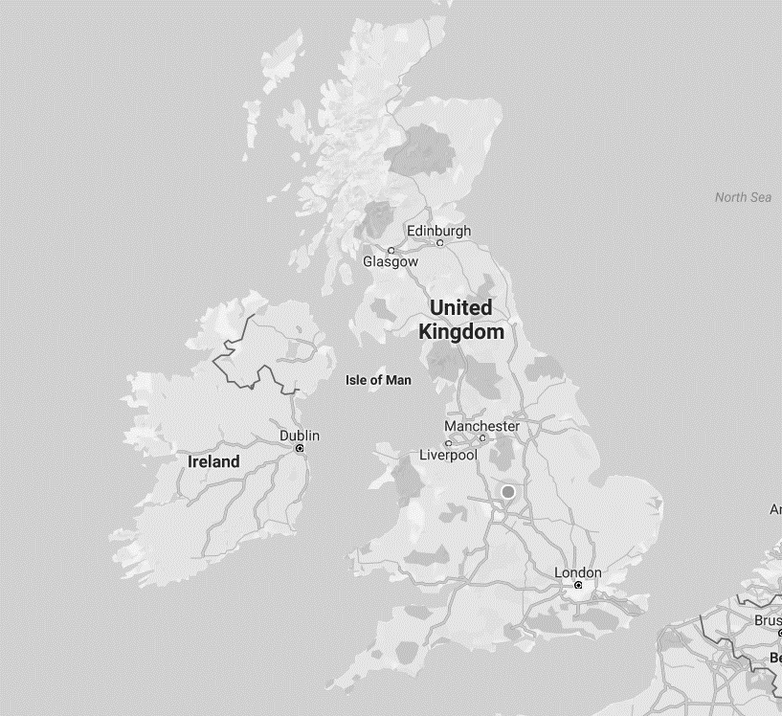
Add the arrow

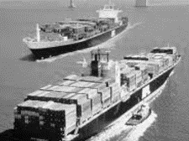

What does the UK import? Write a list here:

Where does the UK import from? Write another list here:

Exports explained
Add the arrows
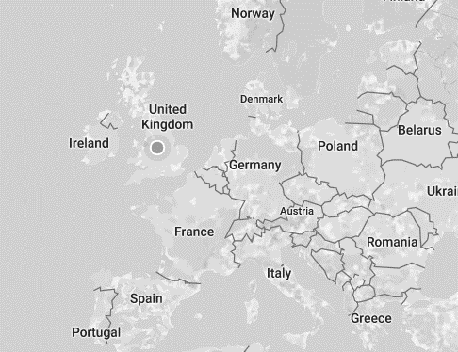

What does the UK export? Write a list here:

Where does the UK export to? Write a list here:

Specialisation and comparative advantage
Write a definition of specialisation here:

Specialisation and comparative advantage
________________________________________________________________________________________________________________________________________________________________________________________________________________________________________________________________________________________________________________________________________

Benefits to India of specialisation
A

B
C
D

The downside of specialisation

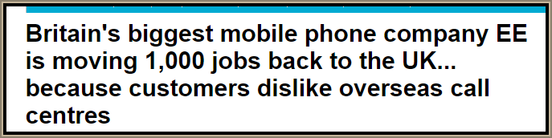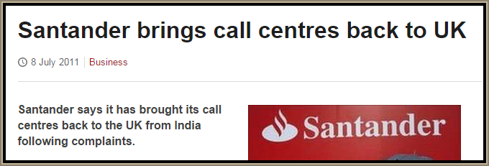

________________________________________________________________________________________________________________________________________________________________________________________________________________________________________________________________________________________________________________________________________

Write a definition of FDI here:
________________________________________________________________________________________________________________________________________________________________________________________________________________________________________________________________________________________________________________________________________
FDI and business growth
________________________________________________________________________________________________________________________________________________________________________________________________________________________________________________________________________________________________________________________________________

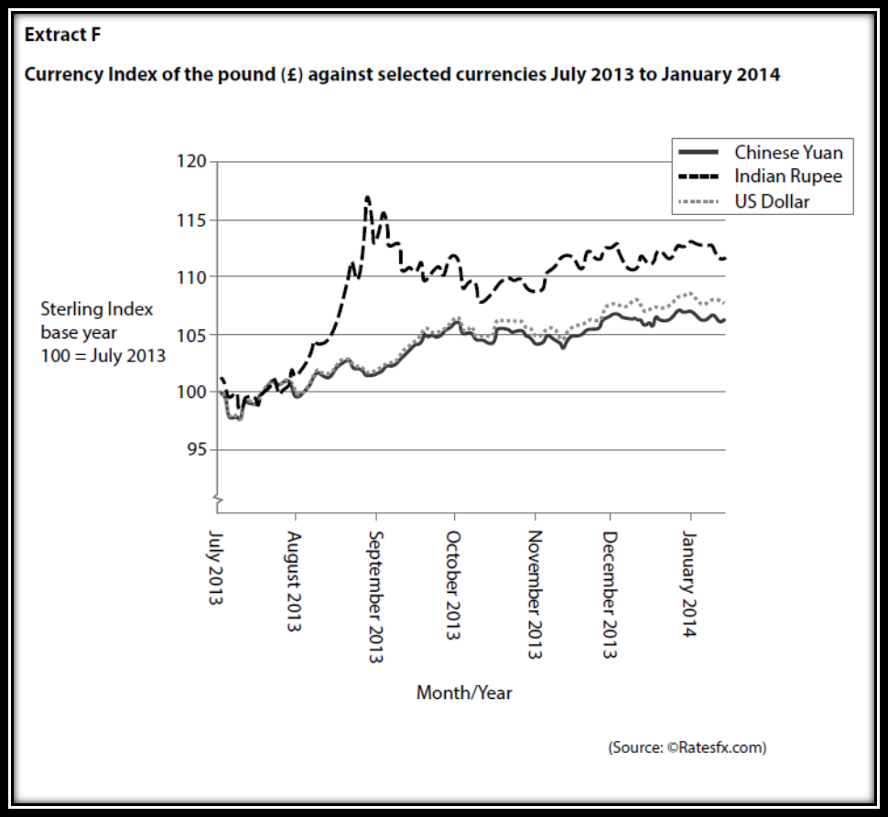

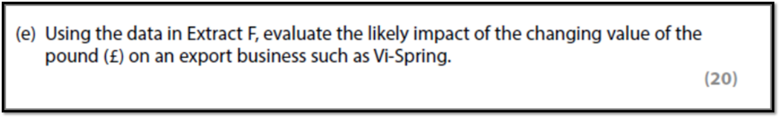
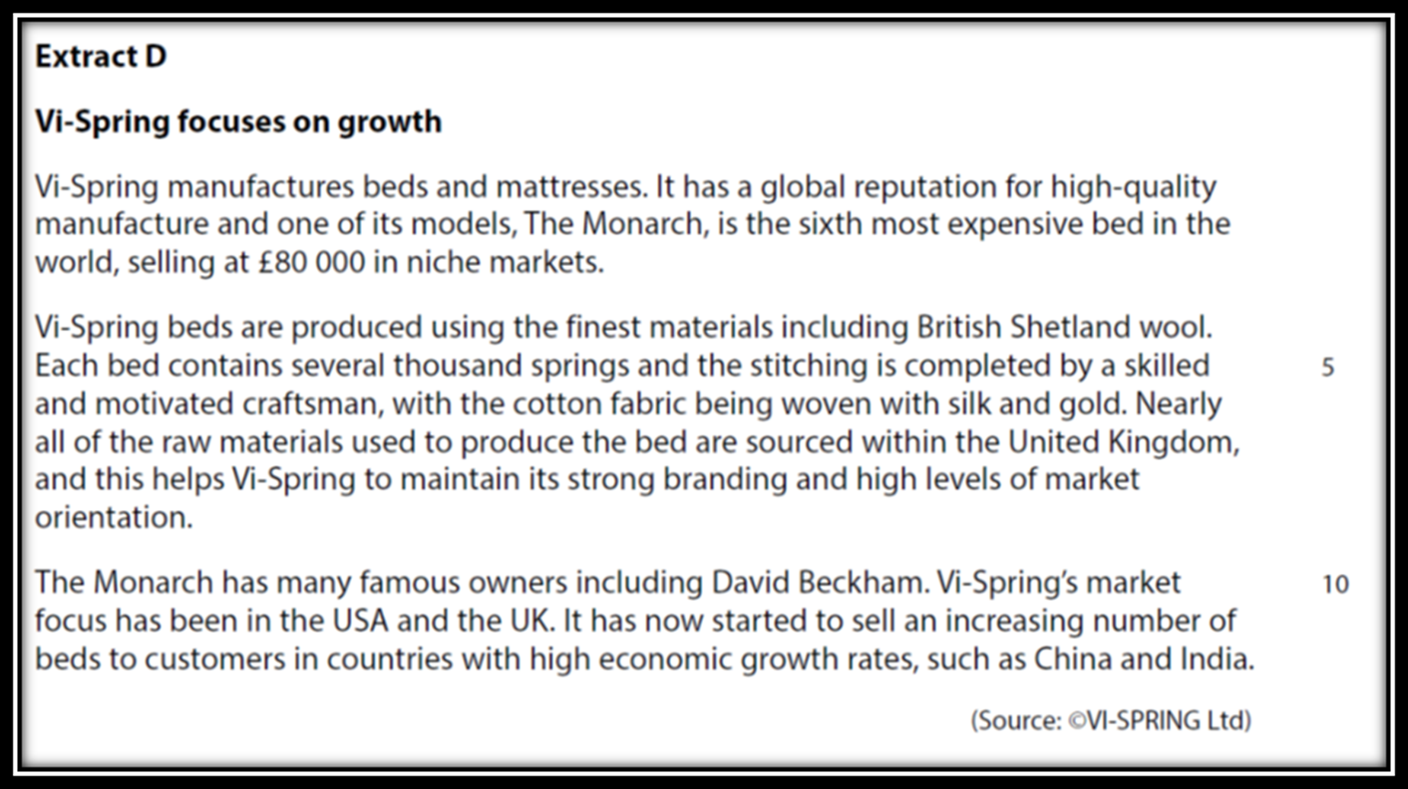

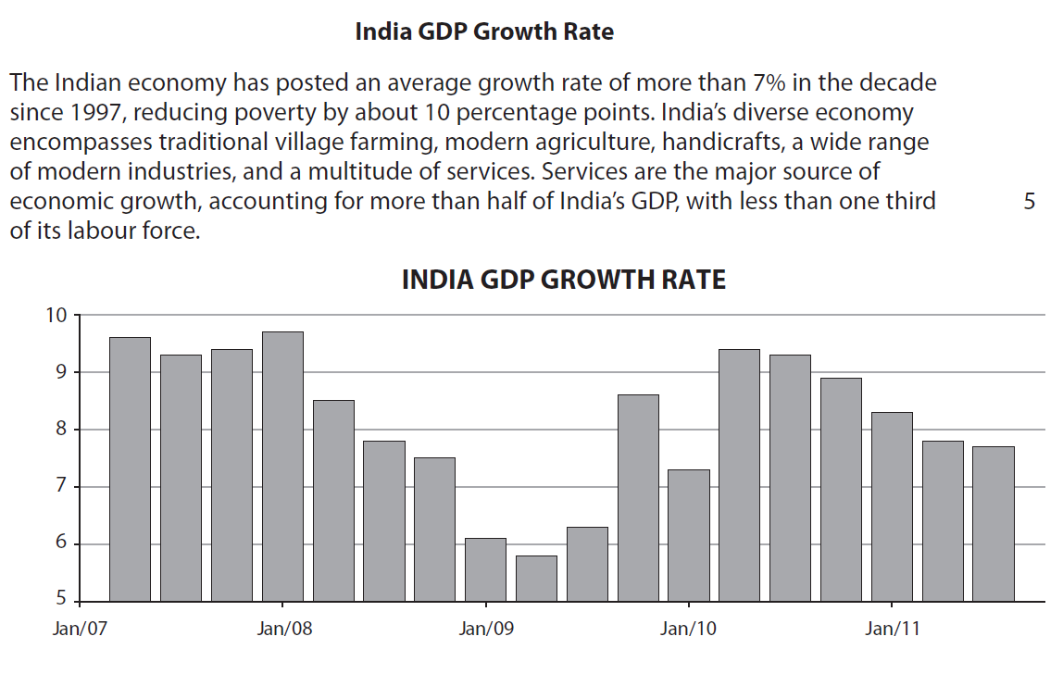

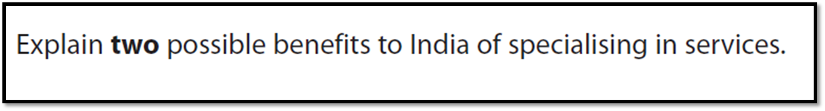
[6]

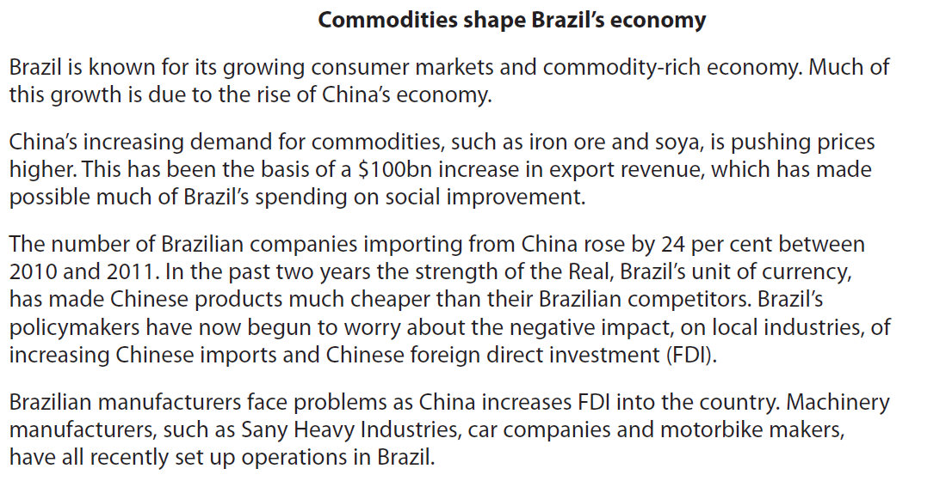

[9]

[9]

