3.3.1 Quantitative sales forecasting

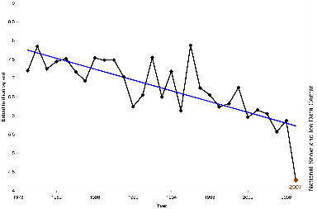
What is QSF?
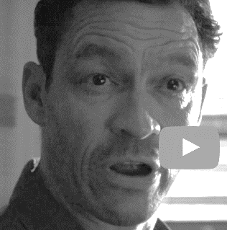
________________________________________________________________________________________________________________________________________________________________________________________________________________________________________________________________________________________________________________________________________
What can a business do with QSF information?

________________________________________________________________________________________________________________________________________________________________________________________________________________________________________________________________________________________________________________________________________

Calculate three period moving average:
Date | Sales | Smoothed data (average of 3 years)
2007 | 400 | Leave this blank
2008 | 500 | 556.6
2009 | 770
2010 | 900
2011 | 600
2012 | 700
2013 | 1,100
2014 | 1,500 | Leave this blank

Plot your smoothed 3-year average amounts, and the sales onto a chart (use 2 colours)

Sales

Dates

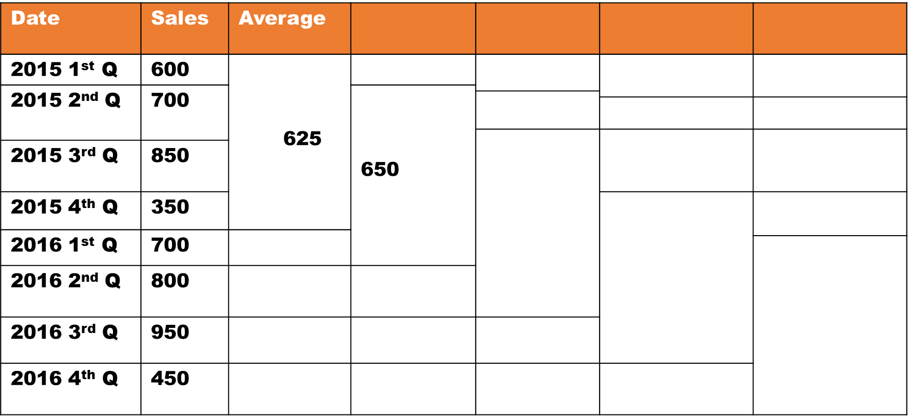
Now complete the 4 quarter moving average

Plot your smoothed 4 quarter average amounts, and the sales onto a chart (use 2 colours)

Sales

Dates
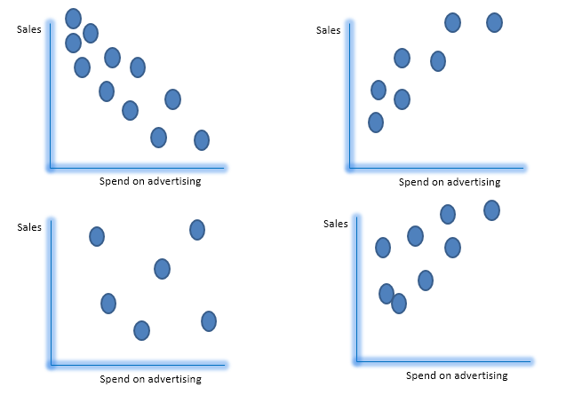
Add notes to these diagrams

Limitations

