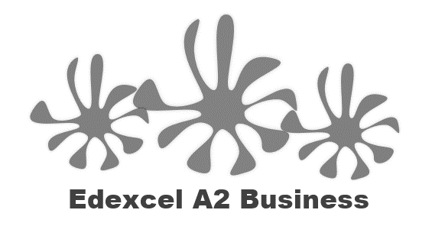
111 The Market

Starter
What were the last pair of shoes that you bought?
Had all your other shoes worn out?

Write a definition of niche markets here:
________________________________________________________________________________________________________________________________________________________________________________________________________________________________________________________________________________________________________________________________________
Write a definition of mass markets here:
_______________________________________________________________________________________________________________________________________________________________________________________________________________________________________________________________________________________________________________________________________

Divide up this circle with as many brands as you can think of, use research and ideas from others to complete the diagram

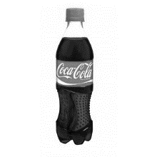
Mass market characteristics
________________________________________________________________________________________________________________________________________________________________________________________________________________________________________________________________________________________________________________________________________
Mass market examples
________________________________________________________________________________________________________________________________________________________________________________________________________________________________________________________________________________________________________________________________________

Advantages of operating in a mass market

________________________________________________________________________________________________________________________________________________________________________________________________________________________________________________________________________________________________________________________________________

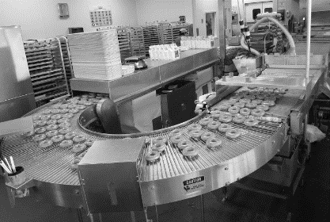
Disadvantages of operating in a mass market

________________________________________________________________________________________________________________________________________________________________________________________________________________________________________________________________________________________________________________________________________

Mass market brands

________________________________________________________________________________________________________________________________________________________________________________________________________
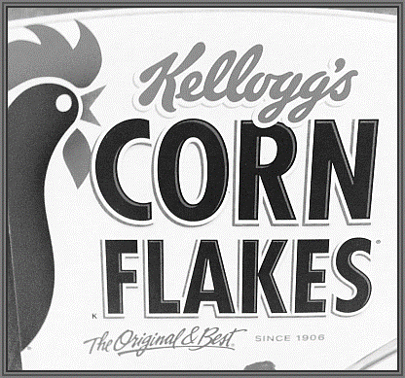

Niche market characteristics
________________________________________________________________________________________________________________________________________________________________________________________________________________________________________________________________________________________________________________________________________
Niche markets – example supercars ________________________________________________________________________________________________________________________________________________________________________________________________________________________________________________________________________________________________________________________________________

Niche Markets
Pros | Cons

Niche markets and profitability
________________________________________________________________________________________________________________________________________________________________________________________________________________________________________________________________________________________________________________________________________

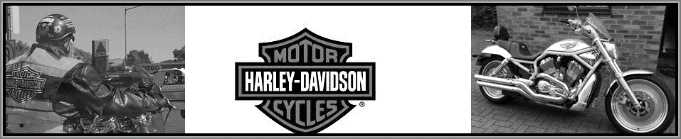

Mass or niche markets?
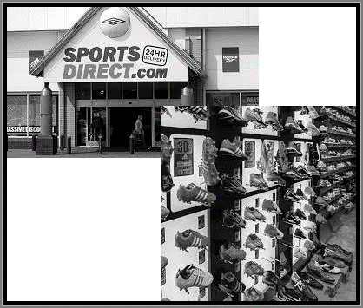 |  | 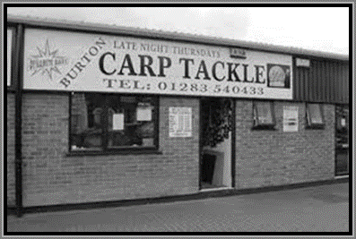
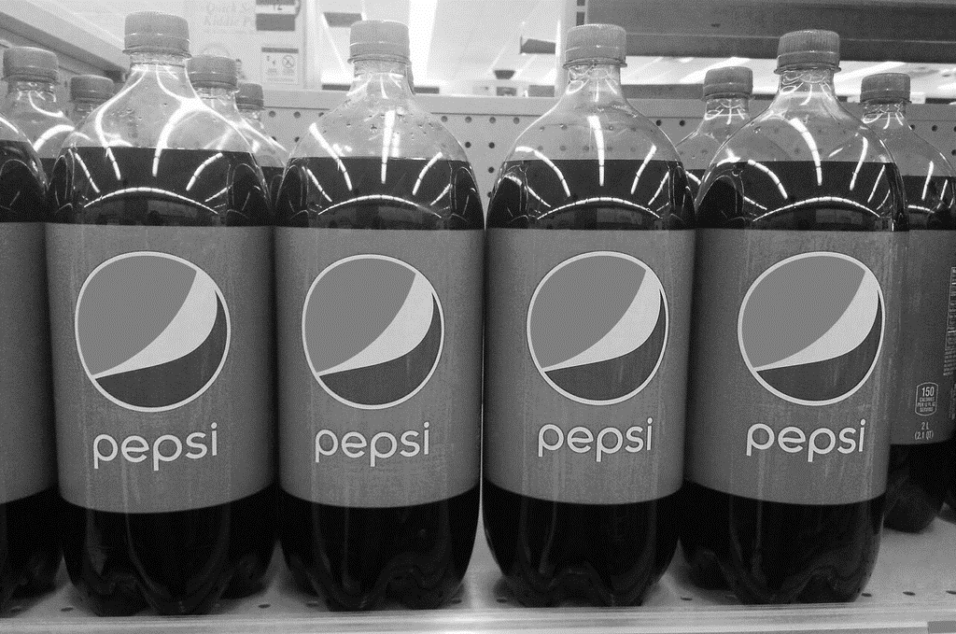 |  | 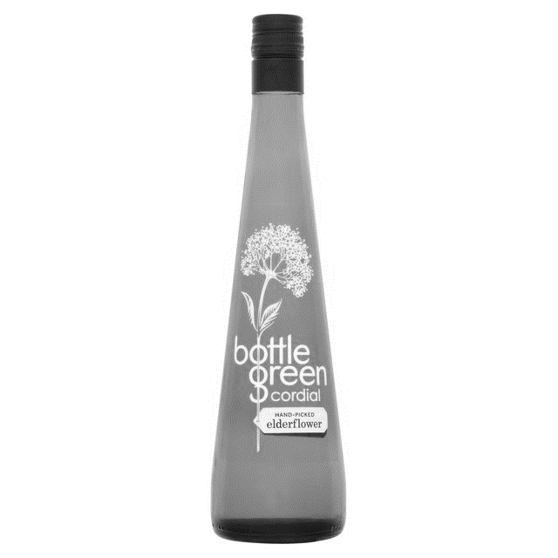
 |  | 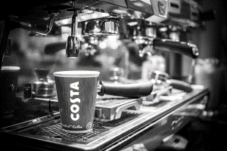
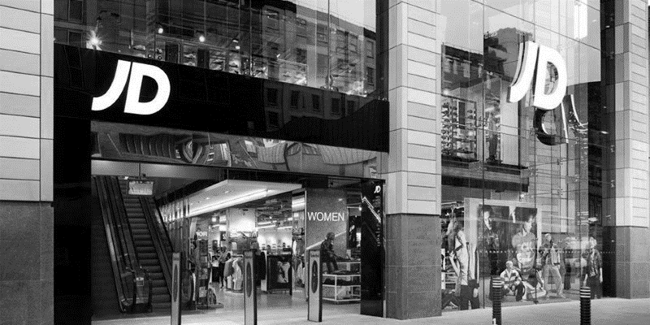 |  | 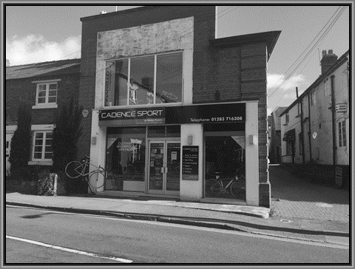

Market size

1.______________________________________________________________________

2._____________________________________________________________________

Market share

__________________________________________________________________ x100

 | Question 1 | Question 2 | Question 3 | Question 4 | Question 5
Sales of x | 50,000 | 2,847 | 465,000 | 5,789 | 1.2 million
Total sales of market | 500,000 | 18,000 | 1.8 million | 6,789 | 50 million
Market share

Write a definition of a dynamic market here:

________________________________________________________________________________________________________________________________________________________________________________________________________________________________________________________________________________________________________________________________________
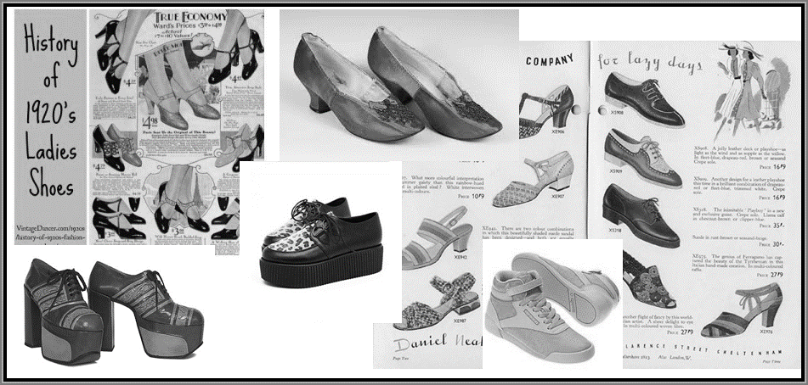

Dynamic market – tastes and fashion
________________________________________________________________________________________________________________________________________________________________________________________________________________________________________________________________________________________________________________________________________
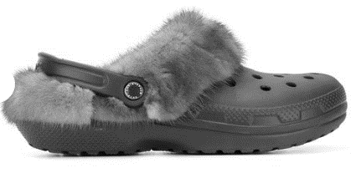
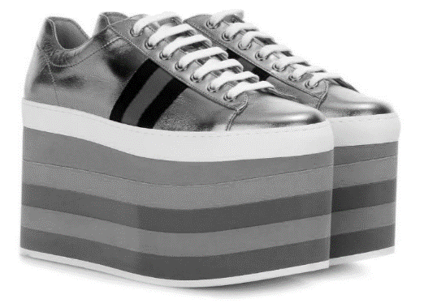

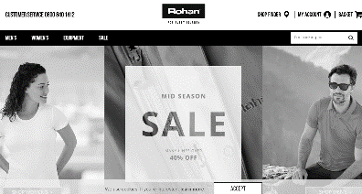
Dynamic markets - Online retailing

________________________________________________________________________________________________________________________________________________________________________________________________________________________________________________________________________________________________________________________________________
Suggested activity: Discussion
- In the future will shopping be all online? Can you explain your opinion?
____________________________________________________________________________________________________________________________________________________________________
- How much shopping do you do online now?
____________________________________________________________________________________________________________________________________________________________________
- Is most of your online shopping on your phone, a computer or a tablet?
____________________________________________________________________________________________________________________________________________________________________
- What products can’t be bought online?
____________________________________________________________________________________________________________________________________________________________________
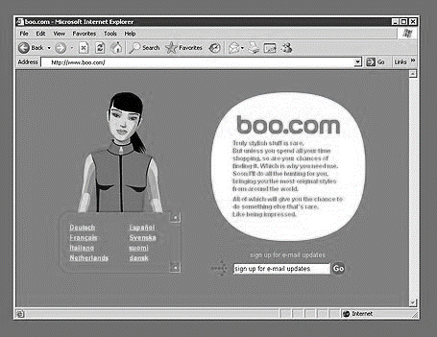

Explain what went wrong with boo.com here:

Advantages and disadvantages of online retailing

Advantages | Disadvantages

Market growth

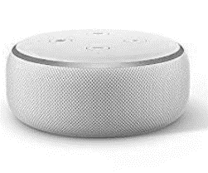

- With dynamic markets, comes constantly changing ________________________ tastes and ___________________________________
- Products not used widely 20 years ago:
  - Internet
  - Mobile Phones
  - PC _____________________ for home use
  - Computer games / games _______________________
- Technology is a massive ____________________________ market, consider how many of these items are in most UK households’ now
What is an echo dot?

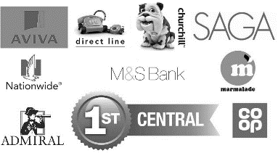
Competition and the market
________________________________________________________________________________________________________________________________________________________________________________________________________________________________________________________________________________________________________________________________________

Write a definition of risk here:
____________________________________________________________________________________________________________________________________________________________________

____________________________________________________________________________________________________________________________________________________________________
Risk – lack of job security

________________________________________________________________________________________________________________________________________________________________________________________________________________________________________________________________________________________________________________________________________

Risk – financial risk

________________________________________________________________________________________________________________________________________________________________________________________________________________________________________________________________________________________________________________________________________

Write a definition of uncertainty here:
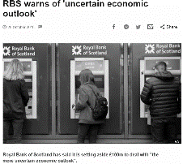
_______________________________________________________________________________________________________________________________________________________________________________________________________________________________________________________________________________________________________________________________________
Uncertainty and spending decisions

_______________________________________________________________________________________________________________________________________________________________________________________________________________________________________________________________________________________________________________________________________
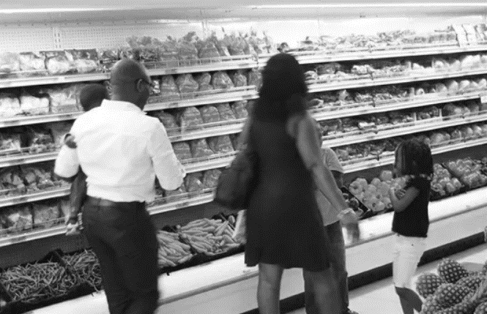
Uncertainty and spending decisions
_______________________________________________________________________________________________________________________________________________________________________________________________________________________________________________________________________________________________________________________________________

Uncertainty

- There is a ________________ of uncertainty in most business _______________________
- This is because the ______________________ cannot be predicted with any _________________________, we cannot be 100% sure that any ________________ will happen
- Uncertainty ________________________ with time; a forecast a week ahead will be more ___________________ than a year ahead

How might a business may protect itself from uncertainty?

- A business may worry about __________________ interest rates and so may take out a long term loan at a FIXED rate of interest, then it will know exactly how much loan ______________________ will be a month, making it easier to ______________________ and plan
- This means that loan ____________________ stay the same each month and the business knows its fixed costs each _______________ will not change

How a business may protect itself from uncertainty – insurance
_______________________________________________________________________________________________________________________________________________________________________________________________________________________________________________________________________________________________________________________________________

