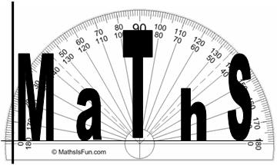
Guide to online resources
for Mathematics

MyMaths
To access MyMaths
Go here www.mymaths.co.uk username: bevhs password: sphere
Enter your individual login details (available from your maths teacher)
Booster Packs
There are online packs to help boost you from a grade 4 to a grade 5, a grade 6 to a grade 7 and a grade 8 to a grade 9*. Once you have logged in using your in individual login details, you will need to select ‘My Booster Packs’ and the relevant pack that is aimed at the grade that you would like to achieve. For each topic there is a revision lesson and an online worksheet. The online worksheet is marked once you have completed each page to give you instant feedback.
To review your progress you will need to select ‘My Boosters’. From this page both yourself, your teacher and your parents can see your progress through the relevant booster packs.
Online Tutorials
There are online tutorials to help you with a particular topic in maths. You will first need to login in. You can either search for the topic you are looking for using the search function at the top right side of the screen, or alternatively, go to ‘My Library’ on the right side of the screen and then select either number, algebra, shape, or data from the top of the screen.
Videos
Look out for the videos on some of the homeworks.

GCSE Maths Resources on Teams
To access the Teams section
On Teams look for GCSE Maths Resources.
You should have access automatically but if you are struggling email c.brooke@beverleyhigh.net
There are a range of resources including advice for revising and sitting exams, links to videos and worksheets useful for revision, links to exam practice and checklists and schemes of work.

Other useful websites:
Websites of resources and help
https://mathsbot.com/
http://corbettmaths.com/
https://www.piximaths.co.uk/the-revision-zone
https://mrchadburn.school.blog/resources/a-little-bit-of-maths-each-day/
http://www.mrbartonmaths.com/gcse.htm
http://www.mathsgenie.co.uk/gcse.html
https://whiterosemaths.com/resources/secondary-resources/secondary-sols/ - contains all the schemes of work detailing the work covered during your GCSE lessons
https://revisionmaths.com/gcse-maths-revision
https://mathsmadeeasy.co.uk/gcse-maths-revision/gcse-maths-past-papers/
https://www.examsolutions.net/gcse-maths/past-papers/
https://mathsaurus.com/gcse-and-igcse/

