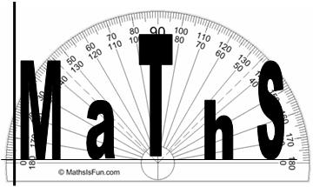
Guide to online resources
for Mathematics

MyMaths
To access MyMaths
Go here www.mymaths.co.uk username: bevhs password: sphere
Enter your individual login details (available from your maths teacher)
Booster Packs
There are online packs to help boost you from a grade 4 to a grade 5, a grade 6 to a grade 7 and a grade 8 to a grade 9*. Once you have logged in using your in individual login details, you will need to select ‘My Booster Packs’ and the relevant pack that is aimed at the grade that you would like to achieve. For each topic there is a revision lesson and an online worksheet. The online worksheet is marked once you have completed each page to give you instant feedback.
To review your progress you will need to select ‘My Boosters’. From this page both yourself, your teacher and your parents can see your progress through the relevant booster packs.
Online Tutorials
There are online tutorials to help you with a particular topic in maths. You will first need to login in. You can either search for the topic you are looking for using the search function at the top right side of the screen, or alternatively, go to ‘My Library’ on the right side of the screen and then select either number, algebra, shape, or data from the top of the screen.

School’s website
To access Moodle
Go to www.beverleyhigh.net
Scroll down to the bottom of the page and select Moodle
Login using your school login
Select Subjects then Maths
On these pages you will be able to choose from
GCSE Course Overview – Details of the contents and breakdown of the GCSE course, revision checklists and advice and guidance on revision resources and techniques.
GCSE Maths Year 11 – study tips, C if U can booklets for grade C and revision cards and checklists
GCSE Maths Year 10 – assessment ILs for the course

Other useful websites:
Websites of resources and help
https://mathsbot.com/
http://corbettmaths.com/
https://mrchadburn.school.blog/resources/a-little-bit-of-maths-each-day/
http://www.mrbartonmaths.com/gcse.htm
http://www.mathsgenie.co.uk/gcse.html

