Hot Handout
Christian Beliefs about the Nature of God

Key Words:
monotheism - belief in the existence of only one God
holiness - a) purity
b) distinctiveness
c) being set apart
attribute - a characteristic, a feature or trait
omniscient - all knowing
omnipotent - all powerful
omnipresent - all present (present everywhere)
benevolent - kind, wishing good for others
doctrine - a belief or teaching
redeemer - one who buys freedom or rescues others
just - fair, honest
righteousness - goodness
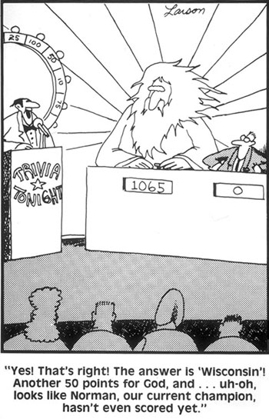

Page 1/2
Gary Larson – Far Side Cartoons

- Attributes of God:
Nature of God
  - Monotheist: Christians believe that there is only one God.
  - Eternal – no beginning or end
  - 3 omnis:
    - omnipotent
    - omniscient
    - omnipresent
  - Trinity:

    - God the Father – heavenly ruler
    - God the Son – Jesus (God in human form)
    - God the Holy Spirit – the spiritual presence of God everywhere in the universe who is directly involved with the world

- Personality of God
  - Loving - God is love. (1 John 4:16)
  - Merciful - Jesus said, "Father, forgive them, for they do not know what they are doing." (Luke 23:34 - Jesus said this about those who were crucifying him.)
  - Just - Righteousness and justice are the foundation of your throne.
(Psalm 89:14)

- Roles of God
  - Creator of the universe (Genesis 1)
  - Redeemer – God rescued human souls through the sacrifice of Jesus on the Cross.
  - Sustainer – God keeps the whole universe going, including life.
  - Judge – at the end of the age he will judge all who have ever lived.
Page 2/2

