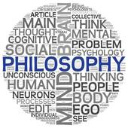

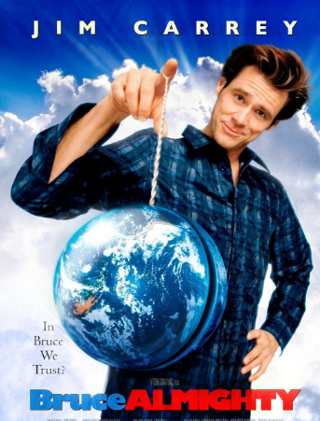
- Do you think the film, Bruce Almighty, suggests any possible answers to the following questions people often ask? Explain your answers as fully as possible. Refer to philosophical opinions where appropriate.

  - Why does God allow people to suffer?
  - Why doesn’t God answer my prayers?
  - Does God exist?

- What does God say is a ‘real’ miracle?

- What is it Bruce has no affect over even with God’s powers? Why is this (e.g. what effect would it have on human lives if God could affect this?

- What does the film suggest about beliefs about the nature of God? How might this relate to the idea of the ‘Inconsistent Triad’?

- Why do you think God saves Bruce and gets Grace to go back to him?

- How does Bruce change after talking to God and recovering from his accident?

- What does Bruce learn by the end of the film? How is ‘Grace’ a big part of this?

- ‘God’ appears at various points in the film as a tramp in the background. What does this suggest about the nature of God and how contemporary people think of God?

- Bruce is having a religious experience. Use some of the philosophers arguments (e.g. James, Otto, Swinburne) that we have looked at to suggest Bruce’s experience is real and that God exists.

- Use some philosophers arguments (e.g. Dawkins, Marx, Freud) to suggest Bruce’s experience is not real and God does not exist.



