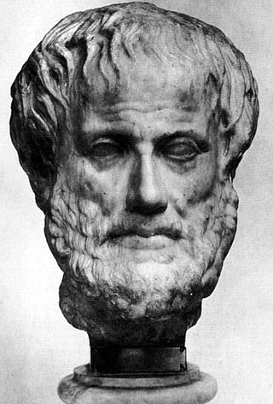
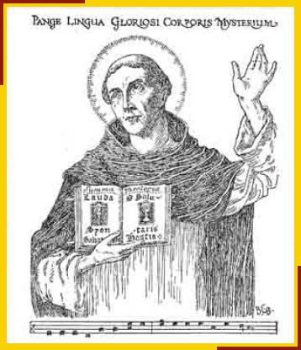
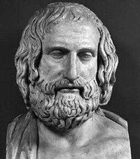

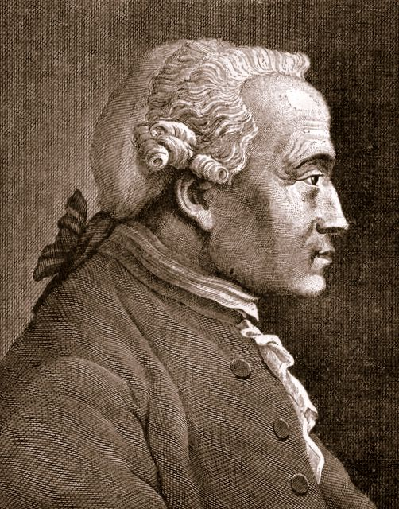
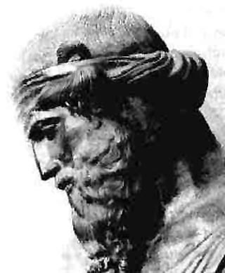
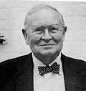

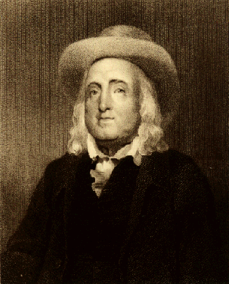
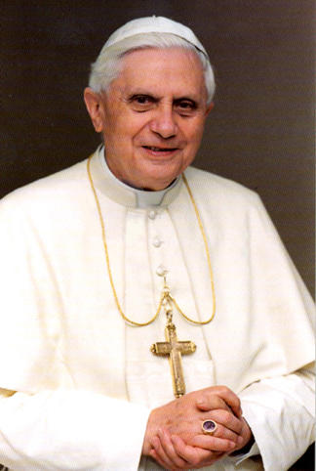

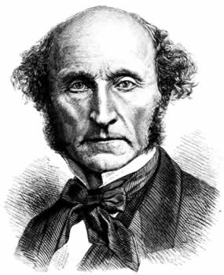

Pope Benedict XVI

John Stuart Mill

Jeremy Bentham

Protagoras

Plato

Aristotle

Thomas Aquinas

Joseph Fletcher

Kant
There are no universal forms beyond this world – forms are in the world and therefore not absolute. Moral behaviour should be a midway approach between two extremes; human circumstances are infinite and it is not possible to have a general rule which will cover every situation. Moral rules hold for the most part but there are times when they won’t. Aristotle
We were all made by God with a shared human purpose; this leads to a set of rules that people have a duty to follow. These rules are absolutist, because they know of no exception. For example, using contraception to prevent conception is absolutely wrong, regardless of consequences such as the spread of AIDS, unwanted pregnancies etc. Aquinas
There is no truth in anything beyond the way it seems. There is no objective knowledge, because all knowledge depends upon the perceptions of the person. There’s no objective truth. Truth is only true for you, or true for me. Man is the measure of all things. Protagoras
Scripture is important but doesn’t give guidance on many important matters so tradition is also important, as interpreted by the magisterium. Following Aquinas, reason is used as a tool for showing that certain acts are intrinsically right or wrong as they go against our true purpose; certain absolutes, such as the sanctity of life, cannot be changed by the circumstances. Pope
Moral absolutes such as goodness and justice really exist, beyond our normal perceptions of the world. This other world is inhabited by forms or ideas, which are the true reality. What we perceive around us is a shadow of this truth. Plato
The consequences of our actions are irrelevant to whether they are right or wrong - evil actions may have unintended good consequences, and someone might act heroically without any guarantee that the consequences will be good. No character quality is absolutely good (good without exception) - for example, it is possible to act kindly but do the wrong thing. The only good thing is a good will that does what is logically the right thing to do. Kant

“The principle of utility aims to promote happiness which is the supreme ethical value. Nature has placed us under the governance of two sovereign masters, pain and pleasure. An act is right if it delivers more pleasure than pain, and wrong if it brings about more pain than pleasure.” Bentham
Each individual situation is different and absolute rules are too demanding and restrictive. The Bible shows what good moral decisions look like in particular situations, but it is not possible to know what God’s will is in every situation; therefore love or agape is the only moral rule. Fletcher
“The Greatest Happiness principle holds that actions are right in proportion as they tend to produce happiness, wrong as they tend to produce the reverse of happiness. By happiness is intended pleasure, and the absence of pain; by unhappiness, pain and the privation of pleasure. Quality should be considered as well as quantity. Mill

