B1b: 17
Nasty pollution
Learning Objectives:
- Recall the possible causes of water pollution
- Apply knowledge of invertebrate animals and use them as natural water pollution indicators.

Here is a map of a river and the countryside around it.
Have a careful look at this map.
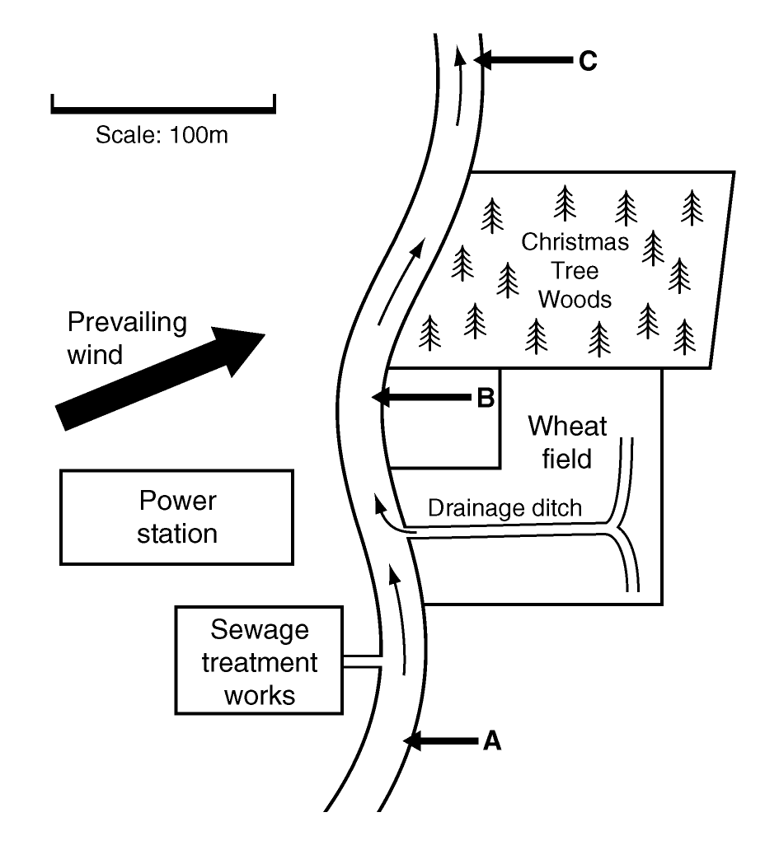

questions
1. List 3 ways in which the water could become polluted.
______________________________________________________________________________
2. One day, by mistake, the sewage treatment works releases raw sewage into the river. What would you expect would happen to the oxygen levels in the river? Why?
______________________________________________________________________________
______________________________________________________________________________
3. Which invertebrates would you expect to find at site A? Why?
______________________________________________________________________________
______________________________________________________________________________
4. Which invertebrates would you expect to find at site B? Why?
______________________________________________________________________________
______________________________________________________________________________

B1b: 17
Answers to Worksheet
Worksheet B1b: 17
1 Most fish would be caught at site A
2 Fish can not cope with pollution - site A is upstream from any pollution.
3 Oxygen levels would go down and then gradually recover.
4 Farmer Brown uses fertilisers to increase productivity.
5 His field’s drainage empties into the river, so if he uses fertilisers he must know that excess fertilisers could be washed into the river.
6 Site A: freshwater shrimps and mayfly larvae; Site B: rat-tail maggots and Chironomus larvae; Site C: clean water species would include – flat worms, caddis fly larvae, stonefly larvae, as well as any species found at Site A.
7 Prevailing wind blows from the power station towards the wood land – sulfur dioxide pollution.
8 a) Anywhere upstream from Site B
b) This would avoid sulfur dioxide air pollution areas.
B1b: 17
Technician’s Notes
Teaching and learning activities
Resources:
- 2–3 images of a polluted river
- 2–3 images of an unpolluted river
- samples of lichens
- samples of freshwater invertebrates (live or preserved)

