B1b: 14
The effect of sewage on a river
This graph shows what happened to bacteria and oxygen in a river when untreated sewage was added.

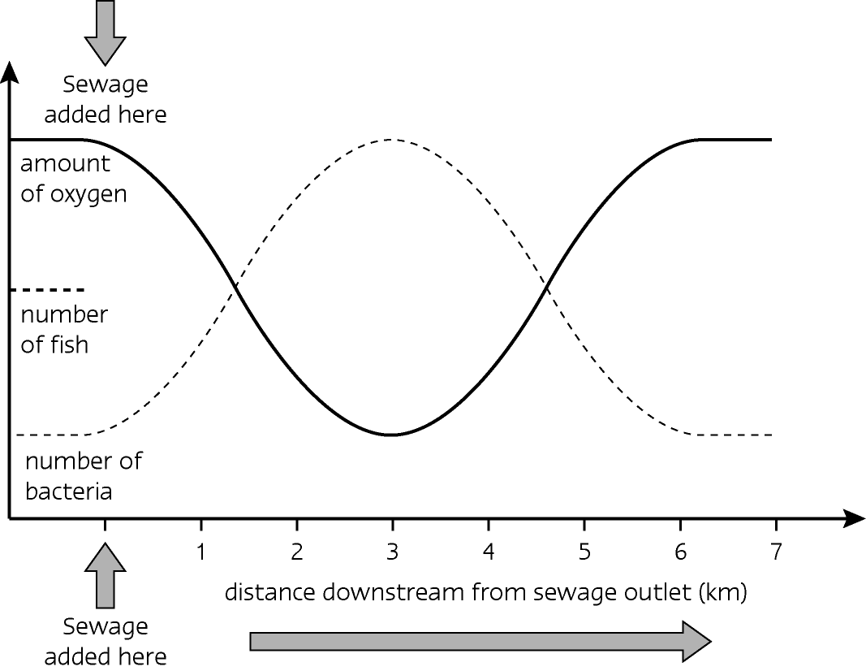

Look at the graph carefully, and then answer the following questions.
1 Why did the number of bacteria increase after the untreated sewage was added?
2 What happened to the oxygen concentration in the river downstream from the sewage outlet?
3 Why did the oxygen concentration return to normal after about 6 kilometres?
4 At what distance downstream did the number of bacteria return to normal?
5 A dotted line has been started to represent the number of fish in the river.
Complete this dotted line.
6 Explain why you have drawn the line in the way you have.
7 How would you be able to tell that this river has been polluted by sewage?
8 What could be done to prevent such sewage pollution accidents?
B1b: 14
Answers to Worksheet
Worksheet B1b 14
1 Bacteria feed on sewage, so as there was lots of food for them they multiplied in numbers.
2 Initially it fell up to about 3 km. This is because the bacteria respire and so use up oxygen.
3 Due to: the dilution effect of the river on the sewage; the bacteria using up the food (sewage) the river gradually recovered.
4 Bacteria returned to normal at about 6km.
5 The fish line would be similar in shape to the oxygen line.
6 Fish respire aerobically so they need oxygen.
7 Its smell.
8 Better monitoring procedures; legislation – laws to prevent it – fines; environmental water inspectors; etc …

