Shape and space (Foundation) – Grade that question
Name:
Describe the work at each grade:
F Grade | E Grade | D Grade | C Grade
Reading a number off a scale  Know what acute, obtuse and reflex are | Volume by counting cubes  Calculate missing angles at a point and on a straight line  Area and perimeter by counting squares  Area and perimeter of a rectangle | Area and perimeter of parallelograms and triangles  Area and perimeter of compound shapes  Isosceles triangles | Volume of a cube or cuboid  Area of a trapezium  3D coordinates  Alternate (Z) and corresponding angles (F)

Q | Grade | Question | 1 to 5
1. |  | 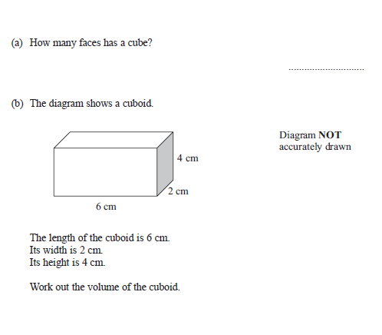
2. |  | 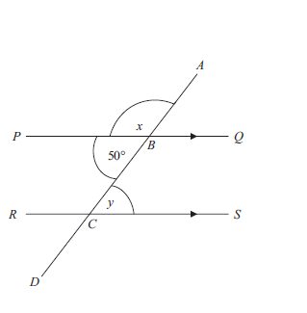  Work out the value of x and y and GIVE reasons for your answers.
12. |  | 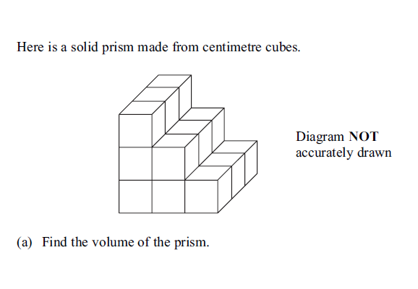
13. |  | 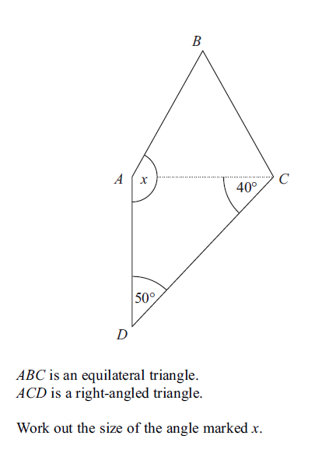
3. |  | 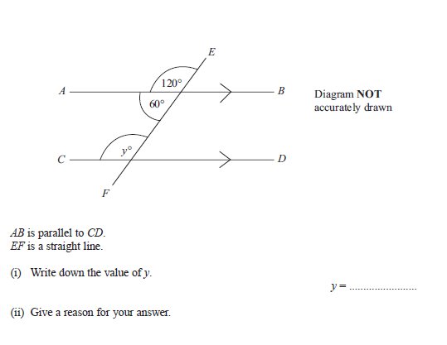
4. |  | 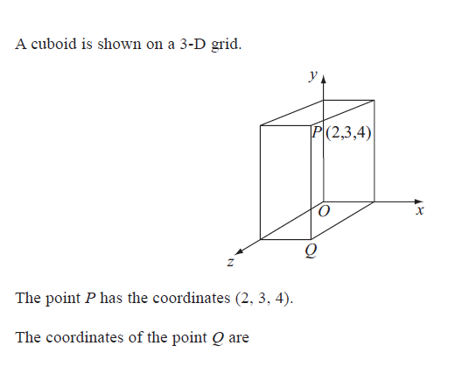
14. |  | 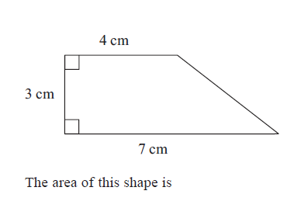
15. |  | 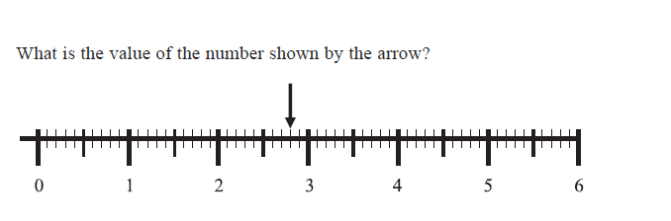
16. |  | 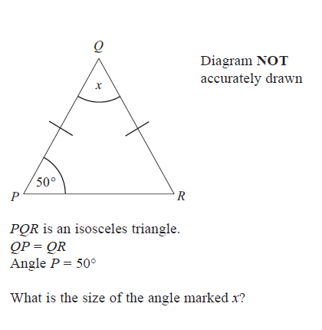
5. |  | 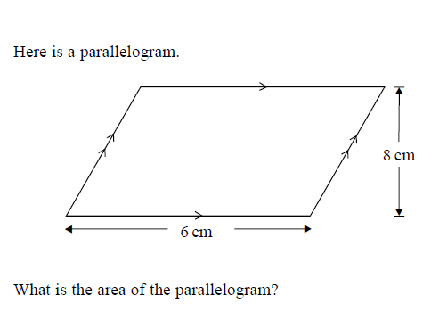
6. |  | 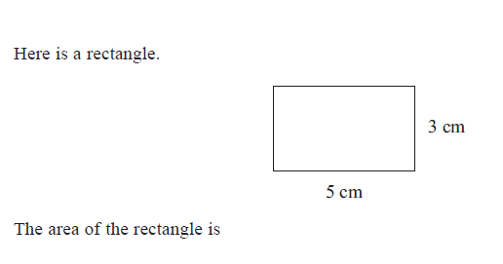
7. |  | 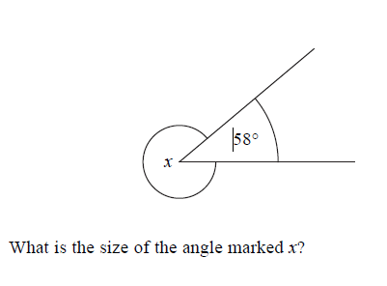 | F | 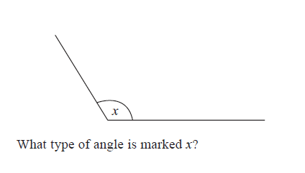
8. |  | 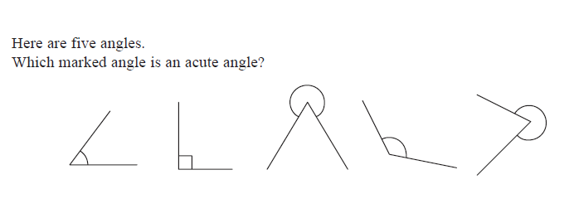
17. |  | 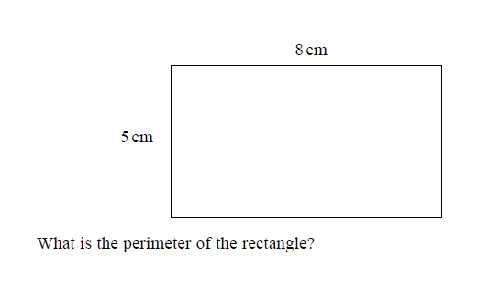
18. |  | 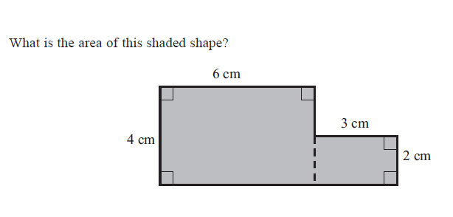
19. |  | 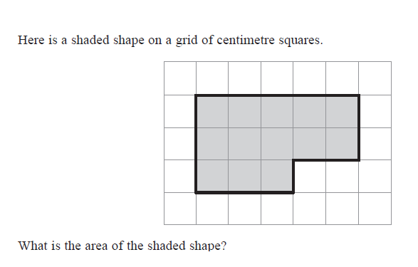
9. |  | 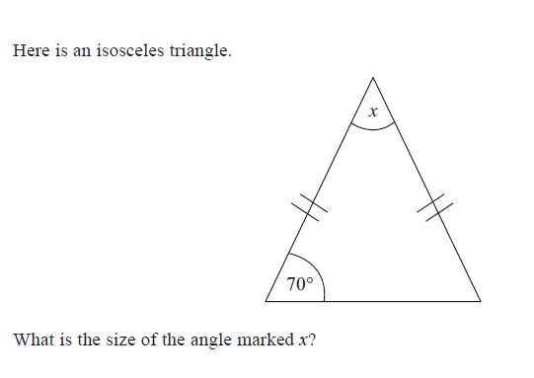
10. |  | 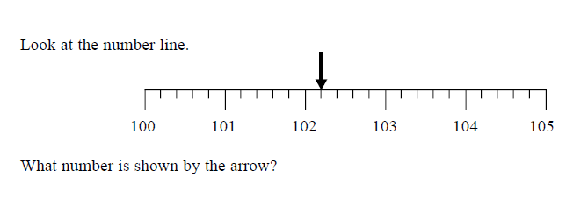
11. |  | 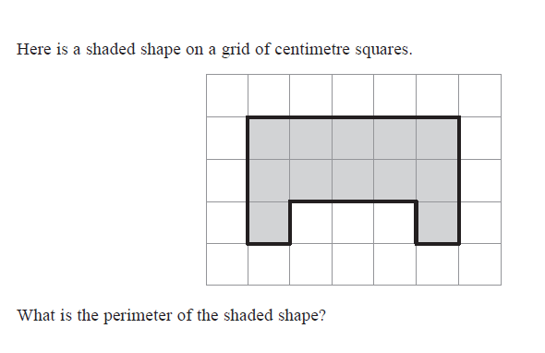
20. |  | 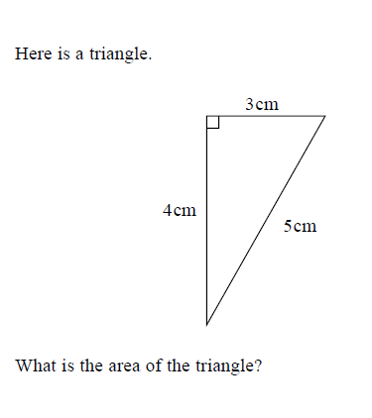
21. |  | 