Shape and space (Foundation) – Grade that question
Name:
Describe the work at each grade:
F Grade | E Grade | D Grade | C Grade
Reading a number off a scale  Know what acute, obtuse and reflex are | Volume by counting cubes  Calculate missing angles at a point and on a straight line  Area and perimeter by counting squares  Area and perimeter of a rectangle | Area and perimeter of parallelograms and triangles  Area and perimeter of compound shapes  Isosceles triangles | Volume of a cube or cuboid  Area of a trapezium  3D coordinates  Alternate (Z) and corresponding angles (F)

Q | Grade | Question | 1 to 5
1. | C | 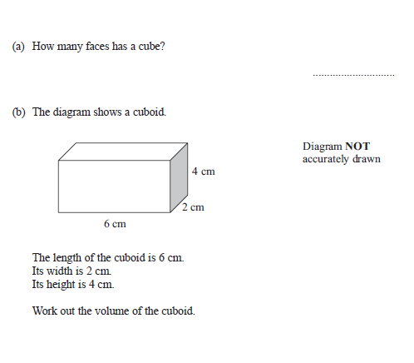
2. | C | 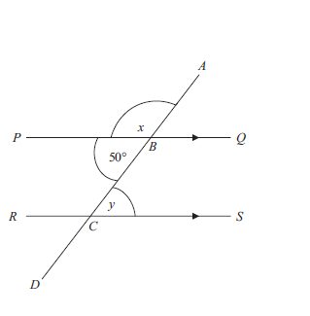  Work out the value of x and y and GIVE reasons for your answers.
12. | E | 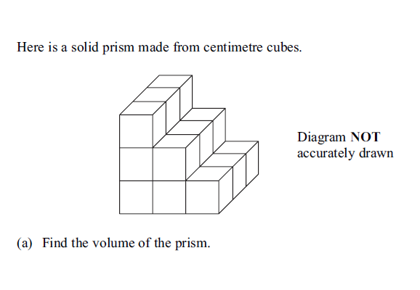
13. | D | 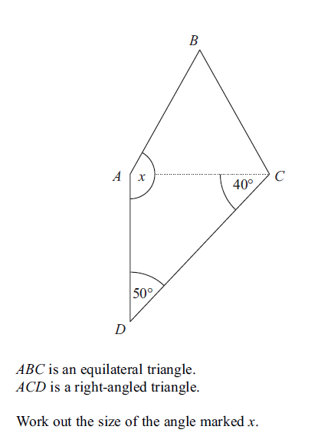
3. | C | 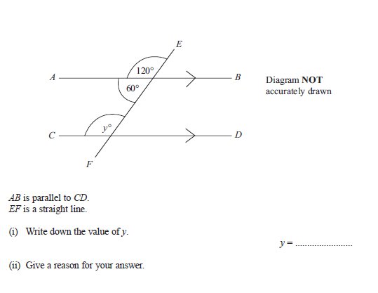
4. | C | 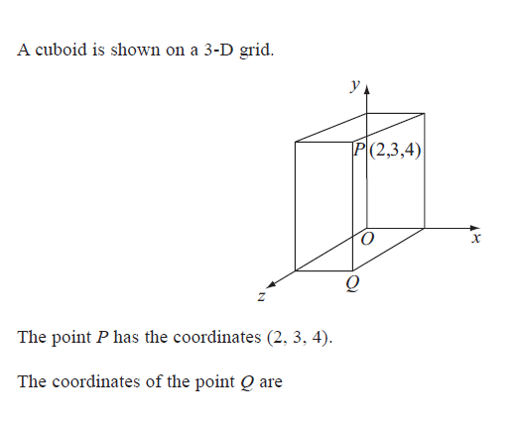
14. | C | 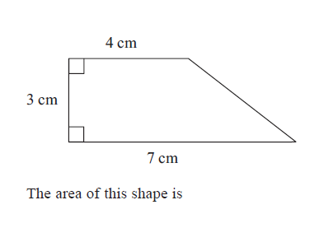
15. | F | 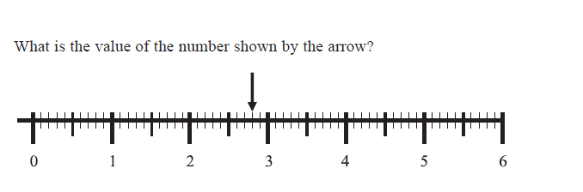
16. | D | 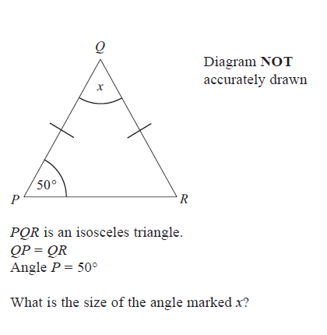
5. | D | 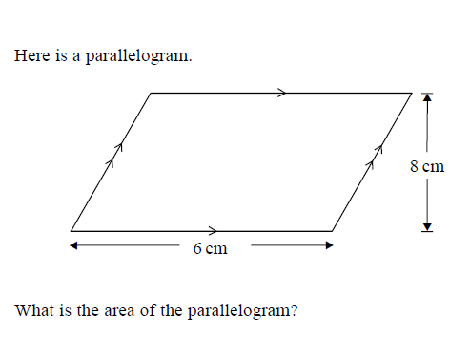
6. | E | 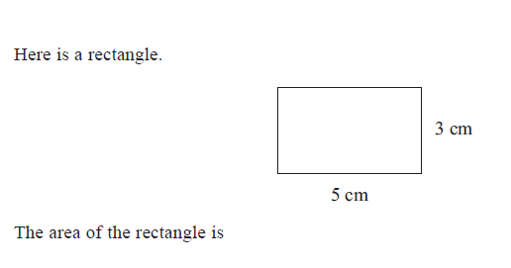
7. | E | 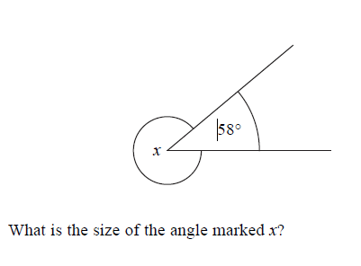 | F | 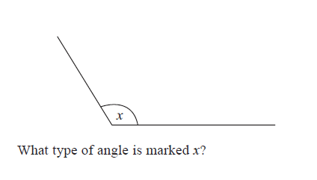
8. | F | 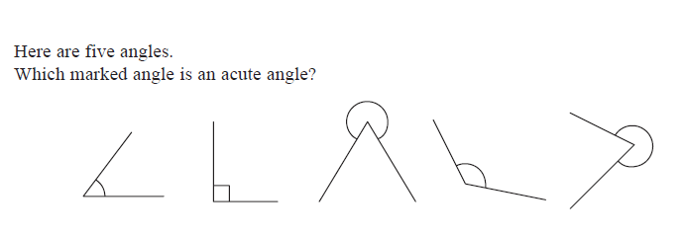
17. | E | 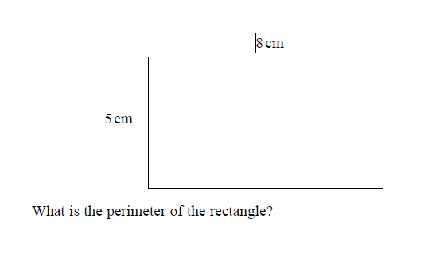
18. | D | 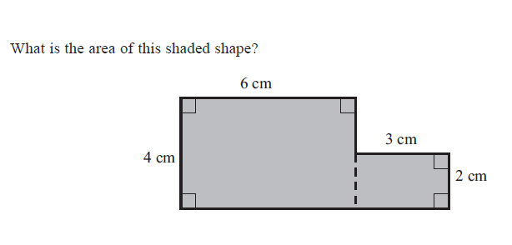
19. | E | 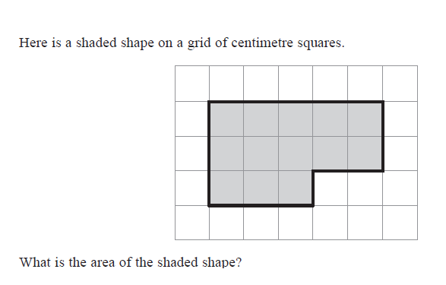
9. | D | 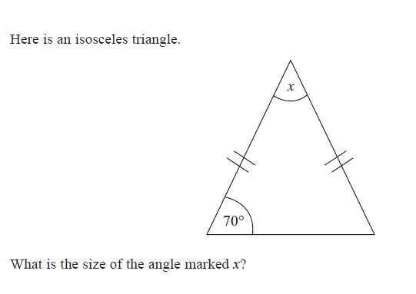
10. | F | 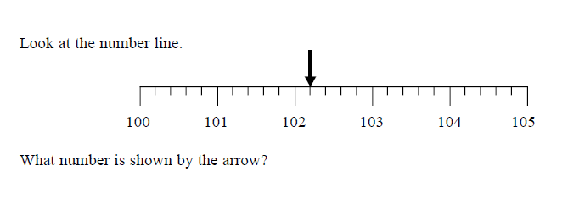
11. | E | 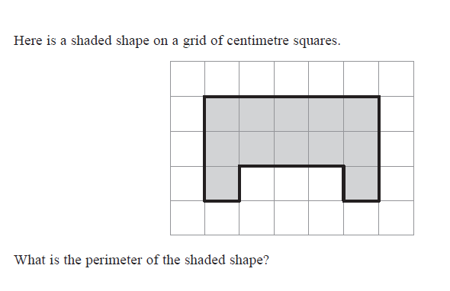
20. | D | 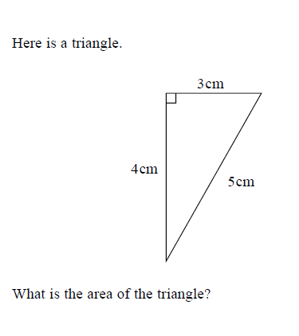
21. | C | 