Mainly number (foundation) – Grade that question
Name:
Describe the work at each grade and see if you can figure out which questions are calculator and which are from the non-calculator paper.:
F Grade | E Grade | D Grade | C Grade
Add and subtract integers | Round numbers to the nearest whole, 10, 100, 1000 etc  Factors, multiples and prime numbers  Use negative numbers  Multiply and divide integers  Add and subtract decimals | Square and square roots  HCF and LCM  Round numbers to 1 significant figure  Multiply and divide decimals  Convert between fractions and decimals | Cubes and cube roots  Index laws for multiplying and dividing  Use a calculator efficiently

Q | Grade | Question | 1 to 5
1. | Calc  C | 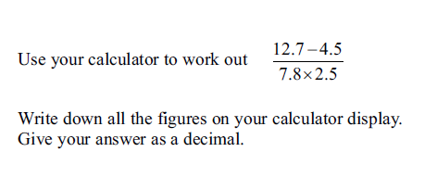
2. | Non  E | Which of these numbers is a multiple of 9?  19 15 6 45 3
3. | Calc  Non  E | Work out - 8 - - 4  Work out - 7 + - 2  Work out - 3 x – 5  What is -5 added to +3?
4. | Calc  C | Simplify 5⁵ ÷ 5²  Write your answer as a power of 5
5. | Non  E | The first odd number is 1. What is the seventh odd number?
6. | Non  E | 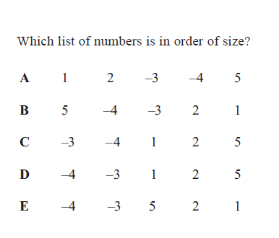
7. | Calc  F | 26 people are in a café.  21 people leave the café and 15 more people come in.  How many people are now in the café?
8. | Non  F | Paul buys some stamps.  The cost of each stamp is 25p and the total cost of the stamps is £14.  How many stamps does Paul buy?
9. | Calc  C | Simplify 3⁴ x 3²  Write your answer as a power of 3
10. | Calc  D | Find the value of 3.5²
11. | Non  F | 500 - 237 =
12. | Non  D | 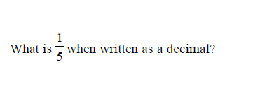
13. | Calc  D | Find the square of - 3
14. | Calc  D | Find the square root of 2.25
15. | Calc  E | Here is a list of numbers:  2 4 8 12 16 20 32 40  From the list write down a square number  Also, from the list write down a cube number
16. | Calc  D | Find the value of 4²
17. | Calc  E | Magazines cost £2.45 each.  Farah buys 3 magazines and pays with a £10 note.  How much change should she get?
19. | Non  E | 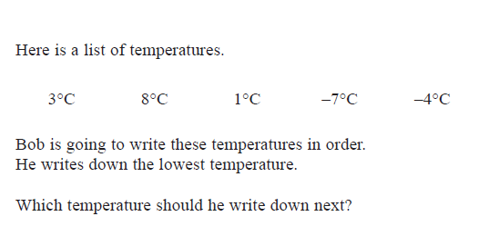
20. | Calc | 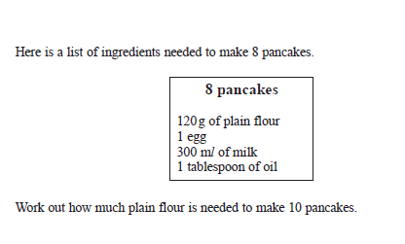
21. | Calc | Ahmed is planning a holiday. The holiday costs £450. He pays a deposit of 30% of the cost of the holiday.  Work out how much deposit he pays.
22. | Calc  C | 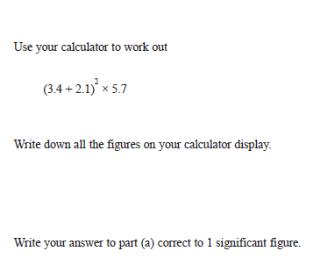
23. | Calc | 83% of the houses in Springfield road have a satellite dish.  What percentage of the houses do NOT have a satellite dish?
24. | Calc  C | Write down the cube of 2.
25. | Calc  D | Write down the square root of 25.
26. | Calc  D | Find the value of √2.25
27. | Calc  E | Grace buys  1 book for £3.95 1 magazine for £1.80 2 pens for 40p each.  How much change will she get if she pays with a £10 note?
28. | Non | 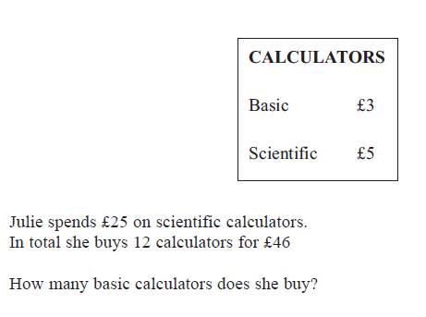
29. | Non  D | The number 37.68 correct to 1 significant figure is….?  What is 3762 when rounded to the nearest 100?
30. | Non  D | 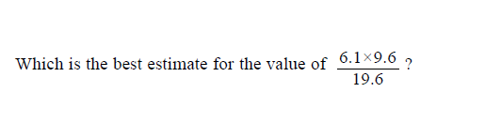
31. | Non  E | What is the value of the 7 in the number 32 715?  What is the value of the 6 in the number 2564?
32. | Non  E | 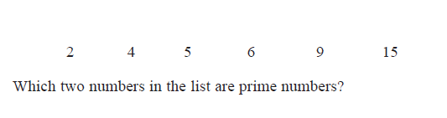
33. | Non  D | 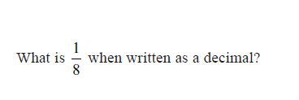
34. | Non  D | 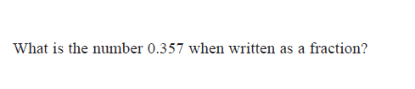
35. | Non  D | 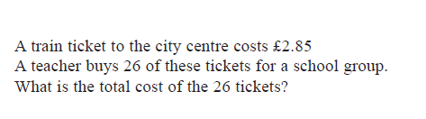
36. | Non  D | What is 372.42 correct to one significant figure?
37. | Non  D | 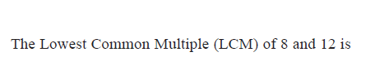
38. | Non  E | 325 x 23 =

