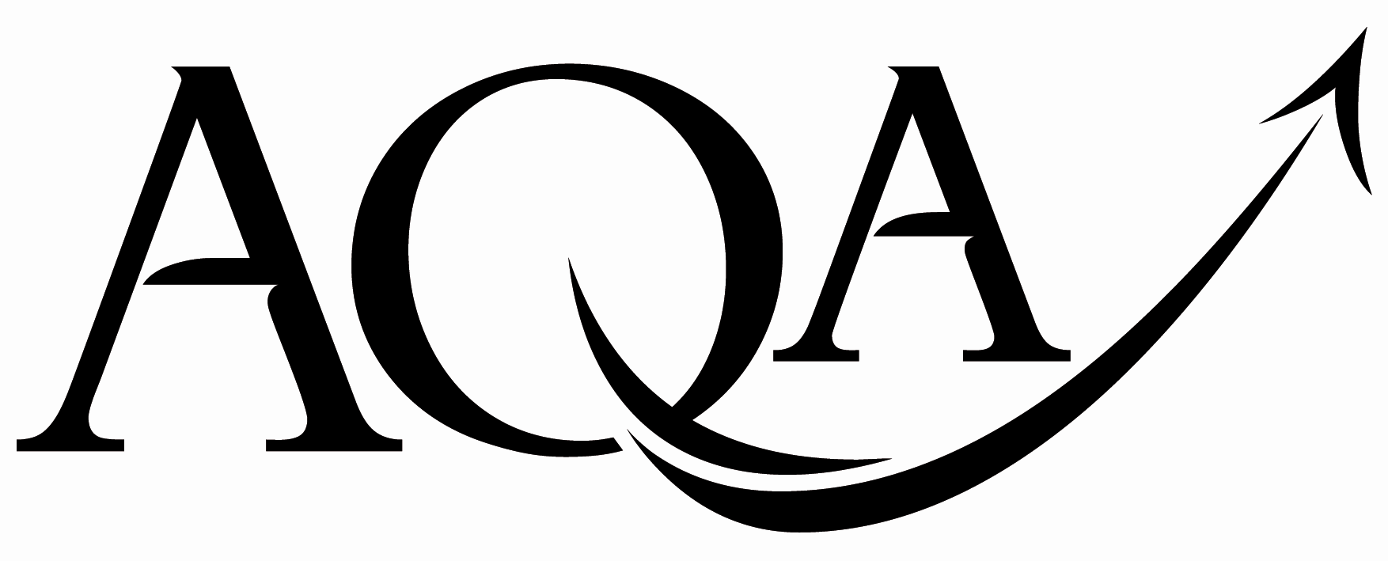 | General Certificate of Secondary Education  Foundation Tier
  For Examiner’s Use
  Examiner’s Initials
  Pages | Mark
  3
  4 - 5
  6 - 7
  8 - 9
  10 - 11
  12 - 13
  14 - 15
  16 - 17
  18 - 19
  TOTAL

GCSE Mathematics
FF

Unit 3 Foundation Tier

Practice Paper Set 4 Specification 4360

For this paper you must have:
mathematical instruments.
You may use a calculator

Time allowed
- 1 hour 30 minutes

Instructions
- Use black ink or black ball-point pen. Draw diagrams in pencil.
- Fill in the boxes at the top of this page.
- Answer all questions.
- You must answer the questions in the space provided. Do not write outside the box around each page or on blank pages.
- Do all rough work in this book. Cross through any work that you do not want to be marked.
- If your calculator does not have a π button, take the value of π to be
3.14 unless another value is given in the question.

Information
- The marks for questions are shown in brackets.
- The maximum mark for this paper is 80.
- The quality of your written communication is specifically assessed
in questions 5 (a) and 10 (b)
These questions are indicated with an asterisk ()
- You may ask for more answer paper, graph paper and tracing paper.
These must be tagged securely to this answer booklet.
Advice
- In all calculations, show clearly how you work out your answer.

Practice Paper Set 4/43603F
Area of trapezium =
(a + b)h
Volume of prism = area of cross-section × length
h
a
b
length
cross-
section
Formulae Sheet: Foundation Tier

Answer all questions in the spaces provided.
Do not write
outside the
box
1 Here are some signs.
D
A
B
C
E
F
G
H

1 (a) Which signs have only one line of symmetry?
Answer .......................................................................... (3 marks)
1 (b) Which signs have rotational symmetry?
Answer .......................................................................... (2 marks)
1 (c) Which sign does not have line symmetry and does not have rotational symmetry?
Answer .......................................................................... (1 mark)

Turn over for the next question

6
2 (a) Here is a grid.
What fraction of the grid is shaded?
Give your answer in its simplest form.
...................................................................................................................................................
...................................................................................................................................................
Answer ................................. (2 marks)
2 (b) Here is a different grid.
What percentage of this grid is shaded?
...................................................................................................................................................
...................................................................................................................................................
Answer .................................% (2 marks)

2 (c) Here is a grid made from 20 equal rectangles.

Which of these proportions of the grid can be shaded using only whole rectangles?
Circle your answers.

$\frac{2}{3}$ 25% $\frac{3}{4}$ 30% $\frac{4}{5}$ 33%
...................................................................................................................................................
...................................................................................................................................................
...................................................................................................................................................
...................................................................................................................................................
...................................................................................................................................................
...................................................................................................................................................

(2 marks)

Turn over for the next question

6

3 Boxes are packed into crates.
Not drawn accurately

Each layer of boxes in a crate is 6 boxes long and 5 boxes wide.
There are 3 layers in a crate.
The boxes cost £3 each to make.
The boxes are sold for £4.50 each.
How much profit will be made on a crate full of boxes?
...................................................................................................................................................
...................................................................................................................................................
...................................................................................................................................................
...................................................................................................................................................
...................................................................................................................................................
...................................................................................................................................................
...................................................................................................................................................
...................................................................................................................................................
...................................................................................................................................................
...................................................................................................................................................
...................................................................................................................................................
Answer £................................. (5 marks)

4 The diagram shows a map of an island with roads joining four towns.
N

North
Coast
Beach Point
Saltsea
Saltsea

South Bay
4 (a) Choose the correct direction from the list to complete each sentence.

North North-east North-west East

South South-east South-west West

Saltsea is ................................................. of South Bay.
South Bay is ................................................. of Beach Point.
(2 marks)
4 (b) A ring is hidden on one of the roads.
Here are some clues to find it.
The closest town to the ring is Saltsea.
The ring is twice as far from Beach Point as from South Bay.

Mark with a cross, the approximate position of the ring on the map.
(2 marks)

9

5 A newspaper uses this formula to work out the cost of an advert.
Cost = Number of words used × 10 + Area of pictures × 20
The cost is in pence.
The area is in cm ².
5 (a) An advert has no pictures.
It has 18 words.

Work out the cost of the advert.
Give your answer in pounds.
...................................................................................................................................................
...................................................................................................................................................
Answer £................................. (3 marks)
5 (b) Work out the cost of this advert.
...................................................................................................................................................

Horse for sale

A mare with top class breeding.

Owner would like a quick sale.

Contact Bramley Stables for
the price and further details.
...................................................................................................................................................
...................................................................................................................................................
...................................................................................................................................................
...................................................................................................................................................
...................................................................................................................................................
Answer £................................. (5 marks)

6 Here is a grid.
x
x
y

9

8

7

6

5

4

3

2

1

0
x
0
1
2
3
4
5
6
7
8
9

6 (a) On the grid plot the points A(1, 3), B(4, 9) and C(7, 9).
Label the points.
(2 marks)

6 (b) Plot a point D on the grid so that ABCD is a trapezium.
(1 mark)

6 (c) Write down the coordinates of the midpoint of BC.

(.............., ..............) (1 mark)

6 (d) Write down the coordinates of a point on the grid that has

an x-coordinate that is a multiple of 3
a y-coordinate that is 1 less than a square number
and a y-coordinate that is 2 more than the x-coordinate.
...................................................................................................................................................
...................................................................................................................................................
...................................................................................................................................................
Answer (.............., ..............) (2 marks)

14

7 The diagram shows a circle on a centimetre grid.
y

x

7 (a) Write down the length of a diameter of the circle.
Answer .................................. cm (1 mark)
7 (b) Write down the coordinates of the centre of the circle.
Answer (.............., ..............) (2 marks)
7 (c) Draw a tangent to the circle.
(1 mark)
7 (d) State the units for the area of the circle.
Answer .................................. (1 mark)

8
Apples
£1.90 per kg
or
86p per pound

4
0
1
2
3
ence ........... ...
kilograms

8 (a) Ravi buys some apples.
The scale shows how much they weigh.
How much should he pay?
...................................................................................................................................................
...................................................................................................................................................
Answer £................................. (2 marks)
8 (b) Shane wants to know how much one apple costs.
He knows that one apple weighs about five ounces.

You are given that 16 ounces = 1 pound

Estimate the cost of one apple.
...................................................................................................................................................
...................................................................................................................................................
...................................................................................................................................................
...................................................................................................................................................
Answer .................................pence (3 marks)

10
9 The diagram shows a rectangle.

Not drawn accurately
(2x – 1) cm
(x + 4) cm

One of the sides is 11 cm.
9 (a) Work out the two possible values of x.
...................................................................................................................................................
...................................................................................................................................................
...................................................................................................................................................
...................................................................................................................................................
...................................................................................................................................................
...................................................................................................................................................
Answer................................. or................................. (4 marks)
9 (b) Work out the largest possible perimeter of the rectangle.
...................................................................................................................................................
...................................................................................................................................................
Answer ................................. cm (3 marks)

10 A homeowner wants to know the percentage of cars speeding past his home.
10 (a) 23 out of 50 cars are speeding.
What percentage are speeding?
...................................................................................................................................................
...................................................................................................................................................
Answer .................................% (2 marks)
10 (b) Signs are put up warning drivers of the 30 miles per hour speed limit.
The homeowner times cars over 200 metres.
Here is a summary of his results.

Time taken, t (seconds) | Number of cars
0 < t ≤ 5 | 2
5 < t ≤ 10 | 3
10 < t ≤ 15 | 4
15 < t ≤ 20 | 10
20 < t ≤ 25 | 6

Has the proportion of speeding cars decreased?
You can use 30 mph = 13.3 metres per second
You must show your working.
.................................................................................................................................................
...................................................................................................................................................
...................................................................................................................................................
...................................................................................................................................................
Answer ................................. (5 marks)

14
11 The diagram shows a farmer’s field.

Not drawn accurately
160 metres
120 metres

The field is to be divided into three rectangular areas.
One-quarter of the field is for sheep.
11 (a) Work out the length and width of a rectangle he could use for sheep.
...................................................................................................................................................
...................................................................................................................................................
Length...............................metres
Width.................................metres (2 marks)
11 (b) Two-fifths of the field is for cows.
The rest is not used.
What fraction of the field is not used for sheep or cows?
...................................................................................................................................................
...................................................................................................................................................
...................................................................................................................................................
...................................................................................................................................................
Answer ................................. (3 marks)

12 In the diagram AB is parallel to CD.
B
A
C
D
Not drawn accurately
x
y
148 °

12 (a) Work out the value of x.
...................................................................................................................................................
...................................................................................................................................................
Answer .................................degrees (2 marks)
12 (b)(i) Write down the value of y.
...................................................................................................................................................
Answer .................................degrees (1 mark)
12 (b)(ii) Give a reason for your answer.
...................................................................................................................................................
...................................................................................................................................................
(1 mark)

9

13 (a) The diagram shows shape A.
y
x
Reflect shape A in the line y = 4
(2 marks)

13 (b) The diagram shows two shapes B and C.
x
y
Describe fully the single transformation which takes shape B to shape C.
...................................................................................................................................................
...................................................................................................................................................
...................................................................................................................................................
(3 marks)

5
14 The diagram shows a cylinder.
The diameter of the base is 14 cm.
The height is 12 cm.
Not drawn accurately

Work out the volume of the cylinder.
Give your answer to the nearest 10 cm ³.
...................................................................................................................................................
...................................................................................................................................................
...................................................................................................................................................
...................................................................................................................................................
...................................................................................................................................................
Answer .................................cm ³ (4 marks)

15 The diagram shows a right-angled triangle.

Not drawn accurately
12 cm
6 cm

Work out the length of the hypotenuse.
...................................................................................................................................................
...................................................................................................................................................

...................................................................................................................................................

...................................................................................................................................................
Answer .................................cm (3 marks)

END OF QUESTIONS

7

There are no questions printed on this page

DO NOT WRITE ON THIS PAGE
ANSWER IN THE SPACES PROVIDED

Copyright © 2011 AQA and its licensors. All rights reserved.

