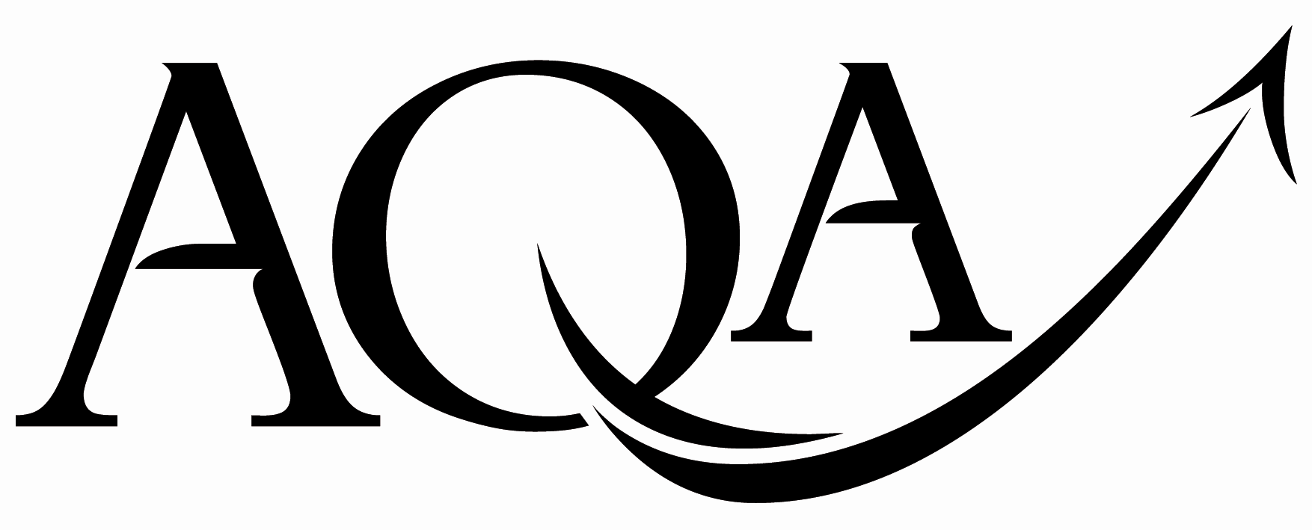 | General Certificate of Secondary Education  Foundation Tier
  For Examiner’s Use
  Examiner’s Initials
  Pages | Mark
  3
  4 - 5
  6 - 7
  8 - 9
  10 - 11
  12 - 13
  14 - 15
  16 - 17
  18 - 19
  20 - 21
  22
  TOTAL
43603F

GCSE Mathematics
FF

Unit 3 Foundation Tier

Practice Paper Set 3 Specification 4360

For this paper you must have:
mathematical instruments.
You may use a calculator

Time allowed
- 1 hour 30 minutes

Instructions
- Use black ink or black ball-point pen. Draw diagrams in pencil.
- Fill in the boxes at the top of this page.
- Answer all questions.
- You must answer the questions in the space provided. Do not write outside the box around each page or on blank pages.
- Do all rough work in this book. Cross through any work that you do not want to be marked.
- If your calculator does not have a π button, take the value of π to be
3.14 unless another value is given in the question.

Information
- The marks for questions are shown in brackets.
- The maximum mark for this paper is 80.
- The quality of your written communication is specifically assessed
in questions 4 and 12
These questions are indicated with an asterisk ()
- You may ask for more answer paper and graph paper.
These must be tagged securely to this answer booklet.
Advice
- In all calculations, show clearly how you work out your answer.

Practice Paper Set 3/43603F
Area of trapezium =
(a + b)h
Volume of prism = area of cross-section × length
h
a
b
length
cross-
section
Formulae Sheet: Foundation Tier

Answer all questions in the spaces provided.
1 PQRS is a quadrilateral.
Q
R
P
S

Complete each sentence using a letter.
Angle ............... is a right angle.
Angle ............... is an obtuse angle.
Angle ............... is an acute angle.

(2 marks)

Turn over for the next question

2
- Trains from Manchester to Sheffield pass through Stockport and Chinley.
The distance from Manchester to Sheffield is 36 miles.
The distance from Manchester to Stockport is 8 miles.
Not drawn
accurately

8 miles
Manchester
Stockport
Sheffield
Chinley
2 (a) Work out the distance from Stockport to Sheffield.
...................................................................................................................................................
...................................................................................................................................................
...................................................................................................................................................
Answer .................................miles (1 mark)
2 (b) Chinley is exactly halfway between Manchester and Sheffield.
Work out the distance from Stockport to Chinley.
...................................................................................................................................................
...................................................................................................................................................
...................................................................................................................................................
Answer .................................miles (2 marks)
2 (c) A train travels from Manchester to Sheffield and back to Manchester 5 times each day.
How far does this train travel each day?
...................................................................................................................................................
...................................................................................................................................................
...................................................................................................................................................
Answer .................................miles (2 marks)

- Here is a centimetre grid.
y
0
1
2
3
4
5
6
7
8
0
1
2
3
4
5
6
7
8
x
3 (a) On the grid, draw a circle of radius 3 centimetres with centre (5, 4).
(2 marks)
3 (b) Here is a circle, centre O.
O
3 (b)(i) Mark with a cross a point on the circumference.
(1 mark)
3 (b)(ii) Draw a diameter.
(1 mark)
3 (b)(iii) Draw a tangent.
(1 mark)

10
4 Tom wants to use blocks to build a rectangular patio.
The patio is 4 metres long and 3 metres wide.
4 m
3 m
Not drawn accurately

y
z

30 blocks cover one square metre.
Blocks are sold in packs of 25.
How many packs does Tom need?
...................................................................................................................................................
...................................................................................................................................................
...................................................................................................................................................
...................................................................................................................................................
...................................................................................................................................................
...................................................................................................................................................
Answer ................................. (5 marks)

5 Here is a list of metric units.
metres litres centimetres

grams kilograms millimetres
5 (a) Complete each statement using one of the units from the list.
The length of a pencil is measured in ……..................................................
The amount of water in a bath is measured in ………...............................................
A packet of crisps is weighed in ………...............................................
(3 marks)

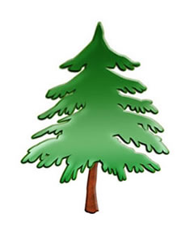
5 (b) In this scale drawing, a man is shown standing next to a tree.
2m

11

Estimate the height, in metres, of the top of the tree.
...................................................................................................................................................

...................................................................................................................................................
Answer ......................... metres (3 marks)
6 (a) Measure the length of line AB in centimetres.
B
A
Answer ......................... cm (1 mark)

6 (b) The length of line CE is 12 centimetres.
CA
E

D is a point on CE.
CD is $\frac{1}{4}$ of CE.
Work out the length of DE.
...................................................................................................................................................
...................................................................................................................................................
...................................................................................................................................................
Answer ......................... cm (3 marks)

7 The number 71 is shaded on the grid.

7 (a) What fraction of the grid is shaded?
Give your answer in its simplest form.
...................................................................................................................................................
...................................................................................................................................................
Answer ......................... (3 marks)
7 (b) The number five is shaded on this grid.
Draw the reflection of the number five in the mirror line.

8
mirror line
(2 marks)

9
7 (c) The number eight is drawn.

Write down the order of rotational symmetry.
Answer .................................. (1 mark)

8 The diagram shows a ladder against a vertical wall.
The wall is at right angles to the ground.
wall
ladder
ground
4.5 m
2.5 m
Not drawn
accurately
8 (a) Make a scale drawing of this diagram.
The ground has been drawn for you.
Use a scale of 2 cm to represent 1 metre.

ground
(3 marks)

4

8 (b) For the ladder to be safe to use, the angle between the ladder and the ground must be between 70° and 75°
Is the ladder safe to use?
Give a reason for your answer.
...................................................................................................................................................
(1 mark)

x
9 A, B and C are plotted on the grid.
y

-2
-1
O
1
2
3
4
-3
-2
-1
1
2
3
4
A
B
C
9 (a) Write down the coordinates of B.
Answer (........... , ...........) (1 mark)
9 (b) ABCD is a rectangle.
Plot point D and draw the rectangle.
(1 mark)
9 (c)(i) Draw the vertical line of symmetry of rectangle ABCD.
(1 mark)
9 (c)(ii) Write down the equation of this line of symmetry.
Answer ................................. (1 mark)

5

10 Here is a formula for changing pints to litres.
number of pints = number of litres ÷ 0.57
A coffee machine holds 10 litres of milk when full.
The milk is bought in 4-pint bottles.
Each bottle of milk costs £1.65
How much does it cost to fill the machine?
...................................................................................................................................................
...................................................................................................................................................
...................................................................................................................................................
...................................................................................................................................................
...................................................................................................................................................
...................................................................................................................................................
...................................................................................................................................................
Answer £................................. (4 marks)

11 Here is a centimetre cube.

30 of these cubes are used to make a cuboid.
Draw a possible cuboid on the grid below.

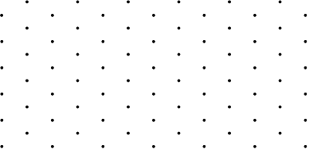
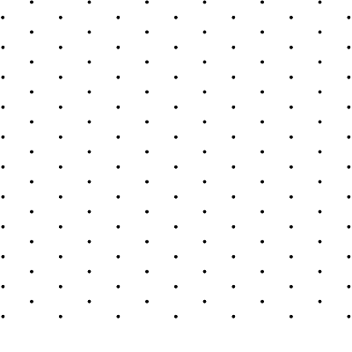
(3 marks)

7

12 Fiona wants to put three equal-sized pictures on a wall as shown.
Not drawn
accurately
5.6 m

space | 40 cm | space | 40 cm | space | 40 cm | space

Each space is the same width.
How wide is each space?
State the units of your answer.
...................................................................................................................................................

...................................................................................................................................................

...................................................................................................................................................
...................................................................................................................................................

...................................................................................................................................................

...................................................................................................................................................
Answer ................................. (6 marks)

13 PQRS is a square of side length 14 cm.
M is the midpoint of PQ.
Two squares are drawn inside PQRS that overlap to form square A.
The area of the shaded rectangle is $\frac{1}{7}$ of the area of PQRS
Not drawn
accurately
M
A
P
Q
R
S

Work out the area of square A.
...................................................................................................................................................

...................................................................................................................................................
...................................................................................................................................................

...................................................................................................................................................
...................................................................................................................................................

...................................................................................................................................................

...................................................................................................................................................
Answer ................................. cm² (5 marks)

11

14 Triangles P and Q are joined together as shown.
x + 30°
P
45°
85°
x
x
Q
Not drawn accurately

What type of triangle is Q?
You must show your working.
...................................................................................................................................................

...................................................................................................................................................

...................................................................................................................................................
...................................................................................................................................................

...................................................................................................................................................

...................................................................................................................................................
Answer ............................................................. (4 marks)

15 Two right-angled triangles A and B are shown.

10 cm
Not drawn
accurately
5 cm
A
B
h
8 cm

The area of triangle B is 50% greater than the area of triangle A.
Work out the height, h, of triangle B.
...................................................................................................................................................

...................................................................................................................................................
...................................................................................................................................................
...................................................................................................................................................
...................................................................................................................................................
Answer ................................. cm (5 marks)

Turn over for the next question

9

16 (a) Complete this table of values for the graph of y = x² − 2x − 4
x | −2 | −1 | 0 | 1 | 2 | 3 | 4
y | 4 |  | −4 |  | −4 |  | 4

...................................................................................................................................................

...................................................................................................................................................
(2 marks)
16 (b) On the grid, draw the graph of y = x² − 2x − 4 for values of x from −2 to 4.
y
(2 marks)
-2
-1
O
1
2
3
4
-5
-4
-3
-2
-1
1
2
3
4
5
x
16 (c) Write down the values of x for which y = −3
Answer.............. and .............. (1 mark)

5
17 The diagram shows parts of two regular polygons A and B.
3x
2x
A
B
A has 12 sides and exterior angle 2x.
B has exterior angle 3x.

Not drawn accurately

Work out the number of sides of regular polygon B.
...................................................................................................................................................
...................................................................................................................................................
...................................................................................................................................................

...................................................................................................................................................
...................................................................................................................................................
...................................................................................................................................................
...................................................................................................................................................
...................................................................................................................................................
Answer ................................. (5 marks)

10
18 Triangle A is shown on the grid.
y
0
1
2
3
4
5
6
7
8
9
0
1
2
3
4
5
6
7
8
9
A
x
Translate triangle A by vector 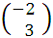
(2 marks)

END OF QUESTIONS

2

There are no questions printed on this page

DO NOT WRITE ON THIS PAGE
ANSWER IN THE SPACES PROVIDED

There are no questions printed on this page

DO NOT WRITE ON THIS PAGE
ANSWER IN THE SPACES PROVIDED

Copyright © 2011 AQA and its licensors. All rights reserved.

