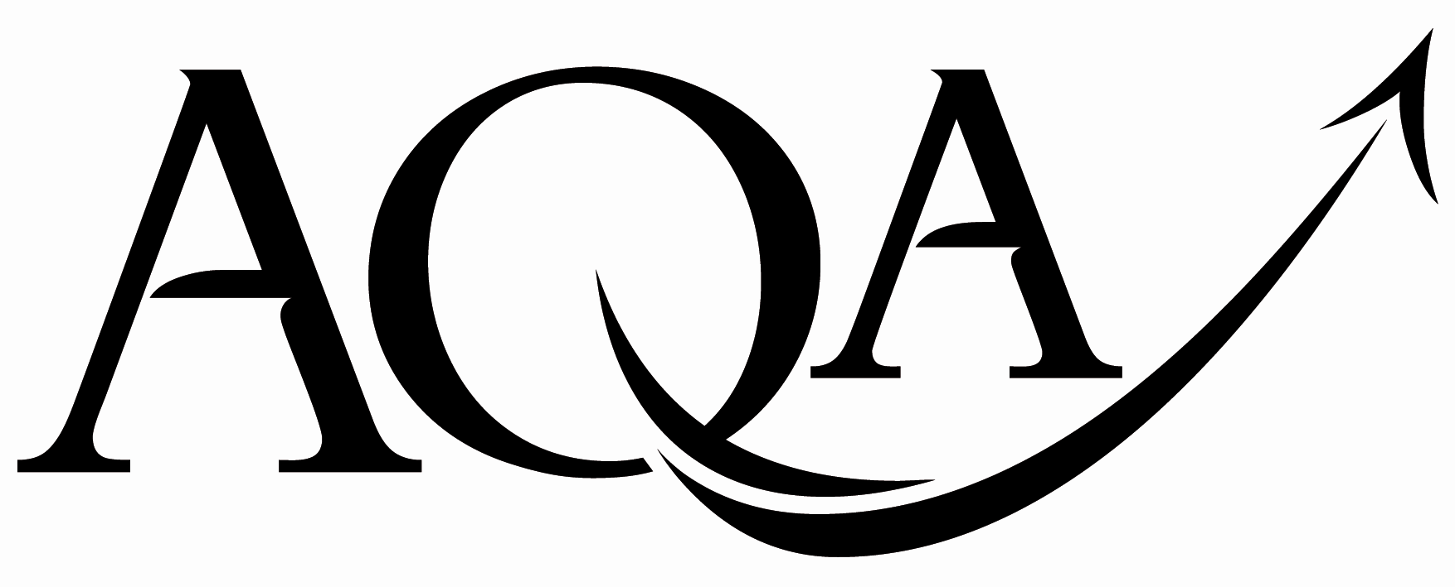 | General Certificate of Secondary Education  Foundation Tier
  For Examiner’s Use
  Examiner’s Initials
  Pages | Mark
  3
  4 - 5
  6 - 7
  8 - 9
  10 - 11
  12 - 13
  14 - 15
  16 - 17
  18 - 19
  20 - 21
  TOTAL
43603F

GCSE Mathematics
FF

Unit 3 Foundation Tier

Practice Paper Set 2 Specification 4360

For this paper you must have:
mathematical instruments.
You may use a calculator

Time allowed
- 1 hour 30 minutes

Instructions
- Use black ink or black ball-point pen. Draw diagrams in pencil.
- Fill in the boxes at the top of this page.
- Answer all questions.
- You must answer the questions in the space provided. Do not write outside the box around each page or on blank pages.
- Do all rough work in this book. Cross through any work that you do not want to be marked.
- If your calculator does not have a π button, take the value of π to be
3.14 unless another value is given in the question.

Information
- The marks for questions are shown in brackets.
- The maximum mark for this paper is 80.
- The quality of your written communication is specifically assessed
in questions 17 and 18
These questions are indicated with an asterisk ()
- You may ask for more answer paper and graph paper.
These must be tagged securely to this answer booklet.
Advice
- In all calculations, show clearly how you work out your answer.

Practice Paper Set 2/43603F
Area of trapezium =
(a + b)h
Volume of prism = area of cross-section × length
h
a
b
length
cross-
section
Formulae Sheet: Foundation Tier

Answer all questions in the spaces provided.
1 (a) Here are some shapes.
Which two shapes are congruent?
Answer.................... and .................. (1 mark)
1 (b) Tick whether each of the following statements is always true, sometimes true or never true.
Congruent shapes have the same perimeter.
 | Always true |  | Sometimes true |  | Never true

Congruent shapes have the same area.
 | Always true |  | Sometimes true |  | Never true
(2 marks)

Turn over for the next question

3
2 (a) Here are four 3D shapes.
A B C D

The shaded area is a net for one of them.

Which shape is it?
Answer ................................. (1 mark)

2 (b) Write down the mathematical name of each of the following.

(3 marks)

3 Here are two angles, y and z.
y
z
What type of angles are they?
Answer y is............................................
z is ........................................... (2 marks)

6
4 Here are some lines drawn on a grid.

 | C |  |  | D
H |  |  |  |  |  |  |  |  | F
 |  |  |  |  |  |  | E
G

 |  | A |  |  |  | B

4 (a) Measure the length of EF.
Answer ................................. cm (1 mark)
4 (b) Which line is parallel to CD.

Answer ....................................... (1 mark)

4 (c) Draw a line at right angles to AB.
(1 mark)

5 (a) Three motorway service stations are represented in the diagram.
The distances between the stations are shown.

22 miles
14 miles
14 miles
22 miles
A
B
C

A car breaks down halfway between B and C.
A breakdown truck travels from A.
How far does the truck have to travel to reach the car?
...................................................................................................................................................
...................................................................................................................................................
Answer .................................miles (2 marks)
5 (b) Five different motorway service stations are represented in this diagram.

T
P
N
W
L

This mileage chart gives some of the distances between the service stations.

T
15 | P
28 |  | N
40 |  |  | W
60 |  |  |  | L

Complete the mileage chart.
...................................................................................................................................................
...................................................................................................................................................

9
(4 marks)
6 Here are some patterns of circles.

6 (a) Shade two more circles to give this pattern symmetry in the mirror line.

mirror line

(2 marks)
6 (b) Shade two more circles to give this pattern symmetry in both mirror lines.

mirror line

mirror line

(2 marks)
6 (c) Shade four more circles to give this pattern symmetry in the mirror line.

mirror line
(2 marks)
7 Points A, B and C are plotted on the grid.
They are three of the four corners of a quadrilateral.
y
-4
-3
-2
-1
O
1
2
-4
-3
-2
-1
1
2
3
4
C
A
B
x
7 (a) Write down the coordinates of the point C.

Answer (............... , ...............) (1 mark)
7 (b) Tick whether each of the following statements is true or false.

 | True |  | False
It is possible to plot point D so that ABCD is a square.
It is possible to plot point D so that ABCD is a rectangle.
It is possible to plot point D so that ABCD is a parallelogram.
(2 marks)

8

9
8 Here is a conversion graph.
0
10
20
30
40
50
60
70
80
90
100
110
0
5
10
15
20
25
30
35
40
45
50
Kilograms
8 (a) Use your graph to convert 66 pounds to kilograms.
Pounds
Answer .................................. kg (1 mark)
8 (b) A dog weighs 20 kilograms.
Use your graph to work out the dog’s weight in pounds.
Answer .......................... pounds (1 mark)
8 (c) Mrs Smith weighs 10 stones.
You are given that 14 pounds = 1 stone
Work out how much Mrs Smith weighs in kilograms.
...................................................................................................................................................
...................................................................................................................................................
...................................................................................................................................................
...................................................................................................................................................
Answer ................................. kg (4 marks)
9 Here is a right-angled triangle.
Two of these triangles can be joined to make a new triangle as shown.
What type of triangle is the new triangle?
Give a reason for your answer.
Type ..................................…………...….…….....…………………………………………….…..
Reason ..................................…………...….…….....…………………………………………….…..
..................................…………...….…….....…………………………………………….…..
(2 marks)

Turn over for the next question

8

10 The shape PQRS is drawn on a grid.
Q |  | R
P |  | S
10 (a) Enlarge PQRS by scale factor 3.
(2 marks)
10 (b) How many times bigger is the area of the enlarged shape than the area of PQRS?
...................................................................................................................................................
Answer ................................. (2 marks)
11 Three straight lines meet at a point as shown.

Not drawn
accurately
x
y
w
x = 80°
y is 40% of x.

Work out the size of w.
...................................................................................................................................................
...................................................................................................................................................
...................................................................................................................................................
...................................................................................................................................................
...................................................................................................................................................
Answer ................................. degrees (4 marks)

Turn over for the next question

8

12 George’s car uses one gallon of petrol for every 40 miles.
He goes on a 320 mile journey in his car.
Petrol costs 130 pence per litre.
How much does the petrol cost for the journey?
...................................................................................................................................................
...................................................................................................................................................
...................................................................................................................................................
...................................................................................................................................................
...................................................................................................................................................
...................................................................................................................................................
Answer £ ................................. (4 marks)

13 (a) James has 72 identical square tiles.
He uses all of them to tile an area that is in the shape of a rectangle.
How many tiles are there along the length and width of the rectangle?
Give two pairs of possible values.
...................................................................................................................................................
...................................................................................................................................................
Answer ..................... tiles and .................... tiles
or ..................... tiles and .................... tiles
(2 marks)

Question 13 continues on the next page

6
13 (b) Katie is tiling her bathroom wall.
She runs out of tiles.
She goes to the shop to buy the exact number of tiles she needs.
She uses this special offer.
Tiles

Normal price: £8 each

Special offer:
15% off
and
for every 5 you buy get 1 extra free

How much does she pay for the tiles?
...................................................................................................................................................
...................................................................................................................................................
...................................................................................................................................................
...................................................................................................................................................
...................................................................................................................................................
...................................................................................................................................................
...................................................................................................................................................
...................................................................................................................................................
Answer £ ................................. (5 marks)

14 The diagram shows the map of an island drawn on a grid.
Each square represents 10 000 m ².
North
Point
Cricket
Ground
Aquarium
Shopping
Mall
Diving
Centre
N

14 (a) Estimate the area of the island.
Give your answer in square metres.
...................................................................................................................................................
...................................................................................................................................................
...................................................................................................................................................
...................................................................................................................................................
...................................................................................................................................................
...................................................................................................................................................
Answer ................................. m ² (4 marks)
14 (b) Measure the bearing of the Aquarium from North Point.
Answer ……................................. (1 mark)
14 (c) A Football Stadium is on a bearing of 200° from North Point and 070° from the Shopping Mall.
Mark with a cross the position of the Football Stadium on the map.
(3 marks)

13

15 Here is a triangle.
Not drawn accurately

Using ruler and compasses only, construct an accurate scale drawing of the triangle.
Use the scale 1 cm represents 50 m.

(3 marks)

16 (a) Here is a formula for the perimeter, P, of a rectangle.
P = 2L + 2W
Work out L when P = 20 cm and W = 4 cm
...................................................................................................................................................
...................................................................................................................................................
...................................................................................................................................................
Answer ................................. cm (3 marks)
16 (b) The diagram shows a semi-circle, radius r, and a rectangle.
Not drawn accurately
r
r

The perimeters are equal.
Work out the value of r.
...................................................................................................................................................
...................................................................................................................................................
...................................................................................................................................................
...................................................................................................................................................
...................................................................................................................................................
...................................................................................................................................................
Answer ................................. cm (4 marks)

10
17 Jordan is using a trial and improvement method to find a solution to this equation.
x ³ − 5x = 30
The first trial is shown in the table.

x | x ³ – 5x | Comment
3 | 12 | Too small
Continue the trial and improvement method to find a solution to the equation.
Give your final answer to 1 decimal place.
...................................................................................................................................................

...................................................................................................................................................

...................................................................................................................................................
...................................................................................................................................................
...................................................................................................................................................
...................................................................................................................................................
Answer x = ................................. (4 marks)

18 A and B are rectangles.
The area of A is 160 cm ².
The length of B is 20 cm.
The ratio of the area of A to the area of B is 2 : 3
A
B
160 cm ²
20 cm
w
Work out the width of B, marked w on the diagram.
...................................................................................................................................................
...................................................................................................................................................
...................................................................................................................................................
...................................................................................................................................................
...................................................................................................................................................
Answer ................................... cm (4 marks)

END OF QUESTIONS

8

There are no questions printed on this page

DO NOT WRITE ON THIS PAGE
ANSWER IN THE SPACES PROVIDED

There are no questions printed on this page

DO NOT WRITE ON THIS PAGE
ANSWER IN THE SPACES PROVIDED

Copyright © 2011 AQA and its licensors. All rights reserved.

