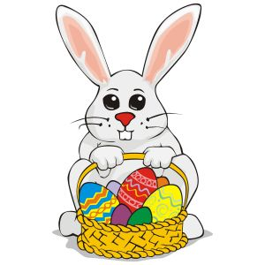
Easter in Germany

How much do you know about Easter in Germany?
Here is your chance to find out more!

- Find the correct answers to the questions below and you could win a German Easter Present!
- Entries must be completed as a power point as you will be asked to present your ideas to your year group should you win! So don’t forget to illustrate and format the power point in a clear and interesting way!
- Save your power point, print out a copy of the slides and hand into Miss Baker

Entries must be completed by Tuesday 5th April.
______________________________________________________

- What is the main religion in Germany?
- Who is the head of this church?
- What is ‘Fasching’?
- How is ‘Fasching’ celebrated in Germany?
- What do we call ’Karwoche’?
- What or who is ‘der Osterhase’?
- What do we call ‘Karfreitag’?
- What happened on this day?
- What do many German families traditionally eat on this day?
10. Why do some Germans light bonfires across Germany at this time?
11. How would you translate ‘Ostersonntag’?
12. What sort of presents do children receive in Germany?
13. Who or what delivers the presents?
- Where are they hidden?
- What are ‘Ostereier’?
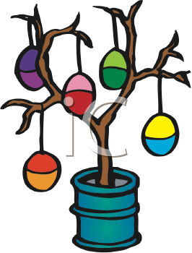
- How do you say ‘Happy Easter’ in German?

