A day at London
In the morning
I set off to school on the 14th of March early in the morning. We waiting until everyone arrived, (Connie McLachlan, Isabelle Barnard, Bethany Wiles, and Beth Hancock) and then we went into Miss Japp’s car. We drove to down to Borough station and met Mrs. Fairhurst. We took a direct train to London. It was a four hour journey to London and arrived at Kings Cross station.
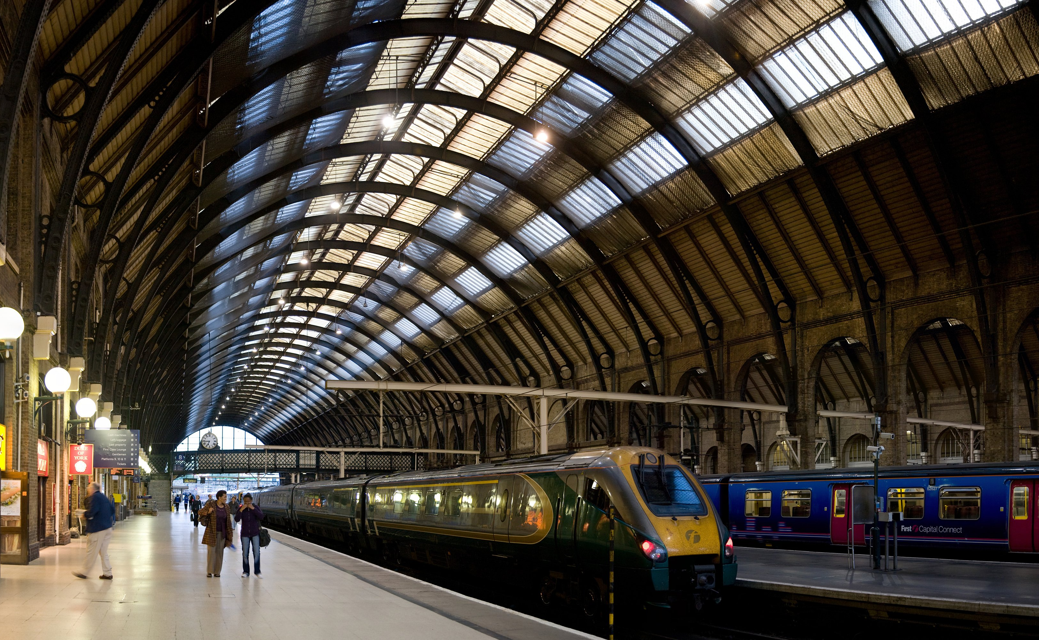

After

At London we walked around the Thames and saw some sights. We also had a look at an art gallery that had hand painted sunflower seeds.

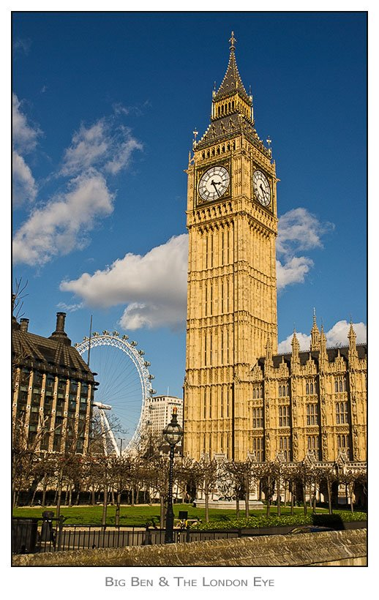
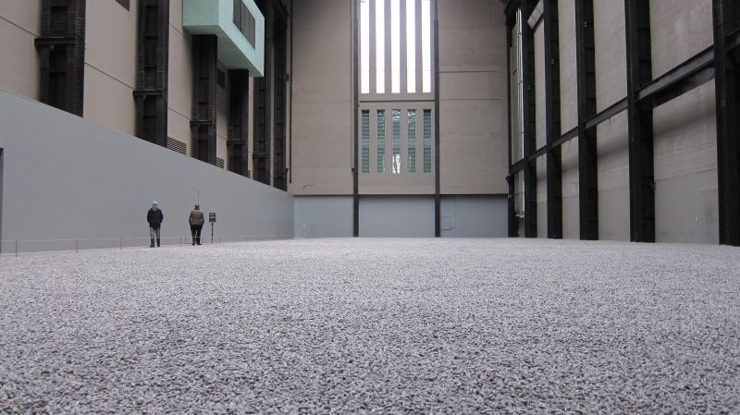

Lunch Time
For lunch we all went down to a café in London. I got a Mozzarella and tomato Panini. Afterwards we walked down to West Minster Abbey. We had yellow tickets but it was so unfair because we saw people with pink, green and red tickets and they got to skip the queue!

In the West Minster Abbey

An Observance for Commonwealth Day 2011
In the presence of Her Majesty the Queen and His Royal Highness the Duke of Edinburgh.
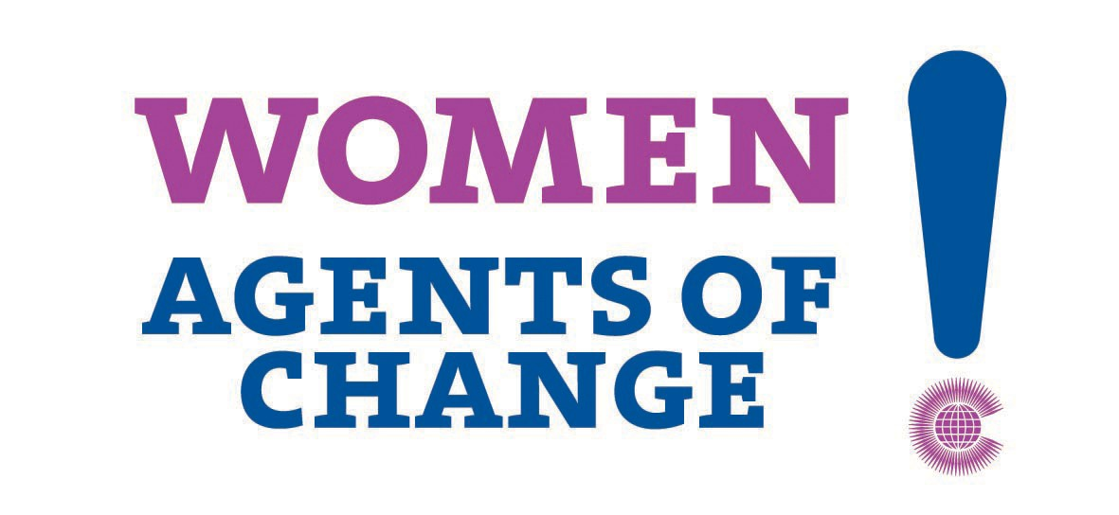
Each year, on the second Monday in March, the council of Commonwealth Societies organise an event in West Minster Abbey. The observance marks commonwealth day, when people across the world celebrate the special partnership of nations, peoples and ideals. Many speakers such as, Kamla Persad, Dr Dambisa Moyo, Ms Carol Ann Duffy CBE, Ms Marie Staunton, Dr Martina Roth, Ms Annie Lennox, and Mr Kamalesh Sharma were there. The Queen also had a pre-recorded speech, which was quite disappointing. Performers such as Bear Love, Maria Fidelis Convent School Gospel Choir, Ms Denyse Plummer, The choir of Westminster Abbey, and Dance Ihayami were there too.



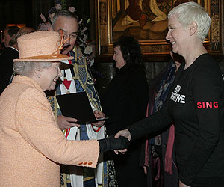

After that…
Mrs Japp bought us a drink then we went down to the train station. We went on to the train on the way home. We had a great day.

